Programming Project

By Nathaniel Lowis

Contents

Analysis 4

Basic Program Specification and Justification of Program 4

Describe and justify the features that make the problem solvable by computational methods and explain why it is amenable to a computational approach. 4

This is what my initial ideas and breakdown of the problem: 4

Thinking Abstractly 4

Thinking Procedurally 5

Thinking Logically 5

Thinking Concurrently 5

Thinking ahead 6

Programming Paradigm 6

Computational methods 6

Identify suitable stakeholders for the project and describe them, explaining how they will make use of the proposed solution and why it is appropriate to their needs. 7

Research the problem in depth looking at existing solutions to similar problems, identifying and justifying suitable approaches based on this research. 8

Papa Louie When Sundaes Attack found on Coolmaths Games 8

Projectile Motion Maker A simulator for calculating the flight of a projectile in the atmosphere. 9

Identify the essential features of the proposed computational solution 10

Identify the essential features of the proposed computational solution explaining these choices: 10

Limitations 12

Specified and justified the requirements for the solution including (as appropriate) any hardware and software requirements. 13

Hardware 13

Software 13

Success Criteria 15

Pre-Development 17

Looking at Unity and Tkinter 17

Code I have found. 17

Design 20

Break the problem down systematically into a series of smaller problems suitable for computational solutions, explaining and justifying the process 20

Describe the solution fully, using appropriate and accurate algorithms, justifying these algorithms form a complete solution to the problem and identify and justify the test data to be used during the iterative development of the solution 27

Storyboard 68

Describe, justifying choices made, the usability features to be included in the solution 69

Identify and justify the key variables/ data structures / classes (as appropriate to the proposed solution) justifying and explaining any necessary validation 70

Identify and justify any further data to be used in post development phase. 78

Development 83

Prototype 0 83

First prototype 84

Prototype 1 Code 94

Second Prototype 98

Prototype 2 Code 104

Third Prototype 112

Prototype 3 Code 118

Fourth Prototype 134

Prototype 4 code 139

Evaluation 140

Testing to inform development. 140

Provided annotated evidence of post development testing for function and robustness. 140

Provided annotated evidence for usability testing. 151

Beta Testing 155

Use the test evidence to cross reference with the success criteria to evaluate the solution explain how the evidence shows that the criteria has been fully, partially or not met in each case. 156

Success Criteria 156

Provide comments on how any partially or unmet criteria could be addressed in further development. 159

Provide evidence of the usability features justifying their success, partial success or failure as effective usability features. 160

Provided comments on how any issues with partially or unmet usability features could be addressed in further development. 161

Considered maintenance issues and limitations of the solution. 162

Maintenance 162

Limitations 162

Describe how the program could be developed to deal with limitations and potential improvements / changes. 163

Final Code 164

Bibliography 191

# Analysis

## Basic Program Specification and Justification of Program

The program I want to create is a platform game where the user will use projectile motion to track the motion of bullets. The user will be able to move to an endpoint, with enemies which you can shoot who guard the way. Once you have reached the endpoint you will have completed the level. You will have a set amount of bullets to use and when you fire one, the amount you have decreases. You will score points by the time taken, the amount of health left, how many bullets you have left and how many enemies you kill. The different guns will use different amount of bullets. The user will try and complete level and gain the most points which will then be put into a database which the user will be.

This game is hard enough as it requires a complex GUI and a way to hold the scores. It is also complex with the use of physics equations which will be used.

One of the video’s (Example of my Game) shows a playthrough of my game so you can see what is happening and how the program works.

## Describe and justify the features that make the problem solvable by computational methods and explain why it is amenable to a computational approach.

### This is what my initial ideas and breakdown of the problem:

When a bullet hits either you (from an enemy) or the enemy (from you) the amount of health to be taken off will be calculated using the SUVAT equations (v = u + at, s = (u + v)/2 * t, v ^2 = u ^2 + 2as, s = ut + ½ a(t^2), s = vt - ½ a(t^2)). I would set the initial velocity, the acceleration, the time (worked out by how long the bullet has been generated) and I have to work out velocity and displacement. However, this could change. I would then work out the kinetic energy (E = ½ mV^2) and then work out the power (p = E/t) with the power being the amount of health lost. Unsurprisingly, each character in the level will have their own health pool and the level will not just be a straight line (IE there will be things to jump over which will be decided by one of the SUVAT equations). I will make 2 guns (made by a parent class and then each gun inheriting from the parent class) with one making the bullet move in a parabolic curve and one moving in a horizontal direction. I will use threads to make everything work simultaneously. Finally I will have a database with all the high scores of the user.

### Thinking Abstractly

I will represent the level using rectangles and squares along with circles which are simple things for a computer to draw. A character will be represented by a rectangle along with the end point being represented by a square and a bullet by a circle.

I am going to make two different kinds of bullets, however I am going to make both of them inherit attributes and methods with attributes they will both inherit is mass, acceleration, time, and methods will be the kinetic energy equation and power equation.

I will use the equations of motion (Also known as SUVAT) to move the bullets.

I will have a collision detector where it will detect whether the character or bullet will pass a certain x axis value if the object is stationary and if not an x value which will be worked out.

I will have different window for the menu, the game and highscores. All the characters will be rectangles to make it easy to make and also the end point will be a square as well on the screen for the user to see.

Another bit of abstraction will be that the bullet will not be accelerating when on the screen but will have constant speed as this is easier to implement.

I have also abstracted that the parabolic bullet will be at the angle of 45 degrees however, in real life, this is unlikely to happen.

### Thinking Procedurally

I will have most of the code in procedures, functions and classes. The main classes will be the bullet and character classes and the most important modules will be the menu. They will be the most important modules as if they work the whole game will be able to work as I intend it to do. I will have a larger top down structure diagram later.

I will write the code using classes, functions and procedure with hopefully little code outside any functions, procedures or classes.

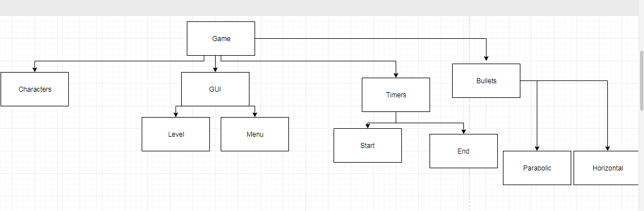

### Thinking Logically

There will be a decision to see if a bullet has actually hit a character and if it has hit a character, then how much health needs to be taken off. Another decision will be whether a button has been clicked and what to do if it has been. Another decision will be where in the screen the person has pressed so if they have clicked a button it will take them to the next screen. Another decision will be whether the character has reached the endpoint and if it has the game will end.

There will also be a menu which will require decisions about which button was pressed so to decide where the user will go from there.

Another decision will be whether the bullet has ‘hit’ the enemy and what should happen from there.

Another decision will be which button the user has pressed and what should happen. As well, there will be a decision to decide whether you have clicked the screen allowing you to use the buttons for the game.

There will be another decision on whether the user has entered their username and what the largest Primary key is in the database. Another decision will be which score is the largest and which score is the smallest.

Another decision will be which button has been clicked thus meaning the game knows when to shoot a bullet or the character to move.

### Thinking Concurrently

I will try and get threads working in Python however this whole section could be void if I cannot get it working. The different characters will all be able to work concurrently, as will the bullets. These should all be able to work independently of each other. The characters should all be able to move at the same time as the bullets. This then means that the user is facing an actual enemy. They should also be able to fire bullets to try and hit the enemy and this should be able to work without everything else stopping. This will mean you could have to or 3 bullets or being fired at once. I will also have a timer on another thread meaning you can get the correct time at all times.

### Thinking ahead

I will reuse the code for the bullet and for the characters. I will use the Tkinter library, the time library, SQLite3 library and CSV libraries meaning I do not need to code this from the bottom up. I will also reuse code which I have already programmed (IE I already have a working way to work out how long the program runs).

I will not be deliberately using the cache because I do not know how to and it is not necessary for my program.

### Programming Paradigm

I will be using multiple programming paradigms however I will mostly use procedural, object oriented and event driven. The object oriented paradigm will be used as it will allow me to use classes so I can use new code for bullets and characters but am still able to call them multiple times in the code. It also allows me to inherit features from a super class meaning I can have methods and attributes which are the same for different sub classes but can still differentiate between them.

Event driven programming will be used as I am using a GUI so am waiting for the user to do something to then actually make something happen. It then allows me to wait for when the user wants to move or press a button to start the level.

I will also use logic programming for using the database as I will be using a version of SQL. This will allow me to interrogate the database when needed.

I will finally use procedural programming to execute commands which have been triggered by the user pressing a button and so the code actually works.

### Computational methods

I will use visualisation so the user can see what is happening and react to what is happening in the game. It will also mean the user can see it and so it looks nice. It is only a representation so I will only use rectangles for the characters as anything else would be too complex. When I am programming it I will use visualisation, as I will try and solve the equations of motion, on paper beforehand, so I can use them correctly.

I have already recognised the initial problem which is at the top of the document. I will also use problem recognition meaning I can decompose what the problem is at each point of the program.

I will use pipelining with the output of the velocity of the bullet being put into the kinetic energy equation then the final kinetic energy going into the power equation. As well the power from the final equation will then go into how much health needs to be taken off.

I will also use performance modelling, as I will see how much health is taken off when I shoot a bullet and see if I need to take more or less off.

## Identify suitable stakeholders for the project and describe them, explaining how they will make use of the proposed solution and why it is appropriate to their needs.

I am going to aim my game at the teenager demographic as I believe they will like the competiveness of trying to get a high score but will also like the setting of the game.

|  |  |  |
| --- | --- | --- |
| Person | Description | How they will use it and whether appropriate to needs |
| Cameron Bird | 17 year old who likes games | Cameron enjoys playing games so this will be good for him as it will be a different experience for him. He also does A level physics meaning he understands how the motion will work so will be able to say whether my physics engine feels realistic |
| Max Bateman-Sandy | 17 year old who likes games | He is a casual gamer who plays a lot of his games on the computer. This makes him very good at saying whether the controls feel naturals and work. Also he is mildly colour blind so can say whether my colour scheme is any good. |
| Ben Lowis | 14 year old who plays a lot of games | It will be appropriate for Ben as he is someone who likes games like Fortnite so should enjoy the more colourful aspect of the game but he also plays a lot of games meaning he will be able to say whether it is fun and something he would like to go back to. It also means he will enjoy playing a different game with easier objectives. |

## Research the problem in depth looking at existing solutions to similar problems, identifying and justifying suitable approaches based on this research.

### Papa Louie When Sundaes Attack found on Coolmaths Games

On Coolmaths Games there is a game which I have taken inspiration from. This is because as you move through the levels you can unlock characters which use projectiles (like in the picture below). They use these projectiles to hit enemies which you will be able to see if you can complete a few levels. One of the biggest differences between this game and the game I want to make is that Papa Louie has many different enemies and only one uses projectile motion whilst I am more likely only going to make 1 enemy in the level so my game does not use too many threads. Papa Louie also has the lives and different things on the bottom. I will simplify it to just health pool and bullets remaining. You can also see the projectile moving which I will so but this will not be very hard to do on Tkinter. The GUI is also complex to what I will be able to produce so I will simplify it

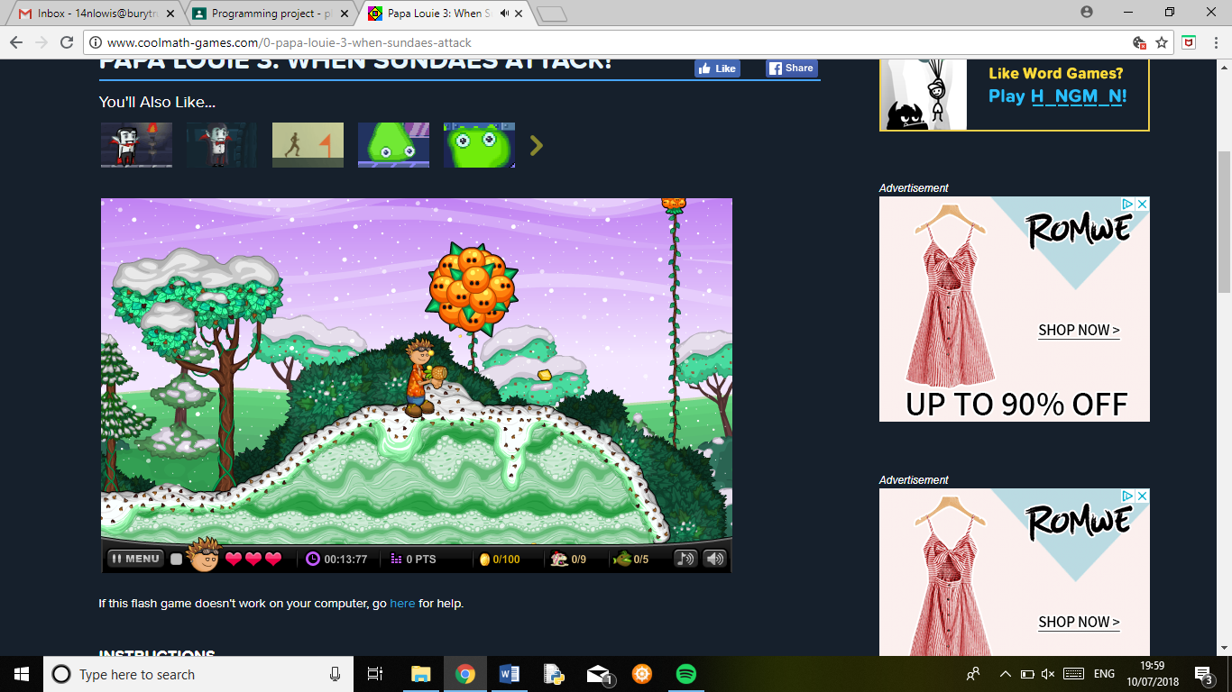

This is the amount of points which you have earnt which I will try and do

We see how much health the user gets which I will also want to do

You can see the ‘bullet’ here which is starting to go down as it follows the equations of motion.

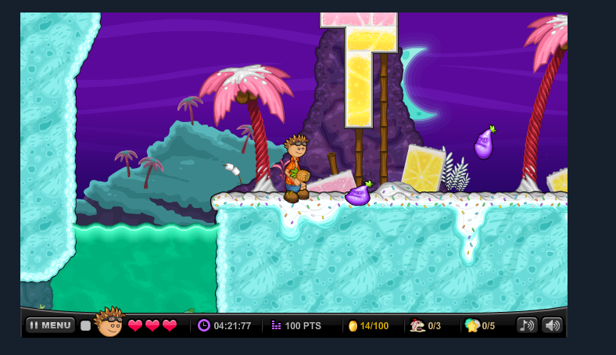

We have enemies which we want to try and defeat. They have no powers but this is the sort of idea I will want to try and implement.

I cannot get to the code but I assume it will use some sort of concurrency to try and get the enemies to bounce at the same time as you moving. I also assume it will have its own physics engine which is a separate module which will have things like the gravity constant in it and also other things which can help with the physics.

### Projectile Motion Maker A simulator for calculating the flight of a projectile in the atmosphere.

This is a program which works out the distance of how far a projectile will go in the atmosphere which I have found in REPL. This code uses vectors to work out the distance which I will use if I use a parabolic motion for one bullet. I am more likely to take away a lot of complex parts, like drag (this is where the air pushes back on you whilst you move) and just use the equations of motion which I can use to show the motion of the bullet. The code is useful as you can see the path which the bullet would take when shot. This will be a bit like when the person can see the bullet move when shot. It also will have a module call another module when it runs which is interesting to see as if there are too many of them it will slow the code down and maybe even reach the stack limit. However as he has only done it a few times it rarely fails. Another interesting problem is that there can be a lot of dividing by 0 errors. This is an error which he has not caught thus making it harder for the user to play with.

However, the code is easy to read as it only uses 5 -10 lines per module which I would like to do.

## Identify the essential features of the proposed computational solution

|  |  |
| --- | --- |
| Description of feature | Solvable by computational methods and amenable to computational approach |
| A GUI to show what the level looks like at any one moment | A GUI is solvable by using pre-existing libraries like Tkinter. It will be connected to the function and classes of the objects on the screen being used. |
| Buttons to start game or go to high scores or contents page | This is a GUI feature which I can implement so when the user presses the button, it will call the appropriate function so it can run the correct part. |
| Algorithms to work out how far a bullet goes. | It is solvable by using maths so the developer will work out how to solve the equation then will implement it by putting it in a class. |
| Algorithm to work out how many points the user gets | This will be done by an equation the developer will make up then be put into a function |
| Threads to make different parts work at the same time | This is solvable as I can use the pre-existing library in  Python. This allows me to have many different characters moving at the same time. |
| A sorting algorithm to put the scores in order | This is solvable with the merge sort. I already have code for it and the scores are most likely to already be in order so this will be the fastest. |
| Algorithms to move the character left/right | This is solvable as you can bind keys to move left or right from a pre-existing library. It is also solvable as I can move the character left or right easily. |

## Identify the essential features of the proposed computational solution explaining these choices:

The level: This is very important as the way to actual allow the user to play the game. It will be very basic but characters will be represented by rectangles and bullets by circles.

The menu: This will mean the user can decide whether to play the game or to see the highscores of other players.

The bullets: This will be the only way to stop the enemy and needed to win the game

An endpoint: The only way to stop the game.

User’s character: The only way the user can interact with the environment

The scoring system: This is the way the user knows how well they have done and also needs to reward finishing the level, getting a good time and finally not using too many bullets.

How to win: You finish the level (win) by getting to an endpoint which you activate when you go past.

How to score: You score by completing the game as quickly as possible and by defeating all the enemies with the least amount of health lost and least amount of bullets used. This is computational as I will create an equation to work it out

The GUI: This is important as it allows the user to interact with the game. During the level the user will see rectangles and circles for the characters and the bullets. In the menu there will be buttons to choose where to go.

How to play: The user will play the game by using the left/right keys which allows them to move left or right. The user will also use the different button keys to fire the bullet, change the bullet and also to jump.

Enemy’s character: This is the person which you have to defeat. It will be able to use both guns and fire every 3 seconds or so and will have a high damage output. This is essential so that you have an actual objective to try and defeat.

## Limitations

|  |  |  |
| --- | --- | --- |
| Limitation | Explanation | Justification |
| Timescale of the project | There is a limited length of time to have all documentation and programming to be completed by. | Will not be able to make many different bullets as they will take a while to work out the maths for |
| The GUI | The GUI will not look good and will not look professional and just uses blocks and circles | Not using a game engine as it has its own prebuilt physics engine built in so will have to use Tkinter instead. So the graphics will look less impressive |
| The amount of enemies | Will not have many enemies to fight | More enemies will equal more threads to make which then makes the game harder to program. I do not want many threads to work with so will not use many enemies. As well more enemies would require my basic collision detector to be overloaded. |
| Short levels | The whole level will probably be on the one page | This is because I do not know how to get Tkinter to scroll. If I can I could then make the level larger. |
| Inaccurate Bullets | The bullets will not be completely accurate. Would behave differently in real life. | This is because I am not learning new equations which bring in drag and other components which I do not know. I am abstracting the bullets down to just using the SUVAT equations making them simpler to use. As well there will be no acceleration on the screen as this would be too hard to make |
| Having to have a user input for anything to happen. | For the enemy to shoot a bullet there must be a user input so we need to disguise this for the user. | This is because of using Tkinter and also how I will have most of the main commands to do different things on the screen, in the main program, it will be hard for me to program the game to keep on getting the enemy to shoot bullets all the time. |

## Specified and justified the requirements for the solution including (as appropriate) any hardware and software requirements.

### Hardware

|  |  |
| --- | --- |
| Hardware | Justification |
| Intel® Core™ i5-2520M @2.50GHz | This is the core in my laptop which I am using meaning the people playing my game should have a laptop of the same specification. |
| 4GB of RAM | This will allow the whole game to run without too many problems |
| 2 or More Processors | This will allow the game to use more than 1 thread and will allow the program to run everything at the same time. |
| Basic GPU | This is so the computer will be able to render in the basic graphics. All home computers will have this GPU. |
| Hard Disk Drive of 1 MB | This will be enough memory to store the whole game and also means it should be able to make quite a large database of scores for different people. |
| Monitor | This will be needed so the user can see what is happening to their character and react to it. |
| Mouse | This is needed so the user can press the buttons to access the menu and also so they will be able to interact with the game. |
| Keyboard with arrow keys | This will be so the user is able to control how the character moves and control the bullets being shot. |

### Software

IDE research

If I was to use Tkinter and Python I would then need to use a better IDE than IDLE so either Anaconda (think it is specific to Python) or Visual Studios (which I’ve used before). I will need an IDE so I can save multiple files and access them easily and also so I can have a decent debugger and so I can also see errors before I run the code. I am going to use Thonny (which I have been shown by my teacher) and Visual Studio 2017.

|  |  |
| --- | --- |
| Software | Justification |
| IDE: Thonny | Even though this is not a widely used IDE, I will use it as it has a very good debugger and also it can help show syntax errors very quickly. (When you open a bracket there will be highlighted bit until you close the bracket) |
| Python 3.6 | Python is a programming language which was created in 1991 by Guido van Rossum which emphasises readability making the syntax very important certainly concerning tabs and whitespace. I will use Python 3.6 as this is the style of the language which I am used to the most and I do not want to confuse myself with errors as I do not know the current version of the language. The user must also have installed Python 3.6 to run the game. |
| Libraries: Time | This is a library which allows me to work out how long something has been on the screen for or how long it has taken the user to play the game. It is needed for these reasons thus I will be able to score the player on how well they have done |
| Libraries: CSV | This is a library which will allow me to use CSV files which will hold the score so this can be used in different parts of my program which are in different files |
| Libraries: SQLite3 | This allows me to use SQL to create, interrogate and update a database. This is the library allowing me to use SQL within Python meaning I do not need a different file integrated into my program. |
| Libraries: Tkinter (known as tkinter in the code) | This allows me to create a GUI for the user to be able to see what is happening and visualise what is happening. I am using Tkinter as there is a lot of help which I can find on the internet and also it allows me to create my own physics for the game. |
| OS: Windows 7 (or equivalent) or better | This is the OS on my most basic laptop and this can run the game. If you went to a lower OS the game might not work as it might not be able to download Python. |

## Success Criteria

|  |  |
| --- | --- |
| Statement | Justification |
| The program will work. The player will be able to play a game which is realistic and is a shooting 2D platform game with an enemy which you need to defeat in it. The program will be robust enough to not break if a wrong input is entered. | I do not want there to be any game breaking bugs or glitches so I will want to have caught them before I finished. I want the game to be finished and that the user feels that it is polished and finished. |
| The program will allow the user to move the character side to side and also to jump. | Again self-explanatory. The user will only be able to use one character and this will be the way to actually interact with the level. |
| The program will have an enemy | This is so there is some difficulty in the game. |
| The program will end when the user’s character reaches an endpoint. | This means the level will end at one point and will not go on forever. |
| The program will detect when the bullet hits either a character or the wall. | This will make the bullet more realistic and also mean the bullet does not go for infinity. |
| The program will take away health from a character when a bullet hits it using the power equation. | This makes it realistic and also means you can destroy the enemy/character. |
| The program will make the bullet go the correct distance using SUVAT. | This make the game realistic |
| The program will have two bullets a parabolic one and a horizontal one. | This allows the user to have more than one weapon |
| The program will allow the user to change which bullet to use | This means they can use both bullets. |
| The program will take away bullets from the total amount of bullets when one is fired | This makes it more difficult to the user and gives the game a level of difficulty. |
| The program will have a timer which allows it to work out how long the user has taken. | This is to be used in the total points and allows the user to try and make it quicker |
| The program will work out a total. | This is to give a point for the game |
| The program will allow the user to see how well they have done | This will allow the user to see how well they have done |
| The program will put the score in a database | This is so the user can see how they compare to other people. |
| The program will have a database of highscores | This is so all scores can be entered and also so the user can see how well they are doing. |
| The program will allow the user to enter a username. | This is so it can go into the database along with their score. |
| The program will allow the user to choose whether to see the highscores or to play the game | This will be a menu and allow the user to see different bits. |
| The program will display a table of highscores. | This allows the user to see how well they are doing. |
| The program will make sure all characters are on the ground when jumping. | This will then make sure it looks realistic and also means you can see how high they are. |
| The program will end if the user’s character hits 0. | This is so there is a risk if you are hit by a bullet |
| The program will have a bullet being shot by the enemy every 5 seconds | This is so there is a continuous risk to the user. |
| The program will allow any characters in the username | This means it’s easy for the user to have any name |
| The program will only allow usernames which no one else has used before. | This is so it is easy for the User to see their score in the database |
| The program will have an instructions screen | This will allow the user to know how to play the game |
| The program will have a menu | Allows the user to go to different parts of the program |
| The program will have a leaderboard screen | This will allow the user to see the current best scores |
| The program will output the leaderboard from the largest score (Best) to the smallest score (worst) | This will make it easy for the user to see the best and worst scores |
| The program will take away health if the user’s character touches the enemy | This means there is some danger to touching the enemy and means you cannot just run straight to the endpoint |
| The game will do nothing if you press buttons which are not q, w or the arrow keys. | This means the game cannot break if you enter an accidental input. |

# Pre-Development

This research which I had done prior to the start of the project.

I will use the libraries Tkinter and time and CSV and SQLite3

I have no need for a game engine as this will already have a pre-built physics engine which I will not want to use as my main complexity for the code comes from getting the bullets to work.

## Looking at Unity and Tkinter

I have looked into using Unity and this is what I thought of it:

I have never used Unity before and when getting an account I decided I would do the lessons thus meaning I know the basics of it. From there I will then try and see what language it is used I then will find a website to try and learn that language. The first tutorial just told me where the play area is (The testing area). There are a lot of different tutorials so I will look through them over the next week. However I cannot seem to find how to actually code with it and it looks like it already has a Physics engine with it which might not be good as that is what my project is going to be about and I would like to work out how you code in it.

I have programmed in Python before and have been shown Tkinter. This is what I thought of that:

Tkinter means I can actually have to make my own ‘physics engine’. I have found out how you can move objects and have found some documentation for a new method canvas. I have also found this which can make a ball and get it moving across the screen. I’ll have the code on me. This is actually really interesting as then it means I do not have to worry about making that class. I can make it update I’s position which actually is not very hard. Need to look into the canvas method more but this means using Tkinter and Python is much more viable. The problems will making a way for it to ‘see’ when a ball collides but this makes it easier. Also means I can use the ‘move’ method for the other the characters I have. I have also been able to make a floor using the canvas model. The other things to see if I can do I make a human (unlikely).

## Code I have found.

Code for bullet:

All this code is from <https://stackoverflow.com/questions/25430786/moving-balls-in-tkinter-canvas> .

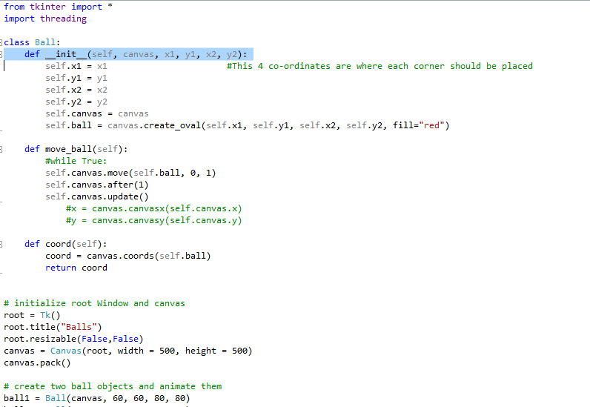

This is code which I have ameneded slightly. I ammended by working out the coordinates of the bullet and then stopping which it reaches a certain point. This is a basic collision dectector which I will use. As you can also see I did play around with threading in Python.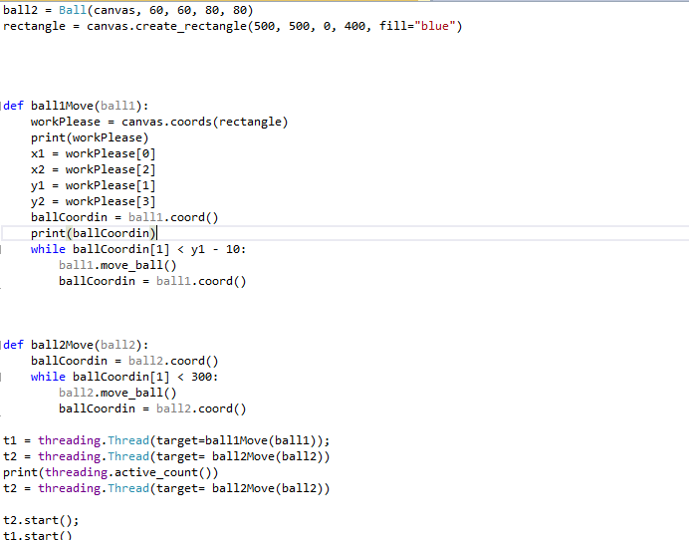

# Design

## Break the problem down systematically into a series of smaller problems suitable for computational solutions, explaining and justifying the process

**Structure Diagram**

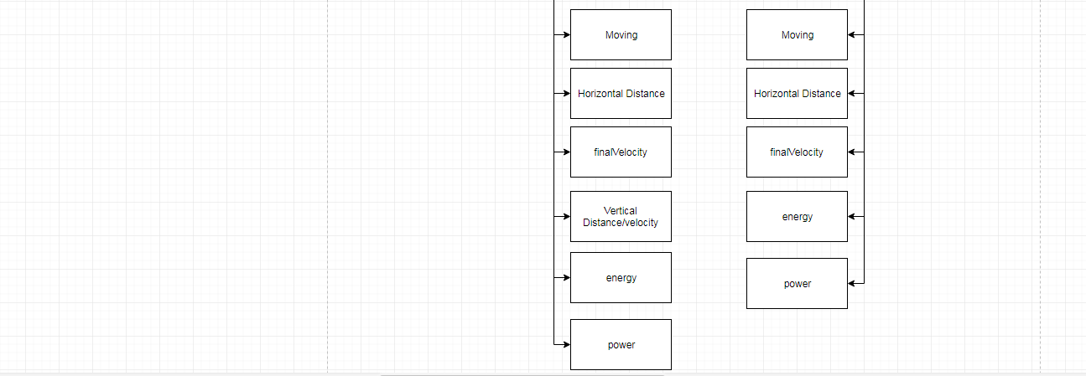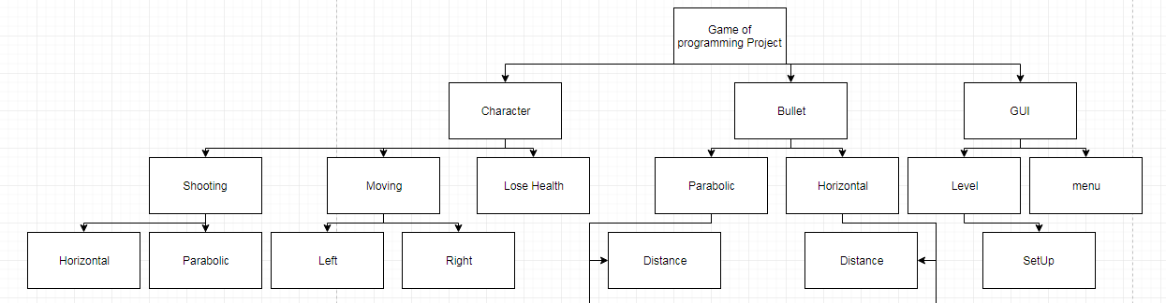

Class diagram:

|  |
| --- |
| CLASS BulletsShot |
| Attributes: howManyShot (Integer) |
| Methods: bullets_Sub , bullets_Show |

Class diagram:

|  |
| --- |
| CLASS Character |
| Attributes: characterOnScreen (Tkinter Object) , canvasForScreen (Tkinter Object), x0 (Integer), x1(Integer), y0(Integer), y1 (Integer), health (Float) |
| Methods: delete_Character, lose_ Health, move_Left, move_Right, coord_Player, fire_Hori_Bullet_Class, jump, fire_Hori_Bullet_Class, fire_Hori_Bullet_Class_Enemy, fire_Para_Bullet_Class, health_Left |

Class diagram:

|  |
| --- |
| CLASS Bullet |
| Attributes: intialSpeedHori (Float), intialSpeedHoriPara (Float), finalSpeedHori (Float), finalSpeedVertical (Float), finalSpeed (Float)m distanceHori (Float), distanceVertical (Float), horizontalAcceleration (Float), verticalAccelerationUp (Float), verticalAccelerationDown (Float), x1Bullet (Integer), y1Bullet (Integer), x2Bullet (Integer), y2Bullet (Integer), canvasBullet (Tkinter Object), ball (Tkinter Object), time (Integer), mass (Float), energy (Float) |
| Methods: delete_Bullet, energy_In_Bullet, power_At_Point, coord |

|  |
| --- |
| Class: ParabolicBullet |
| Attributes: No New |
| Methods: distance_Worker_Up, distance_Worker_Down, speed_Vert_Up, speed_Vert_Down, final_Speed_Parabolic, move_Ball_Para_Up, move_Ball_Para_Down |

|  |
| --- |
| Class HoriBullet |
| Attributes: No New |
| Methods: speed_At_Any_Point, move_Ball, distance_To_Work_Out |

These classes are made to be the two bullets which you can fire

|  |  |  |
| --- | --- | --- |
| Sub procedure/ method | Explanation | Justification |
| __init__ (Character) | This will draw the character onto the level and also set up its variables. It will be the __init__ module of the class character | This allows the character to be seen and also for instances to be made of them. |
| __init__ (Bullet) | This will set up all the variables needed to set up a bullet | This is needed so the bullet can be made when it is shot and also so it is also outputted to the screen. |
| fireBullet | This will make sure the bullet is fired for class character | This allows the user to be able to fire a bullet |
| jump | The class character will be able to jump | Allows the user to maybe be able to jump over bullets or obstacles |
| move_Left | Let’s the class character to move left | This means they can traverse the whole level and go back if needs to |
| lose_Health | Means the class character will be able to lose health | Means the character can actually die if there is any health. |
| move_Right | Let’s the class character to move right | This means they can traverse the whole level and go to the endpoint |
| set_Up | This will set up the level and makes sure everything is ready | This can be called when the user says they want to play the game |
| finish_Game | This will check to see if the game has finished and if it has to work out the highscore | This means the game can actually finish and then can work out the whole highscore and will ask for a username |
| energy_In_Bullet | This will use the equation e = 1/2mv^2 | This will work out the energy the bullet had so I can work out the Power |
| power_At_Point | This will use the equation = p = e/t | This will work out the amount of health which needs to be taken off by the character |
| speed_At_Any_Point | This will work out the final Speed | This will mean we can work out the energy |
| move_Bullet_Hori | This will mean the bullet can move on the screen horizontally | Means the user can see where the bullet is moving |
| hero_Move_Right | This will move the hero Right and call the finishGame module | This is needed so I can actually allow the user to move the character and finish the game |
| hero_Move_Left | This will move the hero left and call the finishGame module | This is needed so I can actually allow the user to move the character and finish the game |
| delete_Bullet | This will delete the bullet from the screen | When the bullet has run its full course it will be deleted |
| coord_Bullet | This will work out where the bullet is on the screen. | Must uses the cords function but cannot use it when I have the canvas object in a class so this is how you circumnavigate this problem |
| distance_To_Work_Out | This will work out how far the bullet has to go with s = ut + 1/at^2 | This is so the computer knows how far it needs to send the bullet |
| delete_Character | This will mean the program can fully delete a character when they have ‘died’ | This is so the enemy can be deleted when they have ‘died’ |
| coord_Player | Works out where the character is on the screen and give coordinates for it | This is so I will be able to move the character and also see if they have passed the end point |
| fire_Hori_Bullet_Class | Allows the character to fire the horizontal bullet | This is so the bullet can be fired by the right character |
| fire_Hori_Bullet_Class_Enemy | Allows the enemy to fire the horizontal bullet | This is so the bullet can be fired by the right character |
| fire_Para_Bullet_Class | Allows the enemy to fire the Parabolic bullet | This is so the bullet can be fired by the right character and so the correct bullet will be fired |
| fire_Hori_Bullet_Ene | This will allow the bullet to interact with the environment and will actually show the bullet moving when fired by an enemy. | This is needed so the bullet can actually fire by the character’s character and means the code works correctly |
| fire_Hori_Bullet | This will allow the bullet to interact with the environment and will actually show the bullet moving | This is needed so the bullet can actually fire by the enemy’s character and means the code works correctly |
| fire_Para_Bullet | This will allow a parabolic bullet to be fired and allow it to interact with the environment | This is needed so the code is working in the main program so different characters can get to it and also so the code is split up. |
| callback | This will mean the window will be pressed | This will allow the user to press the keys to actually move |
| distance_Worker_Up | This will work out how far the bullet should go up and to the side. | This will allow the physics of the bullet to work |
| distance_Worker_Down | This will work out how far the bullet should go down and to the side. | This will allow the physics of the bullet to work |
| speed_Vert_Up | Will work out the speed of the bullet going vertically up | This will be very realistic as it using rules which I have learnt from physics. |
| speed_Vert_Up | Will work out the speed of the bullet going vertically down | This will be very realistic as it using rules which I have learnt from physics. |
| final_speed_Parabolic | This will resolve the two components of sped upwards and to the side and work out the final speed of the bullet. | This is needed as before this we only have the speed for the bullet going upwards and to the side. This will use Pythagoras’s theorem to resolve it. |
| move_ball_Para_Up | This will move the bullet upwards and to the side | This is needed so the bullet will actually move in the correct direction |
| move_ball_Para_Down | This will move the bullet downwards and to the side | This is needed so the bullet will actually move in the correct direction |
| enemy_Shooting | This allows the enemy to shoot a bullet | This is needed so each module is not too long and also so you can see what needs to happen at each point. |
| hero_Touch_Enemy | This will take health off the hero if it is touching the enemy | This is needed so there is a danger to touching the enemy. |
| hero_lose_Health | This will take health off the hero if it should be taken off it. | This is needed as the code is needed throughout the program. |
| hero_Jump | This will allow the character to jump | Needed to allow the character to jump and check that it should jump. |
| checker | This will check to see what the largest unique ID is in the database so far | This will then mean I can make a new unique ID for the next thing to be added to the database |
| username_Entering | This will allow the user to enter their username and the score to be inputted so it can be inserted into the database | This will mean I have all the data needed to be inputted into the database |
| adding_To_Database | This will add all the data to the database | This is needed so I can enter all the data into the database and have most of the SQL separate to the rest of the code |
| create_Table | This will allow the person to recreate the leader board | Needed in case I have to ever delete the database so I can create a new one without any problem |
| display_Database | This will allow the database to be outputted to the screen whilst also being sorted | This is needed to get the whole database and then for it all to be sorted and sent back to the main program to be outputted |
| quick_Sort | This will sort out the database using the quick sort | Needed as it has a fast Big O natation O(nlogn) and also allows me to sort the database on a certain piece of data |
| instructions | This will display the instructions for the game on a separate screen | This is needed to be able to display how to play the game to the user |
| play_Game | This will allow the user to play the game | This is needed so the user is able to press a button and play the game |
| database_To_Display | This will allow the user to display the leader board on a separate screen | This is needed so the user can press a button and see the high scores |
| __init__ (BulletsShot) | This will set up the amount of bullets the user can use | This is needed to know how many bullets the user can use |
| bullets_Sub | This will take away 1 from howManyShot | This is needed so the program knows how many bullets the user has left |
| bullets_Show | This will output how many bullets the user has left | This is needed to be used in the final score |
| health_Left | This will output how much health the user has | This is needed to be used in the final score |
| scoring | This will work out the score the user has earnt from the level | Needed to make some sort of completion for completing the level |
| make_Text | This will make the text to output the table | Needed to be able to output the whole table correctly and in a way Tkinter will like. |

## Describe the solution fully, using appropriate and accurate algorithms, justifying these algorithms form a complete solution to the problem and identify and justify the test data to be used during the iterative development of the solution

Light Brown = Procedure boxes

**main_Game.py**

**Class Bullets Shot**

Pseudocode will be at end

|  |  |
| --- | --- |
| Name of Sub-program | Class BulletsShot __init__ |
| Inputs | None |
| Outputs | None |
| Pre-conditions | None |
| Post-conditions | None |

|  |  |  |  |
| --- | --- | --- | --- |
| Test Number | Explanation | Input | Expected Output |
| 1 | This will test that the code is has made the class | None | Can take away bullets |

|  |  |
| --- | --- |
| Name of Sub-program | Class BulletsShot bullets_Sub |
| Inputs | None |
| Outputs | None |
| Pre-conditions | None |
| Post-conditions | None |

|  |  |  |  |
| --- | --- | --- | --- |
| Test Number | Explanation | Input | Expected Output |
| 1 | This will test that the code is able to take away bullets | A bullet is shot | The amount of bullets you have has gone down by 1 |

|  |  |
| --- | --- |
| Name of Sub-program | Class BulletsShot bullets_Show |
| Inputs | None |
| Outputs | howManyShot (Integer) |
| Pre-conditions | None |
| Post-conditions | None |

|  |  |  |  |
| --- | --- | --- | --- |
| Test Number | Explanation | Input | Expected Output |
| 1 | This will test that the code is able to output the bullet | More than 10 bullets shot | You cannot shoot anymore bullets |

Pseudocode

CLASS BulletsShot

public PROCEDURE new

howManyShot = 10

endPROCEDURE

public PROCEDURE bullets_Sub

howManyShot = howManyShot – 1

endPROCEDURE

public PROCEDURE bullets_Show

RETURN howManyShot

endPROCEDURE

endCLASS

**CLASS CHARACTER**

Pseudocode will be at end

Both the user’s character and the enemy characters will use this class.

|  |  |
| --- | --- |
| Name of Sub-program | Class Character __init__ |
| Inputs | x0Given (Integer), x1Given(Integer), y1 (Integer), y0 (Integer), canvasCharacter (Tkinter Object), colour (Tkinter Object) |
| Outputs | Rectangle on screen |
| Pre-conditions | Tkinter has all been imported |
| Post-conditions | None |

|  |  |  |  |
| --- | --- | --- | --- |
| Test Number | Explanation | Input | Expected Output |
| 1 | This will test that the code is able to create a character when initialised | Any x and y coordinates, any colour | Character on screen |

|  |  |
| --- | --- |
| Name of Sub-program | Class Character health_Left |
| Inputs | None |
| Outputs | health |
| Pre-conditions | None |
| Post-conditions | None |

|  |  |  |  |
| --- | --- | --- | --- |
| Test Number | Explanation | Input | Expected Output |
| 1 | This will test that the code is able to output the code | Hitting the enemy 4 times | Character is deleted and game ends |

|  |  |
| --- | --- |
| Name of Sub-program | Class Character jump |
| Inputs | None |
| Outputs | None |
| Pre-conditions | Tkinter has all been imported |
| Post-conditions | None |

|  |  |  |  |
| --- | --- | --- | --- |
| Test Number | Explanation | Input | Expected Output |
| 1 | This will test that the code is able to get the character to jump up a certain amount of pixels | Up Button | Character goes up then down |

|  |  |
| --- | --- |
| Name of Sub-program | Class Character delete_Character |
| Inputs | characterOnScreen (Tkinter Object) |
| Outputs | Character deleted |
| Pre-conditions | There is an a character on the screen |
| Post-conditions | No more of that character |

|  |  |  |  |
| --- | --- | --- | --- |
| Test Number | Explanation | Input | Expected Output |
| 1 | This will test that the code is able to delete a character when initialised | The character to be deleted | Character not on screen |

|  |  |
| --- | --- |
| Name of Sub-program | Class Character move_Left |
| Inputs | Left key (object), amount |
| Outputs | Character Moves left (Object, float) |
| Pre-conditions | Tkinter has all been imported, a character is on the screen |
| Post-conditions | None |

|  |  |  |  |
| --- | --- | --- | --- |
| Test Number | Explanation | Input | Expected Output |
| 1 | This will test that the code is able to move a character | The left key | The character moves left. |

|  |  |
| --- | --- |
| Name of Sub-program | Class Character move_Right |
| Inputs | Right key (object) |
| Outputs | Character Moves Right (Object, float) |
| Pre-conditions | Tkinter has all been imported, a character is on the screen |
| Post-conditions | None |

|  |  |  |  |
| --- | --- | --- | --- |
| Test Number | Explanation | Input | Expected Output |
| 1 | This will test that the code is able to move a character | The Right key | The character moves right. |

|  |  |
| --- | --- |
| Name of Sub-program | Class Character lose_Health |
| Inputs | healthToLose (Float), health (float) |
| Outputs | New health (Float) (new health lost) |
| Pre-conditions | That they will lose health |
| Post-conditions | None |

|  |  |  |  |
| --- | --- | --- | --- |
| Test Number | Explanation | Input | Expected Output |
| 1 | This will test that the code is able to make a character lose health | health = 200  healthToLose = 50 | health = 150 |

|  |  |
| --- | --- |
| Name of Sub-program | Class Character fire_Hori_Bullet_Class |
| Inputs | coordinateInFireBulletHori |
| Outputs | Bullet being fired and deleted |
| Pre-conditions | Tkinter has all been imported |
| Post-conditions | None |

|  |  |  |  |
| --- | --- | --- | --- |
| Test Number | Explanation | Input | Expected Output |
| 1 | This will test that the program can make and delete a bullet | Coordinates worked out by where the user is | Bullet is made and moves |

|  |  |
| --- | --- |
| Name of Sub-program | Class Character fire_Hori_Bullet_Class_Enemy |
| Inputs | coordinateInFireBulletHoriEne |
| Outputs | Bullet being fired and deleted |
| Pre-conditions | Tkinter has all been imported |
| Post-conditions | None |

|  |  |  |  |
| --- | --- | --- | --- |
| Test Number | Explanation | Input | Expected Output |
| 1 | This will test that the program can make and delete a bullet | Coordinates worked out by where the enemy is | Bullet is made and moves |

|  |  |
| --- | --- |
| Name of Sub-program | Class Character fire_Para_Bullet_Class |
| Inputs | coordinateInFireBulletPara |
| Outputs | Bullet being fired and deleted |
| Pre-conditions | Tkinter has all been imported |
| Post-conditions | None |

|  |  |  |  |
| --- | --- | --- | --- |
| Test Number | Explanation | Input | Expected Output |
| 1 | This will test that the program can make and delete a bullet | Coordinates worked out by where the character is | Bullet is made and moves in a parabolic arc |

|  |  |
| --- | --- |
| Name of Sub-program | Class Character coord_Player |
| Inputs | characterOnScreen (Tkinter Object) |
| Outputs | coordinates (Array) |
| Pre-conditions | There is a character |
| Post-conditions | None |

|  |  |  |  |
| --- | --- | --- | --- |
| Test Number | Explanation | Input | Expected Output |
| 1 | This will test that the program can work out where both the bullet and enemy character is | None | Bullet Deletes as the bullet coordinates are equal to person coordinates |

Reusing this later as if bullet deletes when it hits the character I know the code work

Pseudocode

CLASS Character

Public PROCEDURE new(canvasCharacter, x0Given, x1Given, y0Given, y1Given, colour)

characterOnScreen = Create Rectangle On Screen

canvasForCharacter = canvasCharacter

x0 = x0Given

x1 = x1Given

y0 = y0Given

y1 = y1Given

health = 200

endPROCEDURE

public PROCEDURE jump

height = 0

while height <= 50

characterOnScreen move upwards by 1 pixel

Update screen

Wait 10 ms

height = height + 1

downHeight = 0

while downHeight <= 50

characterOnScreen move downwards by 1 pixel

Update canvasForCharacter

Wait 10 ms

downHeight = downHeight + 1

endPROCEDURE

public PROCEDURE delete_Character

delete CharacterOnScreen

endPROCEDURE

public FUNCTION lose_Health (healthToLose)

health = health – healthToLose

RETURN health

endFUNCTION

public PROCEDURE move_Left

move characterOnScreen Left

update canvasForCharacter

endPROCEDURE

public PROCEDURE move_Right

move characterOnScreen Right

update canvasForCharacter

endPROCEDURE

public FUNCTION coord_Player

coordinates = coordinates of characterOnScreen

RETURN coordinates

endFUNCTION

public PROCEDURE fire_Hori_Bullet_Class (coordinateInFireBulletHori)

bulletShootingHori = new HoriBullet(coordinateInFireBulletHori[2], coordinateInFireBulletHori[1], coordinateInFireBulletHori[2] + 5, coordinateInFireBulletHori[1]+5, canvasForCharacter)

bulletShootingHori.deleteBullet()

delete bulletShootingHori

endPROCEDURE

public PROCEDURE fire_Hori_Bullet_Class_Enemy (coordinateInFireBulletHoriEne)

bulletShootingHoriEne = new HoriBullet(coordinateInFireBulletHoriEne[2], coordinateInFireBulletHoriEne[1]+ 45, coordinateInFireBulletHoriEne[2] + 5, coordinateInFireBulletHoriEne[1]+40, canvasForCharacter )

bulletShootingHoriEne.deleteBullet()

delete bulletShootingHori

endPROCEDURE

public PROCEDURE fire_Para_Bullet_Class (coordinateInFireBulletPara)

bulletShootingPara = new HoriBullet(coordinateInFireBulletHori[2], coordinateInFireBulletHori[1], coordinateInFireBulletHori[2] + 5, coordinateInFireBulletHori[1]+5, canvasForCharacter)

bulletShootingPara.deleteBullet()

delete bulletShootingPara

endPROCEDURE

endCLASS

**CLASS BULLET**

The Pseudocode will be at the end

|  |  |
| --- | --- |
| Name of Sub-program | Class Bullet __init__ |
| Inputs | the canvas (Tkinter Object), x1BulletGiven (Integer), y1BulletGiven (Integer), x2BulletGiven (Integer), y2BulletGiven (Integer), canvasToUse |
| Outputs | Bullet on screen when initialised |
| Pre-conditions | Tkinter has all been imported |
| Post-conditions | None |

|  |  |  |  |
| --- | --- | --- | --- |
| Test Number | Explanation | Input | Expected Output |
| 1 | This will test that the code is able to create a bullet when initialised | Any x and y coordinates | Small Bullet on screen |

|  |  |
| --- | --- |
| Name of Sub-program | Class Bullet power_At_Any_Point |
| Inputs | energy (Float), timeTaken (Float) |
| Outputs | power (float) |
| Pre-conditions | Energy has been worked out and timeTaken is known |
| Post-conditions | None |

|  |  |  |  |
| --- | --- | --- | --- |
| Test Number | Explanation | Input | Expected Output |
| 1 | This will test that the code is able to work out the correct Power | energy = 500  timeTaken = 2.5 | 200 |

|  |  |
| --- | --- |
| Name of Sub-program | Class Bullet energy_In_Bullet |
| Inputs | finalSpeed (Float), mass(Integer) |
| Outputs | energy (Float) |
| Pre-conditions | Speed has been worked out |
| Post-conditions | None |

|  |  |  |  |
| --- | --- | --- | --- |
| Test Number | Explanation | Input | Expected Output |
| 1 | This will test that the code is able to work out the correct Energy | speed = 20  mass = 500 | 1000000 |

|  |  |
| --- | --- |
| Name of Sub-program | Class Bullet delete_Bullet |
| Inputs | None |
| Outputs | Bullet deleted (Tkinter Object) |
| Pre-conditions | There is a bullet |
| Post-conditions | Bullet is deleted |

|  |  |  |  |
| --- | --- | --- | --- |
| Test Number | Explanation | Input | Expected Output |
| 1 | This will test that the bullet will delete after a set amount of time | Time >= 5 | Bullet Deleted |
| 2 | This will test that the bullet will delete if hits a character | Hits a character | Bullet Deleted |

|  |  |
| --- | --- |
| Name of Sub-program | Class Bullet coord_Bullet |
| Inputs | None |
| Outputs | CoordinatesBullet (array) |
| Pre-conditions | There is a bullet |
| Post-conditions | None |

|  |  |  |  |
| --- | --- | --- | --- |
| Test Number | Explanation | Input | Expected Output |
| 1 | This will test that the program can work out where both the bullet and enemy character is | None | Bullet Deletes as the bullet coordinates are equal to person coordinates |

|  |  |
| --- | --- |
| Name of Sub-program | Class HoriBullet speed_At_Any_Point |
| Inputs | distanceGone (Float), intialSpeed (Float), horizonatalAcceleration (Integer) |
| Outputs | finalSpeed (Float) |
| Pre-conditions | We have a distance |
| Post-conditions | None |

|  |  |  |  |
| --- | --- | --- | --- |
| Test Number | Explanation | Input | Expected Output |
| 1 | This will test the program can work out the speed of a Horizontal bullet | distanceGone = 7  intialSpeed = 50  horizonatalAcceleration = 10 | 51.3809 |

|  |  |
| --- | --- |
| Name of Sub-program | Class HoriBullet move_Ball |
| Inputs | xMovement (Integer) |
| Outputs | Ball Moving |
| Pre-conditions | We have a value for xMovement |
| Post-conditions | None |

|  |  |  |  |
| --- | --- | --- | --- |
| Test Number | Explanation | Input | Expected Output |
| 1 | This will test the program can move the bullet | Press q | Bullet moves |

|  |  |
| --- | --- |
| Name of Sub-program | Class HoriBullet distance_To_Work_Out |
| Inputs | intialSpeed (Float), horizontalAcceleration (Integer), time (Float) |
| Outputs | The distance the bullet must move |
| Pre-conditions | None |
| Post-conditions | None |

|  |  |  |  |
| --- | --- | --- | --- |
| Test Number | Explanation | Input | Expected Output |
| 1 | This will test the program can work out how far the bullet must move | intialSpeed = 5  horizontalAcceleration = 10  time = 5 | 150 |

|  |  |
| --- | --- |
| Name of Sub-program | Class ParabolicBullet distance_Worker_Up |
| Inputs | None (Only variables in class) |
| Outputs | distanceVertical (Float), distanceHori (Float) |
| Pre-conditions | Time and verticalAccelerationUp are set |
| Post-conditions | None |

|  |  |  |  |
| --- | --- | --- | --- |
| Test Number | Explanation | Input | Expected Output |
| 1 | This will test the program can work out how far the bullet must move vertically | None | 30.65625 |
| 2 | This will test the program can work out how far the bullet must move horizontally | None | 250 |

|  |  |
| --- | --- |
| Name of Sub-program | Class ParabolicBullet distance_Worker_Down |
| Inputs | None (Only variables in class) |
| Outputs | distanceVertical (Float), distanceHori (Float) |
| Pre-conditions | Time and verticalAccelerationDown are set |
| Post-conditions | None |

|  |  |  |  |
| --- | --- | --- | --- |
| Test Number | Explanation | Input | Expected Output |
| 1 | This will test the program can work out how far the bullet must move vertically | None | 30.65625 |
| 2 | This will test the program can work out how far the bullet must move horizontally | None | 250 |

|  |  |
| --- | --- |
| Name of Sub-program | Class ParabolicBullet speed_Vert_Up |
| Inputs | distanceVertUp, timeTakenSoFar |
| Outputs | None |
| Pre-conditions | The values inputted are there |
| Post-conditions | The number is larger than or equal to 0 |

|  |  |  |  |
| --- | --- | --- | --- |
| Test Number | Explanation | Input | Expected Output |
| 1 | This will test the program can work out the speed of the bullet | None | 0 |

|  |  |
| --- | --- |
| Name of Sub-program | Class ParabolicBullet speed_Vert_Down |
| Inputs | timeTaken |
| Outputs | None |
| Pre-conditions | The values inputted are there |
| Post-conditions | None |

|  |  |  |  |
| --- | --- | --- | --- |
| Test Number | Explanation | Input | Expected Output |
| 1 | This will test the program can work out the speed of the bullet | None | 0 |

|  |  |
| --- | --- |
| Name of Sub-program | Class ParabolicBullet final_Speed_Parabolic |
| Inputs | HorizontalSpeed (Float) and Vertical Speed |
| Outputs | finalSpeed |
| Pre-conditions | The values are in the class |
| Post-conditions | None |

|  |  |  |  |
| --- | --- | --- | --- |
| Test Number | Explanation | Input | Expected Output |
| 1 | This will test the program can work out the final speed of the bullet | VerticalSpeed = 100  horiSpeed = 50 | 111.80339887498948 |

|  |  |
| --- | --- |
| Name of Sub-program | Class ParabolicBullet moveBall_Para_Up |
| Inputs | yMovement (Float), xMovement (Float) |
| Outputs | None |
| Pre-conditions | None |
| Post-conditions | None |

|  |  |  |  |
| --- | --- | --- | --- |
| Test Number | Explanation | Input | Expected Output |
| 1 | This will test the program can move the bullet | None | Bullet moving Up |

|  |  |
| --- | --- |
| Name of Sub-program | Class ParabolicBullet moveBall_Para_Down |
| Inputs | yMovement2(Float), xMovement2 (Float) |
| Outputs | None |
| Pre-conditions | None |
| Post-conditions | None |

|  |  |  |  |
| --- | --- | --- | --- |
| Test Number | Explanation | Input | Expected Output |
| 1 | This will test the program can move the bullet | None | Bullet moving Up |

Pseudocode

CLASS Bullet

public PROCEDURE new(x1BulletGiven, y1BulletGiven, x2BulletGiven, y2BulletGiven, canvasToUse)

intialSpeedHori = 50.0

intialSpeedHoriPara = 50.0

finalSpeedHori = 0.0

finalSpeedVertical = 50.0

finalSpeed = 0.0

distanceHori =0.0

distanceVertical = 0.0

horizontalAcceleration = 30.0

verticalAccelerationUp = -9.81

verticalAccelerationDown = 9.81

x1Bullet = x1BulletGiven

y1Bullet = y1BulletGiven

x2Bullet = x2BulletGiven

y2Bullet = y2BulletGiven

canvasBullet = canvasToUse

ball = Create circle on screen with coordinates given

time = 5

mass = 0.008

energy = 0.0

endPROCEDURE

public PROCEDURE delete_Bullet

delete Ball from the screen

endPROCEDURE

public PROCEDURE energy_In_Bullet

energy = .5 * mass * finalSpeed^2

endPROCEDURE

public FUNCTION power_At_Point(timeTaken)

power = energy /timeTaken

RETURN power

endFUNCTION

public FUNCTION coord_Bullet

coordinatesBullet = Coordinates of ball on screen

RETURN coordinatesBullet

endFUNCTION

endCLASS

CLASS HoriBullet inherits Bullet

public FUNCTION speed_At_Any_Point(distanceGone)

finalSpeedHori =( intialSpeedHori ^2 + (2 * horizontalAcceleration * distanceGone)) ^ .5

RETURN finalSpeed

endFUNCTION

public PROCEDURE move_Ball(xMovement)

moveBullet Right by xMovement

wait 100ms

update canvasBullet

endPROCEDURE

public FUNCTION distance_To_Work_Out

distance = (intialSpeed * time) + (.5 *horizontalAcceleration * time^2)

RETURN distance

endFUNCTION

endCLASS

CLASS ParabolicBullet inherits Bullet

public FUNCTION distance_Worker_Up

distanceVertical = (-.5 * verticalAccelerationUp *(time /2) **2)

distanceHori = (intialSpeedHoriPara * (time /2))

RETURN distanceVertical, distanceHori

endFUNCTION

public FUNCTION distance_Worker_Down

distanceVertical = (.5 * verticalAccelerationDonw *(time /2) **2)

distanceHori = (intialSpeedHoriPara * (time /2))

RETURN distanceVertical, distanceHori

endFUNCTION

public FUNCTION speed_Vert_Up(distanceVertUp, timeTakenSoFar)

finalSpeedVertical = (distanceVertUp + (.5 * verticalAcceleration * (timeTakenSoFar ** 2))) / timeTakenSoFar

IF finalSpeedVertical < 0

finalSpeedVertical = 0.0

endIF

RETURN finalSpeedVertical

endFUNCTION

public FUNCTION speed_Vert_Donw(timeTaken)

finalSpeedVertical = verticalAcceleration * timeTaken

RETURN finalSpeedVertical

endFUNCTION

public FUNCTION final_Speed_Parabolic

finalSpeed = ((finalSpeedVertical **2) + (intialSpeedHoriPara **2))**.5

RETURN finalSpeed

endFUNCTION

public PROCEDURE move_Ball_Para_Up(yMovement, xMovement)

moveBullet Right by xMovement and yMovement

wait 100ms

update canvasBullet

endPROCEDURE

public PROCEDURE move_Ball_Para_Down(yMovement2, xMovement2)

moveBullet Right by xMovement and yMovement

wait 100ms

update canvasBullet

endPROCEDURE

**Sub Procedures**

|  |  |
| --- | --- |
| Name of Sub-program | Fire_Hori_Bullet |
| Inputs | bulletFiring (Bullet Class) |
| Outputs | None (But bullet moves and interacts on screen) |
| Pre-conditions | Tkinter has all been imported, bulletFiring is a class Bullet |
| Post-conditions | None |

|  |  |  |  |
| --- | --- | --- | --- |
| Test Number | Explanation | Input | Expected Output |
| 1 | This will test that the code is able to make the bullet move the correct distance | Bullet moves 200 pixels | Bullet moves every few milliseconds |
| 2 | The bullet will stop and take health off enemy when bullet hits | Press q | Enemy is deleted as so much power is in bullet at the moment |
| 3 | The bullet will delete itself after 5 seconds | Press q | Bullet is deleted after 5 seconds |

Pseudocode

PROCEDURE fire_Hori_Bullet(bulletFiring)

timer1Start = Take time

distanceToGo = bulletFiring.distance_To_Work_Out()

distPer10Milli = distanceToGo / 50

bulletGone = 0

timeDoneHoriBullet = 0

WHILE bulletGone != distanceToGo AND timeDoneHoriBullet < 5000

enemyCoordinates = enemy.coord_Player()

bulletCoordinates = bulletFiring.coord_Bullet()

IF NO ERROR MESSAGE

IF bulletCoordinates[2] > enemyCoordinates[2]

timer1Finish = Take time

timer1 = timer1Finish – timer1Start

bulletFiring.speed_At_Any_Point(bulletGone)

bulletFiring.energy_In_Bullet()

bulletPower = bulletFiring.power_At_Point(timer1)

bulletGone = distanceToGo

enemyHealth = enemy.lose_Health(bulletPower)

IF enemyHealth <= 0

enemy.delete_Character()

endIF

ELSE

bulletFiring.move_Ball(distPer10Milli)

bulletGone = bulletGone + distPer10Milli

timeDoneHoriBullet = timeDoneHoriBullet + 100

endIF

IF ERROR CODE APPEARS

bulletFiring.move_Ball(distPer10Milli)

bulletGone = bulletGone + distPer10Milli

timeDoneHoriBullet = timeDoneHoriBullet + 100

endERRORCODECATCHING

endWHILE

endPROCEDURE

|  |  |
| --- | --- |
| Name of Sub-program | scoring |
| Inputs | timeDoneIn (Float), levelScore(Integer) |
| Outputs | finalScore |
| Pre-conditions | addingToDatabase is in same file and CSV is imported |
| Post-conditions | None |

|  |  |  |  |
| --- | --- | --- | --- |
| Test Number | Explanation | Input | Expected Output |
| 1 | This will test that the code is able to work out a school | Getting to the red point | A score over 200 |

Pseudocode

FUNCTION scoring(timeDoneIn, levelScore)

healthForHero = hero.health_Left()

howManyBulletsLeft = bulletsleft.bullets_Show()

finalScore = (1 /timeDoneIn) + (howManyBulletsLeft *5) + healthForHero

OPEN “Scores.csv” in writing mode as addingScores

writingARow = writer(addingScores)

arrayWithScoreIn = [finalScore + “\n”]

writingARow.writerow(arrayWithScoreIn)

CLOSE “Scores.csv”

IMPORT adding_To_Database

RETURN finalScore

endFUNCTION

|  |  |
| --- | --- |
| Name of Sub-program | fire_Hori_Bullet_Ene |
| Inputs | bulletFiringEne (Bullet Class) |
| Outputs | None (But bullet moves and interacts on screen) |
| Pre-conditions | Tkinter has all been imported, bulletFiringEne is a class Bullet |
| Post-conditions | None |

|  |  |  |  |
| --- | --- | --- | --- |
| Test Number | Explanation | Input | Expected Output |
| 1 | This will test that the code is able to make the bullet move the correct distance | Bullet moves 200 pixels | Bullet moves every few milliseconds |
| 2 | That the hero is fired at when pressing q | Press q | Bullet is fired first by enemy then hero. |
| 3 | The bullet will delete itself after 5 seconds | Press q | Bullet is deleted after 5 seconds |

Pseudocode

PROCEDURE fire_Hori_BulletEne(bulletFiringEne)

timer1StartEne = Take time

distanceToGoEne = bulletFiringEne.distance_To_Work_Out()

distPer10MilliEne = distanceToGoEne / 50

bulletGoneEne = 0

timeDoneHoriBulletEne = 0

WHILE bulletGoneEne != distanceToGoEne AND timeDoneHoriBulletEne < 5000

heroCoordinatesEne = hero.coord_Player()

bulletCoordinates = bulletFiringEne.coord_Bullet()

IF bulletCoordinatesEne[0] <= heroCoordinatesEne[2] AND bulletCoordinatesEne[2] >= heroCoordinatesEne[0] AND bulletCoordinatesEne[1] <= heroCoordinatesEne[3] timer1FinishEne = Take time

timer1Ene = timer1FinishEne – timer1StartEne

bulletFiringEne.speed_At_Any_Point(bulletGoneEne)

bulletFiringEne.energy_In_Bullet()

bulletPowerEne = bulletFiringEne.power_At_Point(timer1Ene)

bulletGoneEne = distanceToGoEne

hero_Lose_Health(bulletPowerEne)

ELSE

bulletFiringEne.move_Ball(distPer10MilliEne)

bulletGoneEne = bulletGoneEne + distPer10MilliEne

timeDoneHoriBulletEne = timeDoneHoriBulletEne + 100

endIF

endWHILE

endPROCEDURE

|  |  |
| --- | --- |
| Name of Sub-program | fire_Para_Bullet |
| Inputs | bulletFiring2 (Bullet Class) |
| Outputs | None (But bullet moves and interacts on screen) |
| Pre-conditions | Tkinter has all been imported, bulletFiring2 is a class Bullet |
| Post-conditions | None |

|  |  |  |  |
| --- | --- | --- | --- |
| Test Number | Explanation | Input | Expected Output |
| 1 | This will test that the code is able to make the bullet move the correct distance | Bullet moves 200 pixels | Bullet moves every few milliseconds |
| 2 | This will test that the bullet moves correctly | Press w | The bullet moves in a parabolic arc |
| 3 | The bullet will delete itself after 5 seconds | Press w | Bullet is deleted after 5 seconds |

Pseudocode

PROCEDURE fire_Para_Bullet(bulletFiring2)

timer2Start = Take time

distanceToGoUp, distanceLeft = bulletFiring2.distance_WorkerUp()

distLeft = distanceLeft / 25

distPer10MilliUp = distanceToGoUp / 25

bulletGoneUp= 0

timeDoneParaBullet = 0

goDown = True

WHILE bulletGoneUp != distanceToGoUp AND timeDoneParaBullet < 2500

enemyCoordinates = enemy.coord_Player()

bulletCoordinates2 = bulletFiring2.coord_Bullet()

IF NO ERROR MESSAGE

IF bulletCoordinates2[0] > enemyCoordinates[0] AND bulletCoordinates2[1] >= enemyCoordinates[1] -5 AND bulletCoordinates2[0] < enemyCoordinates[2]

timer2Finish = Take time

timer2 = timer2Finish – time2Start

bulletFiring2.speed_Vert_Up(bulletGoneUp, timer2)

bulletFiring2.final_Speed_Parabolic()

bulletFiring2.energy_In_Bullet()

bulletPowerPara = bulletFiring2.power_At_Point(timer1)

bulletGoneUp = distanceToGoUp

enemyHealth2 = enemy.lose_Health(bulletPowerPara)

IF enemyHealth2 <= 0

enemy.delete_Character()

endIF

ELSE

bulletFiring2.move_Ball_Para_Up(distPer10MilliUp, distLeft)

bulletGoneUp = bulletGoneUp + distPer10MilliUp

timeDoneParaBullet = timeDoneParaBullet + 100

endIF

IF ERROR CODE APPEARS

bulletFiring2.move_Ball_Para_Up(distPer10MilliUp, distLeft)

bulletGoneUp = bulletGoneUp + distPer10MilliUp

timeDoneParaBullet = timeDoneParaBullet + 100

endERRORCODECATCHING

endWHILE

if goDown == True

timer3Start = Take Time

distanceToGoDown, distanceLeft2 = bulletFiring2.distance_Worker_Down()

distLeftToGo = distanceLeft / 25

distPer10MilliDown = distanceToGoDown / 25

bulletGoneDown = 0

timeDoneParaBullet2 = 0

WHILE bulletGoneDown != distanceToGoDown AND timeDoneParaBullet2 < 2500

enemyCoordinates2 = enemy.coord_Player()

bulletCoordinates3 = bulletFiring2.coord_Bullet()

IF NO ERROR MESSAGE

IF bulletCoordinates3[0] > enemyCoordinates2[0] AND bulletCoordinates3[1] >= enemyCoordinates2[1] -5 AND bulletCoordinates3[0] < enemyCoordinates2[2]

timer3Finish = Take Time

timer3 = timer3Finish – timer3Start

bulletFiring2.speed_Vert_Down(timer3)

bulletFiring2.final_Speed_Parabolic()

bulletFiring2.energy_In_Bullet()

bulletPowerPar2a = bulletFiring2.power_At_Point(timer1)

bulletGoneDown = distanceToGoDown

enemyHealth3 = enemy.lose_Health(bulletPowerPara2)

IF enemyHealth2 <= 0

enemy.delete_Character()

endIF

ELSE

bulletFiring2.move_Ball_Para_Down(distPer10MilliDown, distLeft)

bulletGoneDown = bulletGoneDown + distPer10MilliDown

timeDoneParaBullet2 = timeDoneParaBullet2 + 100

endIF

IF ERROR CODE APPEARS

bulletFiring2.move_Ball_Para_Down(distPer10MilliDown, distLeft)

bulletGoneDown = bulletGoneDown + distPer10MilliDown

timeDoneParaBullet2 = timeDoneParaBullet2 + 100

endERRORCATCHING

endWHILE

endPROCEDURE

|  |  |
| --- | --- |
| Name of Sub-program | callback |
| Inputs | event (Tkinter Object), pressing screen |
| Outputs | Can use screen |
| Pre-conditions | Tkinter has all been imported |
| Post-conditions | Can now use screen |

|  |  |  |  |
| --- | --- | --- | --- |
| Test Number | Explanation | Input | Expected Output |
| 1 | This will test that the code is able to let the user use the screen | Click the screen | Can now use the keyboard with Tkinter |

Pseudocode

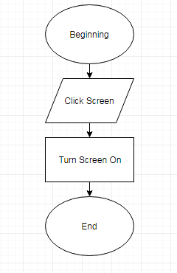

|  |  |
| --- | --- |
| Name of Sub-program | hero_Move_Left |
| Inputs | event (Tkinter Object), pressing left key |
| Outputs | None |
| Pre-conditions | Tkinter has all been imported |
| Post-conditions | None |

|  |  |  |  |
| --- | --- | --- | --- |
| Test Number | Explanation | Input | Expected Output |
| 1 | This will test that the code is able to move a character | The left key | The character moves left. |

Pseudocode

PROCEDURE hero_Move_Left(event)

hero.move_Left(2)

hero_Touch_Enemy

finish_Game

endPROCEDURE

|  |  |
| --- | --- |
| Name of Sub-program | hero_Move_Right |
| Inputs | event (Tkinter Object), pressing Right key |
| Outputs | None |
| Pre-conditions | Tkinter has all been imported |
| Post-conditions | None |

|  |  |  |  |
| --- | --- | --- | --- |
| Test Number | Explanation | Input | Expected Output |
| 1 | This will test that the code is able to move a character | The Right key | The character moves right. |

Pseudocode

PROCEDURE hero_Move_Right(event)

hero.move_Right()

hero_Touch_Enemy

finish_Game

endPROCEDURE

|  |  |
| --- | --- |
| Name of Sub-program | finish_Game |
| Inputs | None |
| Outputs | Checks If Game has finished |
| Pre-conditions | Tkinter has all been imported |
| Post-conditions | None |

|  |  |  |  |
| --- | --- | --- | --- |
| Test Number | Explanation | Input | Expected Output |
| 1 | This will test that the code ends if character gets to the endpoint | None | The window deletes itself if it reaches the endpoint. |

Pseudocode

PROCEDURE finish_Game

x0Endpoint = 375

x1Endpoint = 400

y0Endpoint = 375

y1Endpoint = 400

characterPosistion = hero.coord_Player()

IF characterPosistion[2] > x0Endpoint

finalTimerEnd = Get Time

DELETE EVERYTHING

finalTime = finalTimerStart – finalTimerEnd

scoring(finalTime, 100)

endIF

endPROCEUDRE

|  |  |
| --- | --- |
| Name of Sub-program | fire_Bullet |
| Inputs | letter (String) |
| Outputs | None |
| Pre-conditions | Tkinter has all been imported |
| Post-conditions | None |

|  |  |  |  |
| --- | --- | --- | --- |
| Test Number | Explanation | Input | Expected Output |
| 1 | This will test that the code to see if when the user presses q a bullet is fired | q | A Horizontal Bullet is fired |

Pseudocode

PROCEDURE fire_Bullet(letter)

bulletLeftHori = bulletsLeft.bullets_Show

IF bulletLeftHori > 0

bulletsLeft.bullets_Sub

ERROR CATCHING IF NO ERROR

enemy_Shooting

IF THERE IS AN ERROR

PASS

endERRORCATCHING

characterPosistion = hero.Coord_Player()

hero.fire_Hori_Bullet_Class(characterPosistion)

endIF

endPROCEDURE

|  |  |
| --- | --- |
| Name of Sub-program | fire_Bullet_Para |
| Inputs | letter (String) |
| Outputs | None |
| Pre-conditions | Tkinter has all been imported |
| Post-conditions | None |

|  |  |  |  |
| --- | --- | --- | --- |
| Test Number | Explanation | Input | Expected Output |
| 1 | This will test that the code to see if when the user presses w a bullet is fired | w | A Parabolic Bullet is fired |

Pseudocode

PROCEDURE fire_Bullet(letter)

bulletLeftHori = bulletsLeft.bullets_Show

IF bulletLeftHori > 0

bulletsLeft.bullets_Sub()

characterPosistion = hero.coord_Player()

characterPosistion = hero.Coord_Player()

hero.fire_Para_Bullet_Class(characterPosistionPara)

endIF

endPROCEDURE

|  |  |
| --- | --- |
| Name of Sub-program | set_Up |
| Inputs | None |
| Outputs | A GUI which looks like a level, rootSetUp (Tkinter Object), canvasSetUp (Tkinter Object), floorSetUp (Tkinter Object), endPointSetUp (Tkinter Object), heroSetUp (Tkinter Object), enemySetUp (Tkinter Object), bulletsLeft (Class) |
| Pre-conditions | That there is no screen on. Tkinter has all been imported |
| Post-conditions | None |

|  |  |  |  |
| --- | --- | --- | --- |
| Test Number | Explanation | Input | Expected Output |
| 1 | This will test that the code can make a working level | None | A level is made |

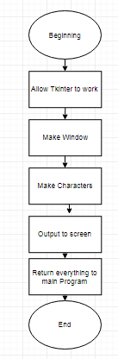

|  |  |
| --- | --- |
| Name of Sub-program | enemy_Shooting |
| Inputs | None |
| Outputs | None |
| Pre-conditions | Tkinter has all been imported |
| Post-conditions | None |

|  |  |  |  |
| --- | --- | --- | --- |
| Test Number | Explanation | Input | Expected Output |
| 1 | This will test that the code to see if when the user presses q a bullet is fired from the enemy | q | A Horizontal Bullet is fired from the enemy going towards the hero. |

Pseudocode

PROCEDURE enemy_Shooting()

characterPosistionForEnemy = enemy.coord_Player()

enemy.fire_Hori_Bullet_Class_Enemy(characterPosistionForEnemy)

endPROCEDURE

|  |  |
| --- | --- |
| Name of Sub-program | hero_Touch_Enemy |
| Inputs | None |
| Outputs | None |
| Pre-conditions | The hero has touched the enemy |
| Post-conditions | None |

|  |  |  |  |
| --- | --- | --- | --- |
| Test Number | Explanation | Input | Expected Output |
| 1 | This will test that if the hero touches the enemy it loses health and dies | Touch the enemy multiple times | The hero dies |

Pseudocode

PROCEDURE hero_Touch_Enemy()

heroCurrentCoordinates = hero.coord_Player()

enemyCurrentCoordinates = enemy.coord()

IF THERE IS NO ERROR

IF heroCurrentCoordinates[2] >= enemyCurrentCoordinates[0] and heroCurrentCoordinates[3] >= enemyCurrentCoordinates[1]

hero_Lose_Health(50)

hero.move_Left(20)

endIF

ERROR FOUND

PASS

EndERRORCATCHING

endPROCEDURE

|  |  |
| --- | --- |
| Name of Sub-program | hero_Lose_Health |
| Inputs | healthToLoseFunction (Integer/Float) |
| Outputs | None |
| Pre-conditions | The hero is losing health |
| Post-conditions | None |

|  |  |  |  |
| --- | --- | --- | --- |
| Test Number | Explanation | Input | Expected Output |
| 1 | This will test that the hero dies if it loses too much health | Touch the enemy multiple times/Get shot at by the enemy | The hero dies |

Pseudocode

PROCEDURE hero_Lose_Health()

heroHealth = hero.lose_Health(healthToLoseFunction)

IF heroHealth <= 0

finalTimerEnd2 = Get time

DELETE EVERYTHING

finalTime2 = finalTimerStart – finalTimerEnd2

scoring(finalTime2, 0)

endIF

endPROCEDURE

|  |  |
| --- | --- |
| Name of Sub-program | hero_Jump |
| Inputs | Event (Tkinter Object) |
| Outputs | None |
| Pre-conditions | Tkinter has all been imported |
| Post-conditions | None |

|  |  |  |  |
| --- | --- | --- | --- |
| Test Number | Explanation | Input | Expected Output |
| 1 | This will test that the code is able to move a character | The Up key | The character Jumps |

Pseudocode

PROCEDURE hero_Jump(event)

heroCoordinatesJumpFunction = hero.coord_Player()

IF heroCoordinatesJumpFunction[3] != 400

PASS

ELSE

hero_Jump()

endIF

endPROCEDURE

|  |  |
| --- | --- |
| Name of Sub-program | main |
| Inputs | None |
| Outputs | Game which works |
| Pre-conditions | None |
| Post-conditions | None |

|  |  |  |  |
| --- | --- | --- | --- |
| Test Number | Explanation | Input | Expected Output |
| 1 | This will test that the code to see if you can play the game | q,w, left key, right key | Something happens on the screen |

Pseudocode

IMPORT tkinter

IMPORT time

IMPORT csv

finalTimerStart = Get time

root, frame, floor, endPoint, hero, enemy, bulletsLeft= set_Up

Press Left = hero_Move_Left

Press Right = hero_Move_Right

Press Up = hero_Jump

Press Left Key = callback

Press “q” = fire_Bullet

Press “w” = fire_Bullet_Para

Send frame to screen

INFINITE LOOP frame

**adding_To_Database.py**

|  |  |
| --- | --- |
| Name of Sub-program | checker |
| Inputs | None |
| Outputs | Largest (Integer) |
| Pre-conditions | There is a database to connect to and SQLite3 is imported |
| Post-conditions | The database is shut |

|  |  |  |  |
| --- | --- | --- | --- |
| Test Number | Explanation | Input | Expected Output |
| 1 | This will test that the code is able to find the largestID | None | The next record has then next number from the previous record |

Pseudocode

FUNCTION checker

connNew = Connect to database

curser = curser for database

largest = 0

curser.execute (SELECT UniqueID FROM Highscores)

uniqueID = get results

FOR idRecord in uniqueID

IF idRecord[0] > largest

largest = idRecord[0]

endIF

endFOR

close Database

RETURN largest

endFUNCTION

|  |  |
| --- | --- |
| Name of Sub-program | username_Entering() |
| Inputs | None |
| Outputs | None |
| Pre-conditions | csv is imported |
| Post-conditions | None |

|  |  |  |  |
| --- | --- | --- | --- |
| Test Number | Explanation | Input | Expected Output |
| 1 | This will test that the code is able to add the correct data to the database | None | (1, Nat, 49….) |

Pseudocode

PROCEDURE user_Entering

OPEN Scores.csv as readingScores

reader = Set a readerScores

FOR recordToBeRead in reader

IF recordToBeRead == []

PASS

ELSE

finalScoreDatabaseFile = recordToBeRead[0]

endIF

endFOR

CLOSE Scores.csv

username = Get from addingUserName

uniqueIDFunction = checker

newID = uniqueIDFunction + 1

labelChange (Change to read: "Your score is being added to the database. Your score was {}".format(finalScoreDatabaseFile) )

adding_To_Database(newID, username, finalScoreDatabaseFile)

endPROCEDURE

|  |  |
| --- | --- |
| Name of Sub-program | adding_To_Database |
| Inputs | uniqueIDToUse (Integer), usernameToAdd (string), scores (Float) |
| Outputs | None |
| Pre-conditions | There is a database, all inputs have values |
| Post-conditions | Database is closed |

|  |  |  |  |
| --- | --- | --- | --- |
| Test Number | Explanation | Input | Expected Output |
| 1 | This will test that the code is able to add the correct data to the database | None | (1, Nat, 49….) |

Pseudocode

PROCEDURE adding_To_Database(uniqueIDToUse, usernameToAdd, scores)

connectionNew = Connect To highscores.db

curserNew = Curser for connectionNew

toAdd = [(uniqueIDToUse, userNameToAdd, scores)]

curserNew.executemany(INSERT INTO highscores VALUES from toAdd)

Save connectionNew

Close connectionNew

endPROCEDURE

|  |  |
| --- | --- |
| Name of Sub-program | main |
| Inputs | None |
| Outputs | GUI |
| Pre-conditions | None |
| Post-conditions | None |

|  |  |  |  |
| --- | --- | --- | --- |
| Test Number | Explanation | Input | Expected Output |
| 1 | This will test that the code is able to produce the GUI | None | A GUI |

Pseudocode

IMPORT tkinter

IMPORT sqlite3

IMPORT csv

databaseScreen = make Window

Name databaseScreen “Bullet Game”

Size databaseScreen (500x500)

addingUserName = Entry to databaseScreen

addingUserName Sent to screen

labelChange = Label saying “Enter Username”

labelChange Sent to screen

buttonAskingForUserName = Button Saying “Enter Username” And when pressed runs username_Entering

buttonAskingForUsername Sent to screen

Infinite Loop databaseScreen

**database_Creater.py**

|  |  |
| --- | --- |
| Name of Sub-program | create_Table |
| Inputs | name (String) |
| Outputs | None |
| Pre-conditions | None |
| Post-conditions | A database has been made |

|  |  |  |  |
| --- | --- | --- | --- |
| Test Number | Explanation | Input | Expected Output |
| 1 | This will test that the code is able to produce a table | highscores.db | A database named highscores.db |

Pseudocode

PROCEDURE create_Table (name)

connection = Make a connection

cursor = Create a cursor for the database

|  |  |
| --- | --- |
| Name of Sub-program | main |
| Inputs | None |
| Outputs | None |
| Pre-conditions | None |
| Post-conditions | None |

|  |  |  |  |
| --- | --- | --- | --- |
| Test Number | Explanation | Input | Expected Output |
| 1 | This will test that the code is able to produce a table | None | A database named highscores.db |

Pseudocode

IMPORT sqlite3

create_Table(“highscores.db”)

**displaying_Database.py**

|  |  |
| --- | --- |
| Name of Sub-program | display_Database |
| Inputs | None |
| Outputs | sortedTable (List of tuples) |
| Pre-conditions | There is a database |
| Post-conditions | Table is sorted, database is shut |

|  |  |  |  |
| --- | --- | --- | --- |
| Test Number | Explanation | Input | Expected Output |
| 1 | This will test that the code is able to produce a sorted table | Table | A sorted table |

Pseudocode

FUNCTION display_Database

connectionDisplay = Connect to “highscores.db”

cursorDisplay = Make a cursor

cursorDisplay.execute(SELECT * FROM Highscores)

table = Fetch result

sortedTable = quick_Sort(table)

CLOSE connectionDisplay

RETURN sortedTable

endFunction

|  |  |
| --- | --- |
| Name of Sub-program | quick_Sort |
| Inputs | dataArray (list Of Tuples) |
| Outputs | first_part + second_Part |
| Pre-conditions | None |
| Post-conditions | None |

|  |  |  |  |
| --- | --- | --- | --- |
| Test Number | Explanation | Input | Expected Output |
| 1 | This will test that the code is able to produce a sorted table | Table | A sorted table |

Pseudocode

FUNCTION quick_Sort(dataArray)

IF len(dataArray) == 1 or len(dataArray) == 0

RETURN dataArray

ELSE

pivot = dataArray[0][2]

i = 0

FOR j in range(len(dataArray)-1)

IF dataArray[j + 1][2] > pivot

tempDataArray = dataArray[j + 1]

dataArray[j + 1] = dataArray[i + 1]

dataArray[i + 1] = tempDataArray

i = i + 1

endIF

endFOR

tempDataArray = dataArray[0]

dataArray[0] = dataArray[i]

dataArray[i] = tempDataArray

first_part = quick_Sort(dataArray[:i])

second_part = quick_Sort(dataArray[i + 1:])

first_Part.append(dataArray[i])

RETURN first_part + second_part

endIF

endFUNCTION

|  |  |
| --- | --- |
| Name of Sub-program | make_Text |
| Inputs | None |
| Outputs | tableDisplay (String) |
| Pre-conditions | None |
| Post-conditions | None |

|  |  |  |  |
| --- | --- | --- | --- |
| Test Number | Explanation | Input | Expected Output |
| 1 | This will test that the code is able to produce text | None | A sorted table in the GUI |

Pseudocode

FUNCTION make_Text

tableToDisplay = display_Database

tableDisplay = “HighScores \n Place, UniqueID, Username, Score \n”

place = 0

FOR recordToDisplay IN tableToDisplay

place = place + 1

placeString = str(place)

recordToDisplayStr = str(recordToDisplay)

tableDisplay = tableDisplay, placeString, recordToDisplayStr + "\n"

endFOR

endFUNCTION

|  |  |
| --- | --- |
| Name of Sub-program | main |
| Inputs | None |
| Outputs | A GUI |
| Pre-conditions | None |
| Post-conditions | None |

|  |  |  |  |
| --- | --- | --- | --- |
| Test Number | Explanation | Input | Expected Output |
| 1 | This will test that the code is able to produce a GUI | None | A GUI with a highscores table |

Pseudocode

IMPORT sqlite3

IMPORT tkinter

databaseShowScreen = Make Window

Name databaseShowScreen “Bullet Game”

Size DatabaseShowScreen 500x500

databaseShowScreen Colour Navy

displayTable = make_Text

labelWithTable = Make Label with displayTable being outputted

Send labelWithTable to screen

Infinite Loop databaseShowScreen

**final_Game_File**

|  |  |
| --- | --- |
| Name of Sub-program | instructions |
| Inputs | None |
| Outputs | None |
| Pre-conditions | Tkinter is imported |
| Post-conditions | None |

|  |  |  |  |
| --- | --- | --- | --- |
| Test Number | Explanation | Input | Expected Output |
| 1 | This will test that the code is able to produce a GUI with instructions in it | None | A GUI with the instructions on it |

Pseudocode

PROCEDURE instructions

instructionsScreen = Make a window

Title instructionsScreen = “Bullet Game”

Size instructionsScreen = 500x500

Background Colour instructionsScreen = Navy

instructionsToDo = Label saying "To play the game click on the screen. Controls (Do not have caps lock on) \n q: Fires a horizontal Bullet. Powerful however the enemy will shoot \n w: Fires a Parabolic Bullet. Not so powerful \n Aim: Get to the red block as fast as you can using the least amount of bullets possible and having the most health at the end. \nCyan Block - Enemy\nDark Blue Block - You"

instructionsToDo Sent to screen

endPROCEDURE

|  |  |
| --- | --- |
| Name of Sub-program | play_Game |
| Inputs | None |
| Outputs | None |
| Pre-conditions | Program is in the same file |
| Post-conditions | None |

|  |  |  |  |
| --- | --- | --- | --- |
| Test Number | Explanation | Input | Expected Output |
| 1 | This will test that the code is able to play the game | None | A GUI with the game on it which you can play |

Pseudocode

PROCEDURE play_Game

IMPORT main_Game

endPROCEDURE

|  |  |
| --- | --- |
| Name of Sub-program | database_To_Display |
| Inputs | None |
| Outputs | None |
| Pre-conditions | Program is in same file |
| Post-conditions | None |

|  |  |  |  |
| --- | --- | --- | --- |
| Test Number | Explanation | Input | Expected Output |
| 1 | This will test that the code is able to produce a GUI the database in it | None | A GUI with the leader board |

Pseudocode

PROCEDURE database_To_Display

IMPORT displaying_Database

endPROCEDURE

|  |  |
| --- | --- |
| Name of Sub-program | main |
| Inputs | None |
| Outputs | A GUI |
| Pre-conditions | None |
| Post-conditions | None |

|  |  |  |  |
| --- | --- | --- | --- |
| Test Number | Explanation | Input | Expected Output |
| 1 | This will test that the code is able to produce a GUI with a menu | None | A GUI with the menu |
| 2 | This will test the user can press each button and the GUI do something | Pressing a button | A New screen appears |

Pseudocode

IMPORT tkinter

window = Make a screen

Title window “Bullet Game”

Size window 500x500

Background Colour window “Navy”

labelWelcome = Make a label saying Bullet Shot

Sent labelWelcome to the screen

buttonInstructions = Make a button saying Instructions With a procedure of instructions

Sent buttonInstructions to the screen

buttonGame = Make a button saying Game and with a procedure play_Game

Sent buttonGame to the screen

buttonLeaderboard = Make a button saying Leaderboard with a procedure database_To_Display

Sent buttonLeaderboard to the screen

Infinite Loop window

## Storyboard

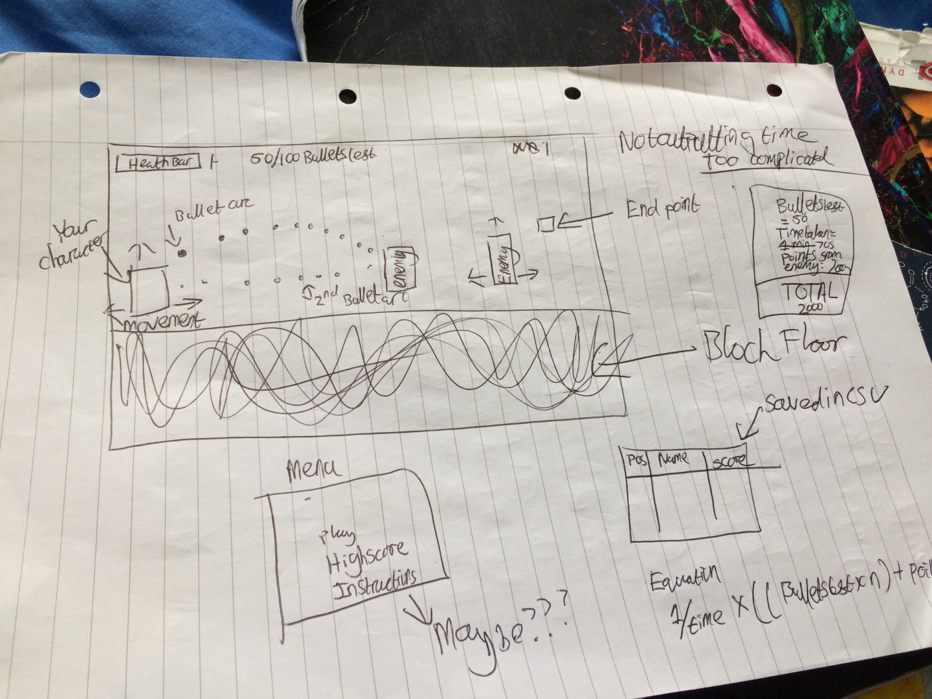

## Describe, justifying choices made, the usability features to be included in the solution

|  |  |  |
| --- | --- | --- |
| Usability Feature | Explanation | Justification |
| Different colours for the different objects | All the different objects made will be different colours. | This is done to make the user able to see what is what and also so that the user knows what is the enemy, your character and the bullet |
| High contrast colours | All the different colours will be very different | This makes it easier for mildly colour blind users see the level |
| Instructions | There will be a choice for the instructions to make it easier for the user to know what is happening. | Means the user can know what is happening and helps the user understand how to play the game. |
| The buttons are close to each other. | This means that I am using buttons which are close to each other so q and w for shooting | This makes it easier for people who cannot move that much meaning they can still play the game |

## Identify and justify the key variables/ data structures / classes (as appropriate to the proposed solution) justifying and explaining any necessary validation

|  |  |  |  |  |  |  |
| --- | --- | --- | --- | --- | --- | --- |
| Variable Name | Initial Value | Global or Local (Where) | Variable/Constant | Purpose | Justification | Validation |
| rootSetUp | Tkinter | Local (setUp) | Constant (Variable in Python) | This means I can use Tkinter | This allows me to use Tkinter as my GUI | Check it has been imported to Python |
| canvasSetUp | Window | Local (setup) | Variable | This means I have a window for the GUI | Allows me to use a window. | Checks that the window is created |
| floorSetUp | Object | Local (setUp) | Variable | This means I have a floor that the user can see | This means the user can see where they need to stand and where to go | Checks the floor has been added |
| endPointSetUp | Object | Local (setUp) | Variable | This means I have an endpoint | Ends the game | Check it has been added to the screen |
| characterHeroSetUp | Character | Local (setUp) | Variable | This means the user has a character to use | Means the user can see what they are doing. Sent as Global so anything can use it | Check it has been added to the screen |
| Root | Tkinter | Global | Constant (Variable in Python) | This means I can use Tkinter | This allows me to use Tkinter as my GUI. Sent as Global so anything can use it | None |
| frame | Window | Global | Variable | This means I have a window for the GUI | Allows me to use a window. Sent as Global so anything can use it | None |
| endpoint | Object | Global | Variable | This means I have an endpoint | Ends the game. Sent as Global so anything can use it | None |
| hero | Character | Global | Variable | This means the user has a character to use | Means the user can see what they are doing. Sent as Global so anything can use it | Check it is all working so can move left, right and shoot |
| x0EndPoint | 375 | Local (finishGame) | Constant (Variable in Python) | I have one coordinate so I know where the final block is | Allows me to know where one edge of the block is so I can end it at the right time | Check this works by going over it and ending the game |
| enemy | Character | Global | Variable | This the enemy will be able to fight against | This gives the user actual danger to fight against. |  |
| Character | Class | Global |  | This means I can have characters in my game | This will mean I can use the same code for both my Hero and Enemy | Validation – Check it can be put on screen, shoot, move left or right, and lose health |
| Bullet | Class | Global |  | This will allow the program to have weapons and means the user can score points | This is a superclass so it will have code which both sub classes will need | Validation – Power, energy are both correct, it can move when need to and move the correct distance |
| HoriBullet | Class | Global |  | This will mean the user can shoot a horizontal bullet which moves the correct distance | This will mean the User can use different bullets in different situations. | Validation – Goes correct distance, will delete if hits something. |
| power | 0 | Local (Bullet) | Variable | This will be where the power is stored when it has been worked out | This will mean we can work out how much health should be lost | Checks if the right power has been worked out |
| energy | 0 | Local (Bullet) | Variable | This will be where the energy is stored when it has been worked out | This will mean the program can work out how much power is needed | Works out the correct energy |
| Ball | Tkinter Object | Local (Bullet) | Variable | Shows the bullet on the screen | This will mean the user can see the bullet on the screen | The bullet is on the screen |
| finalSpeed | 0 | Local (Bullet) | Variable | Works out the final speed on the bullet | This will mean we can work out the correct power of the bullet. Needed in both sort of bullets | Works out the correct final speed |
| distanceHori | 0 | Local (Bullet) | Variable | Works out the distance the bullet goes horizontally | Means the bullet can move the correct distance | Works out the correct distance |
| distanceVertical | 0 | Local (Bullet) | Variable | Works out the distance the bullet goes vertically | Means the bullet can move the correct distance | Works out the correct distance |
| health | 200 | Local (Character) | Variable | This will be the amount of health the character have | This will be used to see whether either of the characters are dead yet | That when health is less than 0 the character dies. |
| bulletShootingHori | HoriBullet | Local (fireHoriBulletClass) | Variable | This will be the horizontal bullet being shot | This will be the instance of the bullet and is needed for the game to be worked | When bullet shot it appears. |
| distPer10Milli | distanceToGo /50 | Local (fireHoriBullet) | Variable | Works out how far the bullet should move on the screen | This is needed so the bullet looks natural on the screen whilst moving | When bullet shot it appears on the screen a few times |
| timer1 | Time Bullet has moved | Local (fireHoriBullet) | Variable | Works out how long the bullet has been on the screen | Needed for working out the power of the bullet | Checks it takes a reading between 0 and 5. |
| bulletFiring | HoriBullet | Local (fireHoriBullet) | Variable | This is the bullet which is being fired at that point | This is needed so the bullet can interact with the environment. | Check it moves when it is fired |
| ParabolicBullet | Class | Global | Class | This is the bullet which will go in a parabolic arc | This is needed to get a bullet moving | That the bullet moves in a parabolic arc |
| finalSpeedVertical | 0 | Local (ParabolicBullet) | Variable | This will work out the vertical speed of a bullet | Needed to work out the energy at the end | Check that the values work out |
| bulletGoneUp | 0 | Local (fireParaBullet) | Variable | This will say how high the character has gone | Needed to check if it has reached the correct height and how far the bullet has gone | Check it is added after every loop in the while loop |
| bulletGoneDown | 0 | Local (fireParaBullet) | Variable | This will say how low the character has gone | Needed to check if it has reached the correct height and how far the bullet has gone | Check it is added after every loop in the while loop |
| goDown | True | Local (fireParaBullet) | Variable | This will say whether the bullet needs to go down | This is needed as if the bullet has hit the character if it is going up it does not need to go down | If the bullet hits the character when going up the bullet does not go down. |
| heroHealth | - | Local (hero_Lose_Health) | Variable | This will be how much health the character has | If this is less than 0 the hero is killed | If this goes below 0 the Hero died |
| finalTimerStart | - | Global | Variable | This will hold the time when the user started the game | This will used to work out the final time | This will be tested to check we get a float in the final score |
| finalTimerEnd2 / finalTimerEnd | - | Local | Variable | This will hold the time the user ends the game | Needed to work out the time for the final game | Check the score is a float |
| finalScore | - | Local (Scoring) | Variable | This will hold the final score of the game | Needed to hold the score for the user and work it out | Output a score |
| Scores.csv | - | Global | CSV file | This will hold the score so it can be transferred across the different files which need it | This is needed so the score can be added onto the database which program is in a completely separate file to the game | That the score is inputted to the database |
| highscores.db | - | Global | Database | This will hold the scores of all the people who have played the game and also the user’s username | This is needed to show all the scores of different players who have played the game | That I can output it into Tkinter |
| newID | - | Local (username_Entering) | Variable | This will hold the unique primary key for the next entry for the database | Needed so I have a unique user ID for the database | Each entry in the database has a unique entry into the database |
| toAdd | - | Local(adding_To_Database) | Variable | This will hold what needs to be added to the database | Needed so I can add the next entries into the database | AN entry is added onto the database |
| databaseScreen | Tkinter window | Global | Variable | This will be the screen for the database | Needed to output asking for the username | This will be tested that a new screen is added after the game ends |
| addingUsername | - | Global | Variable | This will allow the user to enter their username | Needed so the user can enter their username | This will be tested to see if it is on the screen |
| labelChange | - | Global | Variable | This is needed to say what to do | Needed to say to enter the username and also so the user knows what is happening | Text changes after the username is entered |
| buttonAskingForUsername | - | Global | Variable | When pressed it enters the username | Needed so the program knows it can take the username | Enter a username then press the button and name appears in screen |
| cursor | - | Local (create_Table) | Variable | This will help create the table | Needed so the program can create the table correctly | A database is created |
| table | Database Table | Local (display_Table) | Variable | This will hold the current table | Needed so it can be sorted | A database can be shown |
| sortedTable | - | Local (display_Database) | Variable | This will hold the sorted table | Needed so the user can see a sorted table | Table is outputted which is sorted to largest scores to smallest scores |
| dataArray | - | Local (quick_Sort) | Variable | Holds what needs to be sorted | Needed so the table can be sorted | Database which is sorted |
| pivot | - | Local (quick_Sort) | Variable | Holds the number which is used to say whether the score is larger or smaller | Needed so it can be sorted | Database is sorted when outputted |
| first_part | - | Local (quick_Sort) | Variable | This holds the first half of the dataArray | Needed to sort out each half of the database | Database is sorted correctly when outputted |
| second_part | - | Local (quick_Sort) | Variable | This holds the first half of the dataArray | Needed to sort out each half of the database | Database is sorted correctly when outputted |
| tableDisplay | - | Local (make_Text) | Variable | The final text to be outputted for the leaderboard | Needed to add all the data in a way which is consumable to the user | Database is outputted in rows. |
| databaseShowScreen | - | Global | Variable | This will be the GUI | This will mean the user can see the database | Window is made when leaderboard is pressed |
| labelWithTable | - | Global | Variable | This will be the label for the database to be outputted | This is needed so the user can see the current leaderboard | Leaderboard is outputted when leaderboard button pressed |
| instructionScreen | - | Local (instructions) | Variable | The GUI for the instructions screen | Needed to output the instructions | New window when instructions button pressed |
| instructionsToDo | - | Local (instructions) | Variable | This will be the label which outputs the instructions for the game | Needed to output the instructions for the user to read | Instructions are outputted to the instructions screen |
| window | - | Global | Variable | This will be the window for the menu | Needed to show the menu and for the user to start the game | When program started the screen is made |
| buttonInstructions | - | Global | Variable | This will be the button to go to the instructions screen | Needed for the user to go to the instructions | Button saying instructions is in the menu |
| buttonGame | - | Global | Variable | This will be the button to go to the Game | Needed for the user to play the game | Button saying Game is in the menu |
| buttonLeaderboard | - | Global | Variable | This will be the button to go to the leaderboard screen | Needed for the user to go to the leaderboard | Button saying Leaderboard is in the menu |

## Identify and justify any further data to be used in post development phase.

|  |  |  |  |  |  |  |
| --- | --- | --- | --- | --- | --- | --- |
| Test Number | Statement | Justification | Input | Expected Output | Actual Output | Notes |
| 1 | The program will work. The player will be able to play a game which is realistic and is a shooting 2D platform game with an enemy which you need to defeat in it. The program will be robust enough to not break if a wrong input is entered. | I do not want there to be any game breaking bugs or glitches so I will want to have caught them before I finished. I want the game to be finished and that the user feels that it is polished and finished. | - | The game does not unexpectedly dies or anything like that |  |  |
| 2 | The program will allow the user to move the character side to side and also to jump. | Again self-explanatory. The user will only be able to use one character and this will be the way to actually interact with the level. | Valid - Right Key | The character moves to the right |  |  |
| 3 | The program will allow the user to move the character side to side and also to jump. | Again self-explanatory. The user will only be able to use one character and this will be the way to actually interact with the level. | Valid - Left Key | The character moves to the Left |  |  |
| 4 | The program will allow the user to move the character side to side and also to jump. | Again self-explanatory. The user will only be able to use one character and this will be the way to actually interact with the level. | Valid - Up key | The character moves up then down landing on the floor. |  |  |
| 5 | The program will have an enemy | This is so there is some difficulty in the game. | - | There is more than one character on the level |  |  |
| 6 | The program will end when the user’s character reaches an endpoint. | This means the level will end at one point and will not go on forever. | Valid - Reach the endpoint | The Game ends showing the next screen |  |  |
| 7 | The program will allow the user to change which bullet to use | This means they can use both bullets. | Valid – Press q, e, q | This should shoot 2 bullets |  |  |
| 8 | The program will detect when the bullet hits either a character or the wall. | This will make the bullet more realistic and also mean the bullet does not go for infinity. | Valid -Press q | The enemy should shoot a bullet. Hits the user’s character and disappears |  |  |
| 9 | The program will detect when the bullet hits either a character or the wall. | This will make the bullet more realistic and also mean the bullet does not go for infinity. | Valid - Press q | Once the enemy’s bullet disappears the user will fire a bullet and when it hits the enemy, this too will be deleted |  |  |
| 10 | The program will detect when the bullet hits either a character or the wall. | This will make the bullet more realistic and also mean the bullet does not go for infinity. | Valid -Press w | The hero will fire a bullet and when it hits the enemy it will disappear |  |  |
| 11 | The program will take away health from a character when a bullet hits it using the power equation. | This makes it realistic and also means you can destroy the enemy/character. | Valid -Press q | When bullet hits the hero it will output the power of it and the health remaining |  |  |
| 12 | The program will take away health from a character when a bullet hits it using the power equation. | This makes it realistic and also means you can destroy the enemy/character. | Valid -Press q | When the bullet hits the enemy it will output the power and the health remaining |  |  |
| 13 | The program will take away health from a character when a bullet hits it using the power equation. | This makes it realistic and also means you can destroy the enemy/character. | Valid -Press w | When the bullet hits the enemy it will output the power and the health remaining |  |  |
| 14 | The program will make the bullet go the correct distance using SUVAT. | This make the game realistic | Valid – Press q | The program will output how far the enemy bullet is going (Will be a float) |  |  |
| 15 | The program will make the bullet go the correct distance using SUVAT. | This make the game realistic | Valid – Press q | The program will output how far the hero’s bullet is going (Will be a float) |  |  |
| 16 | The program will make the bullet go the correct distance using SUVAT. | This make the game realistic | Valid – Press q | The program will output how far the bullet is going (Will be a float) |  |  |
| 17 | The program will have two bullets a parabolic one and a horizontal one. | This allows the user to have more than one weapon | - | There is two bullets the user can use |  |  |
| 18 | The program will take away bullets from the total amount of bullets when one is fired | This makes it more difficult to the user and gives the game a level of difficulty. | q | The amount of bullets left decreases by 1 |  |  |
| 19 | The program will take away bullets from the total amount of bullets when one is fired | This makes it more difficult to the user and gives the game a level of difficulty. | w | The amount of bullets left decreases by 1 |  |  |
| 20 | The program will have a timer which allows it to work out how long the user has taken. | This is to be used in the total points and allows the user to try and make it quicker | - | There is a time at the end which is similar to the time I will take on my phone |  |  |
| 21 | The program will work out a total. | This is to give a point for the game | - | At the end the program will work out a score |  |  |
| 22 | The program will allow the user to see how well they have done | This will allow the user to see how well they have done | - | The score is outputted |  |  |
| 23 | The program will have a database of highscores | This is so all scores can be entered and also so the user can see how well they are doing. | Running database_Creator | highscore.db is made in same file |  |  |
| 24 | The program will put the score in a database | This is so the user can see how they compare to other people. | - | The score is added into the database (We can see it on the highscores page) |  |  |
| 25 | The program will allow the user to enter a username. | This is so it can go into the database along with their score. | Valid: 10low1 | This is accepted |  |  |
| 26 | The program will only allow usernames which no one else has used before. | This is so it is easy for the User to see their score in the database | Invalid: 10low1 | This is not accepted |  |  |
| 27 | The program will allow the user to choose whether to see the highscores or to play the game | This will be a menu and allow the user to see different bits. | - | There is a menu showing different options |  |  |
| 28 | The program will display a table of highscores. | This allows the user to see how well they are doing. | Press Leaderboard | There is a leaderboard |  |  |
| 29 | The program will make sure all characters are on the ground when jumping | This will then make sure it looks realistic and also means you can see how high they are. | Invalid: Press up button multiple times | Only jumps once until it reaches the ground |  |  |
| 30 | The program will end if the user’s character hits 0. | This is so there is a risk if you are hit by a bullet | Touch enemy 4 or more times | The program will open the page asking for the username |  |  |
| 31 | The program will have a bullet being shot by the enemy every 5 seconds | This is so there is a continuous risk to the user. | - | There is a bullet shooting every 5 seconds |  |  |
| 32 | The program will allow any characters in the username | This means it’s easy for the user to have any name | Valid: hiTh1s @h! | This is accepted |  |  |
| 33 | The program will have an instructions screen | This will allow the user to know how to play the game | Press Instructions in menu | Instructions are outputted |  |  |
| 34 | The program will have a menu | Allows the user to go to different parts of the program | - | There is a menu |  |  |
| 35 | The program will have a leaderboard screen | This will allow the user to see the current best scores | Press Leaderboard | This will output the leaderboard |  |  |
| 36 | The program will output the leaderboard from the largest score (Best) to the smallest score (worst) | This will make it easy for the user to see the best and worst scores | - | Out of the multiple scores largest is top smallest bottom |  |  |
| 37 | The program will take away health if the user’s character touches the enemy | This means there is some danger to touching the enemy and means you cannot just run straight to the endpoint | Touch enemy | Enemy will lose health |  |  |
| 38 | The game will do nothing if you press buttons which are not q,w or the arrow keys. | This means the game cannot break if you enter an accidental input. | Press g | Nothing |  |  |

# Development

Wherever **Testing** appears, it means that there is some iteratrive testing at this point of the development

## Prototype 0

This is code where I have been able to move an object however it is completely autonomous, meaning it will start to run as soon as the program starts. It is proof of concept that I can get objects to move in Tkinter thus meaning my project will be able to go ahead.



This part of the code I edited for it to stop before reaching the ‘floor’ from the code mentioned earlier.

## First prototype

My first prototype will be very simple. I will make a start on the character class (move left and right methods). I will also program a simple level where once reaching the end, the canvas deletes itself. To make things slightly simpler I will do each class in separate windows then add them all together at the end. This is much simpler for me to write the code and also able to test each class by itself.

**Testing** I started by making the canvas and this happened: 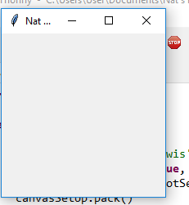

This is ever so slightly too small. The problem is that the Tkinter has no attribute resizable. 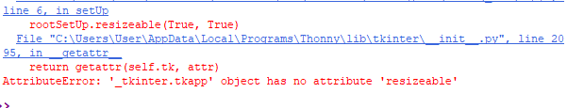

This is just a spelling error and after changing it the first canvas worked!

I then added copied and pasted the code for the blue rectangle and then tried to put in the end point which was a nightmare. I finally used a website which helped me and I have it just above the floor like this: 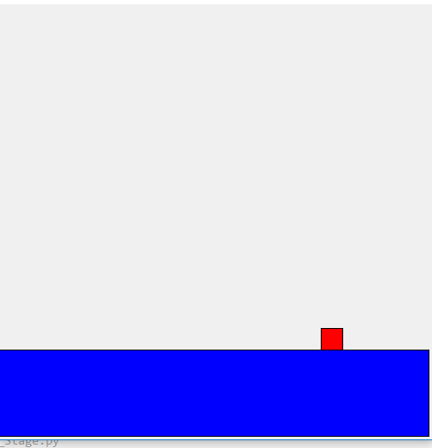

Code for setUp prototype 1:

This makes it easier to use the stuff from tkinter without having to reference when I need to use it

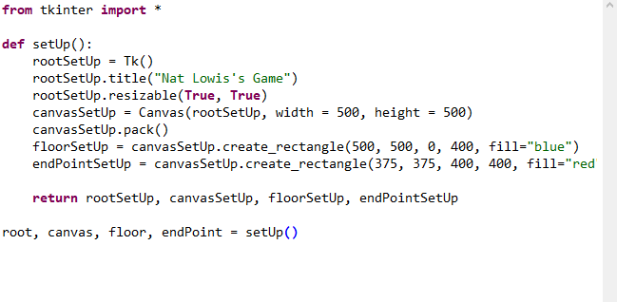

This allows me to use these things in other parts of the program when I make other parts of the game

This means I can make it full screen

I have made comments on parts which are important but the parts which do not have comments will be commented in the actual program. This code allows me to make the screen the right size and also make all the code for it.

For the character I have taken code off effbot and am hopefully going to use it to make the character move left.

**Testing** I then tried to validate the character to see whether it would move when the user wanted it to. When I first ran it I had a couple of errors due to spelling mistakes but once sorted nothing happened. So what I did was copy and pasted some code off effbot again and this worked in a separate file. I then put it in my actual file and it did not work ☹. It has made the window larger than it should so I am going to work it out. The code at the moment:

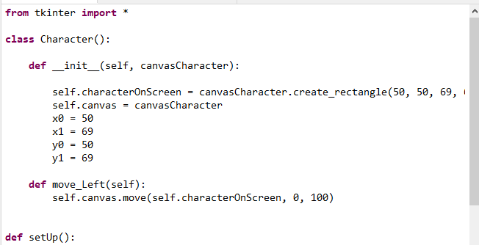

This shows the basic class of Character where I have specified where two of the corners are. The setUp module is a simplified version from the one I have made making it easier for me to just focus on the character working: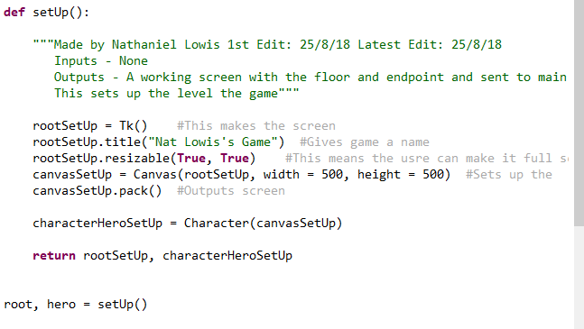

Finally, I have code which I am using to try and test to see whether it is working which it is not: 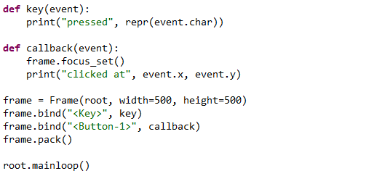

**Testing** When I run the game this is the window which I get: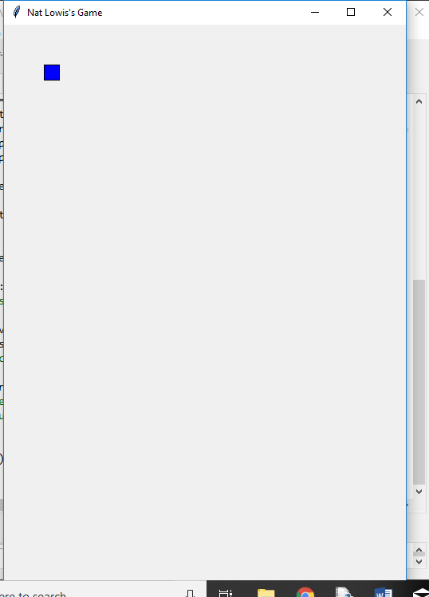

I have decided that to try and remedy this, in the setUp I will make the window a frame instead of a canvas. This hopefully then means I can start to get the player moving so the user can use it.

When I first ran it I got a syntax error as I did not have part of the code on the right line: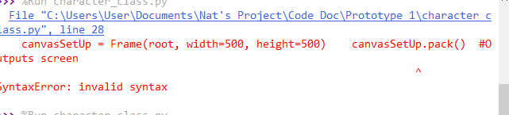

Basic SetUp Code at the moment: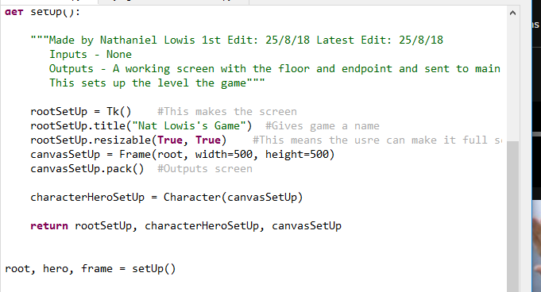

Error here as I should have called it rootSetUp instead of root.

Sadly frame cannot make the rectangle so what I have realised is that canvas can create the character but cannot seem to bind to it and frame can get something to bind to keys but not create the character meaning I cannot seem to have both a character as a canvas object but cannot move it using user inputs.

So I then added a new canvas but when it did not seemed to work but I forgot to pack it: 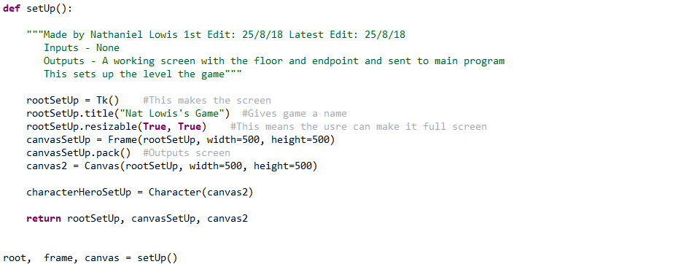

Should have canvas2.pack()

When I ran it, I came across the same problem as before but I have an idea that when I ran the code it was adding the frame and canvas together. This does not seem to be the problem either. I get this error code: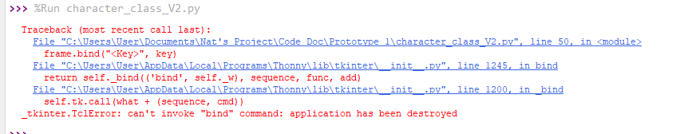

Obviously when I make the canvas I destroy the frame which is unhelpful. However, I changed frame to canvas on my testing code and it still worked!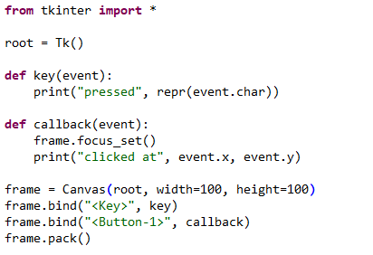

I then took out frame on my main code and just changed it to a canvas and it worked!!!! I will now try and get the character to move left now. This will then allow the user to start to actually control the character. I have changed frame.bind(“<key>”, key) has now been changed to frame.bind(“<Left>”, key) which does work!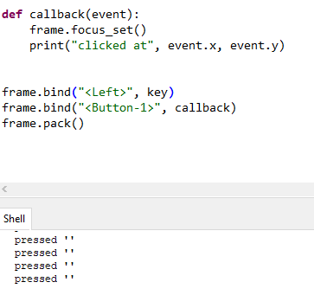

**Testing** So now I will try and change this to move the hero left a little bit. This did not work. After changing other parts of the code which did not work like changing the button-1 callback to move_Left (Did not work), I decided to look at some code from the internet which I have used a bit and I have seen I did not use the update and after methods for the canvas so I added these in the move_Left method which did not help. However I added this testing code into the move_Left function which did work: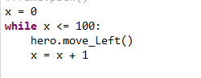

So I know my code works but I do not know why it is not moving left when I press the left button.

I tried taking the brackets off the move_leftwhich did not work: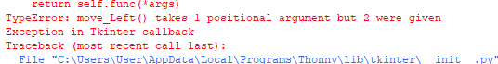

I then found the solution!!!!!!! (Finally) I put the moving left into another procedure which then meant I called that when the user pressed the left button. The object moved downwards but I can forgive that as it is moving!!

The code for the parts I have been programming: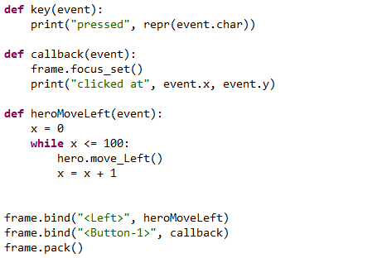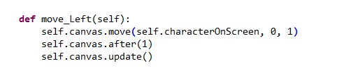

Calls this function which then allows the user’s character to move.

This moves the hero down quite a bit. So I will take out the while loop and just have hero.Move_Left() in the module heroMoveLeft and change self.canvas.moveto (-10, 0) which moves the character left!! I tried this couple of times and it kept moving left. I copied the move_Left code converted it to make the character move right and then copied and pasted the heroMoveLeft code, called it heroMoveRight and converted it and it did not work. 

Might need to change this to Right maybe.

This then worked!! So I now have code to move the character left and right, meaning the user can start to control the character. Now, I want to make the character, delete the level so the user can end the level by completing it. So when you press the screen you can then use the keyboard to move about. Before that I will comment the code and put docstrings in it. (Boring but needed). Code for class character:

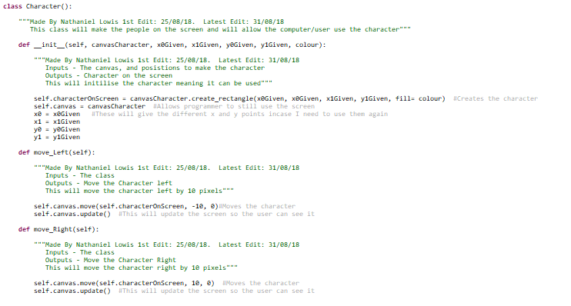

Can make character move left or right

Initialises the class

This means different points can be given and different colours

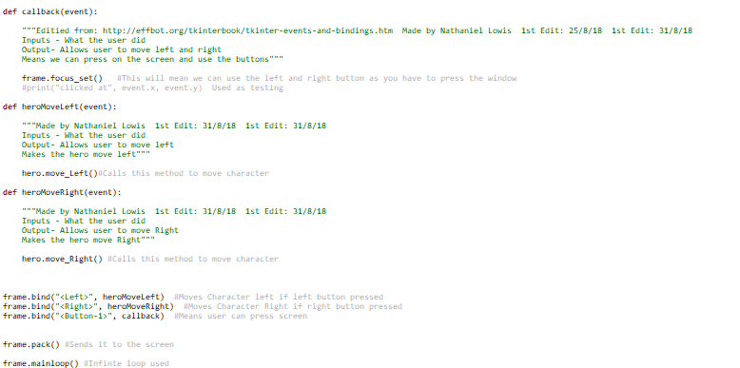

Allows user to use the character

Allows user to make character move left and right

Makes user able to use screen when pressed

The final part of my first prototype will be making the character finish the level. This requires me to initially put the first two parts together.

I did this without many problems. (Only ones I had was me just not naming everything correctly but it was all fine).

I have made a new method in the class character called coord which will give the coordinates of the character. I need this to see whether I have finished. This is the first iteration of finishGame: 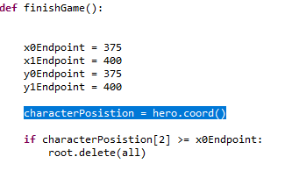 As the endpoint will be constant there is no point trying to find the coordinates of the endpoint and easier to just have the endpoints as variables which I have programmed in.

**Testing** I got to the endpoint and this did not work as I did not update the character’s position and did not call it in the main program. 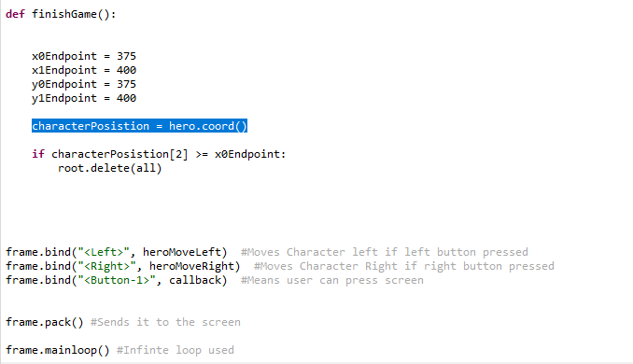

finishGame is not called here

Should be updating position

**Testing** There was then an error which said: 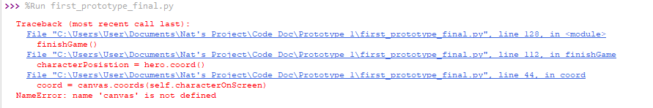

I have forgotten to change the name for the canvas which was meaning it was not working. This got rid of the red text but it still was not finishing and deleting everything on the screen. **Testing**  I added a print(“TRYING”) and this showed me it was not being tried more than once. So I decided to add it to moveHeroLeft and the moveHeroRight. It then worked (Almost). This was the screen I got when the user moved past the screen this is what I see. 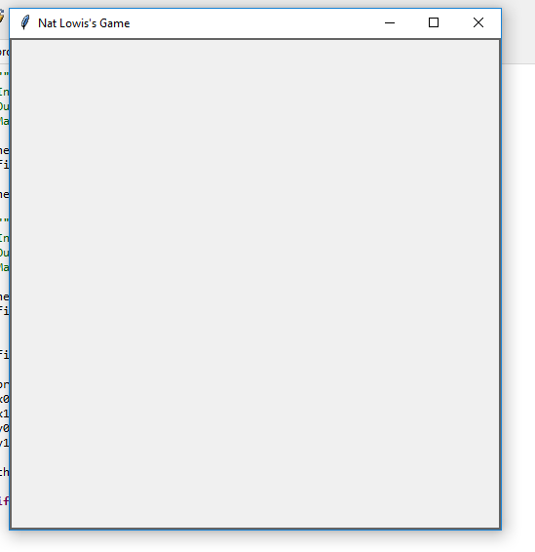

Not entirely what I wanted but I will take this for my first prototype. This does show that the game ends when the user passes the endpoint. I will now finish all the comments and docstrings then I have completed my first prototype!

#### Review

I have now been able to make a screen and get the user to start interacting with the game by moving a character and ending the game at a certain point. I now want to add bullets and an enemy whilst, for the longer term, I want there to be a menu and a database.

### Prototype 1 Code

from tkinter import * #This means I can use Tkinter

class Character():

"""Made By Nathaniel Lowis 1st Edit: 25/08/18. Latest Edit: 31/08/18

This class will make the people on the screen and will allow the computer/user use the character"""

def __init__(self, canvasCharacter, x0Given, x1Given, y0Given, y1Given, colour):

"""Made By Nathaniel Lowis 1st Edit: 25/08/18. Latest Edit: 31/08/18

Inputs - The canvas, and posistions to make the character

Outputs - Character on the screen

This will initilise the character meaning it can be used"""

self.characterOnScreen = canvasCharacter.create_rectangle(x0Given, x0Given, x1Given, y1Given, fill= colour) #Creates the character

self.canvas = canvasCharacter #Allows programmer to still use the screen

x0 = x0Given #These will give the different x and y points incase I need to use them again

x1 = x1Given

y0 = y0Given

y1 = y1Given

def move_Left(self):

"""Made By Nathaniel Lowis 1st Edit: 25/08/18. Latest Edit: 31/08/18

Inputs - The class

Outputs - Move the Character left

This will move the character left by 10 pixels"""

self.canvas.move(self.characterOnScreen, -10, 0)#Moves the character

self.canvas.update() #This will update the screen so the user can see it

def move_Right(self):

"""Made By Nathaniel Lowis 1st Edit: 25/08/18. Latest Edit: 31/08/18

Inputs - The class

Outputs - Move the Character Right

This will move the character right by 10 pixels"""

self.canvas.move(self.characterOnScreen, 10, 0) #Moves the character

self.canvas.update() #This will update the screen so the user can see it

def coord(self):

"""Made by Nathaniel Lowis 1st Edit: 31/8/18. Latest Edit: 31/8/18

Inputs - The character

Outputs - Where the character is

This will show where the character is"""

coordinates = self.canvas.coords(self.characterOnScreen) #This gives the coordinates for the character

return coordinates #Returns it to the main program

def setUp():

"""Made by Nathaniel Lowis 1st Edit: 25/8/18 Latest Edit: 25/8/18

Inputs - None

Outputs - A working screen with the floor and endpoint and sent to main program

This sets up the level the game"""

rootSetUp = Tk() #This makes the screen

rootSetUp.title("Nat Lowis's Game") #Gives game a name

rootSetUp.resizable(True, True) #This means the usre can make it full screen

canvasSetUp = Canvas(rootSetUp, width = 500, height = 500) #Sets up the

canvasSetUp.pack() #Outputs screen

floorSetUp = canvasSetUp.create_rectangle(500, 500, 0, 400, fill="blue") #Sets up the floor

endPointSetUp = canvasSetUp.create_rectangle(375, 375, 400, 400, fill="red") #Sets up the endpoint

characterHeroSetUp = Character(canvasSetUp, 50, 69, 50, 69, "Blue") #This will make the useer's character

return rootSetUp, canvasSetUp, floorSetUp, endPointSetUp, characterHeroSetUp #Sends everything back to main program.

root, frame, floor, endPoint, hero = setUp()

#def key(event):

# """Used as testing """

# print("pressed", repr(event.char)) TESTING

def callback(event):

"""Editied from: http://effbot.org/tkinterbook/tkinter-events-and-bindings.htm Made by Nathaniel Lowis 1st Edit: 25/8/18 1st Edit: 31/8/18

Inputs - What the user did

Output- Allows user to move left and right

Means we can press on the screen and use the buttons"""

frame.focus_set() #This will mean we can use the left and right button as you have to press the window

#print("clicked at", event.x, event.y) Used as testing

def heroMoveLeft(event):

"""Made by Nathaniel Lowis 1st Edit: 31/8/18 1st Edit: 31/8/18

Inputs - What the user did

Output- Allows user to move left

Makes the hero move left and checks if the game has finished"""

hero.move_Left()#Calls this method to move character

finishGame()

def heroMoveRight(event):

"""Made by Nathaniel Lowis 1st Edit: 31/8/18 1st Edit: 31/8/18

Inputs - What the user did

Output- Allows user to move Right

Makes the hero move Right and checks if the game has finished"""

hero.move_Right() #Calls this method to move character##

finishGame()

def finishGame():

"""Made by Nathaniel Lowis 1st Edit: 31/8/18 Latest Edit: 31/8/18

Inputs - Nothing

Outputs - Checks if game has finished

This will check if you have passed the ending point and if you have deletes the screen"""

#print("TRYING") Used for testing

x0Endpoint = 375 #These are the known coordinates for the endpoint

x1Endpoint = 400

y0Endpoint = 375

y1Endpoint = 400

characterPosistion = hero.coord() #Works out where the user's character is

if characterPosistion[2] >= x0Endpoint: #Checks if the character has passed the endpoint

frame.delete(ALL) #If they have it will delete all objects on the canvas

frame.bind("<Left>", heroMoveLeft) #Moves Character left if left button pressed

frame.bind("<Right>", heroMoveRight) #Moves Character Right if right button pressed

frame.bind("<Button-1>", callback) #Means user can press screen

frame.pack() #Sends it to the screen

frame.mainloop() #Infinte loop used

## Second Prototype

– Do bullet and villain and all work going with bullets and health

This prototype will focus on working with the bullets which then allows the user to have an enemy and some danger to the game.

I have now started doing the new bullet class and have started doing the initialisation class:

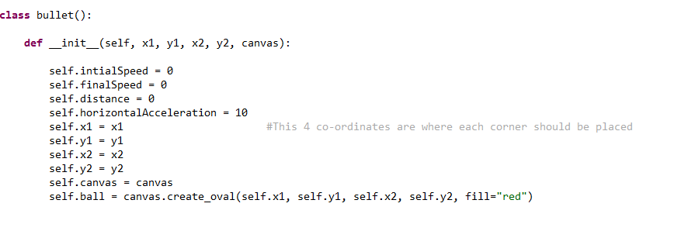

**Testing** And it looks like this: 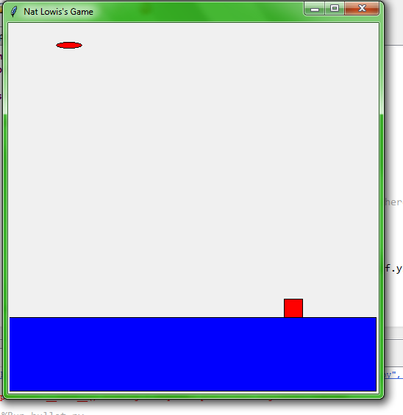

Bullet

I have not made the ball look right at the moment but I will sort that out later but this shows when a bullet is initialised it will create a bullet. I will now try and use code which I have found to make the bullet move which works.

I changed the code I found making it move every 10 milliseconds thus meaning it can looks smoother. I then have programmed the distance worker. **Testing**  When the program runs however I get this error message: 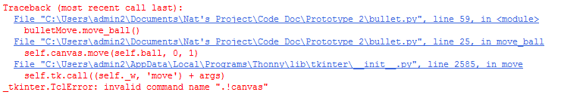

The ball still moves but for some reason it does not like this. The first way I tried to fix it is change the name in the class which worked!! I am now trying to see if the program can work out the distance which it should which it is not at the moment. That was because I forgot some brackets. **Testing** I then could not multiply some numbers together as I had this error message: 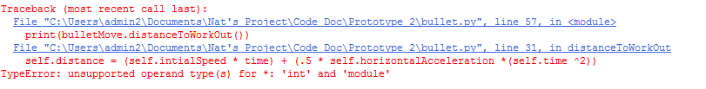 I decided to use the debugger where the problem was that the time was not a number for some reason as I forgot to add self.time. I then got a total of 35 which should be incorrect unless I have done the maths incorrectly. **Testing** This was because I used in the line:

Instead of ^ I should have **. When I ran it this time I got the correct score of 125. I now am going to try and get it moving by the 125 ‘metres’ now. This is the code at the moment: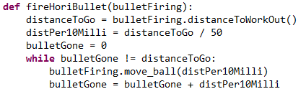I am dividing the distance by 50 so when I am updating the screen it updates the bullet the right amount of distance and also the right amount of times.

**Testing** However the bullet is not moving for 5 seconds like that. It is only moving for about 2 seconds so will now try and change it to move for 5 seconds. I have changed the .after statement to 100 which now means the bullet moves for about 5 seconds.

I am now going to add everything into the first prototype meaning the user can now start to fire the bullet. **Testing** I have a couple of problems however. One is this: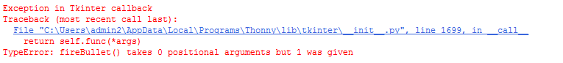

To counter this I have made a local variable which takes this unknown quantity and now will finish writing the function. This works! As you can see I am very happy. What I have to now do is delete the bullet after it has finished. Another good thing is that you can move both the character and shoot at basically the same time. It is a little unrealistic as the person is faster than the bullet however that is easy to change. I also need to delete the bullet and also bring in a new character. I can now however make a bullet be made where the user is and be able to delete itself.

**Testing** I am trying to delete the bullet which is not working at the moment. However, I have changed how fast the character can move and am also moving it to move on the floor.

I have now been able to delete the bullet!! This is after doing many different ways but I have created a method which can delete the object on the screen and then delete the actual variable. This means after a set amount of time (5 seconds or so) the bullet will delete itself. Deleting the bullet is important so the user can see that the bullet has gone.

I will now create new attributes and methods to the class character and move the user’s character down and create an enemy character.

**Testing** The user can now press the button q and the bullet will move the correct distance which is realistic

Beforehand, in my analysis I mentioned that I was going to use threads throughout the project however I am not going to use threads as they are very complicated on Python but somehow you can move whilst the bullet moves (a bit slower than usual but I do not mind) which solves a major headache which could have come later on.

I have chosen the mass to be about 8 grams as this is fairly accurate to real bullets.

I have now added both the user’s character and the enemy to the screen and it looks like this: 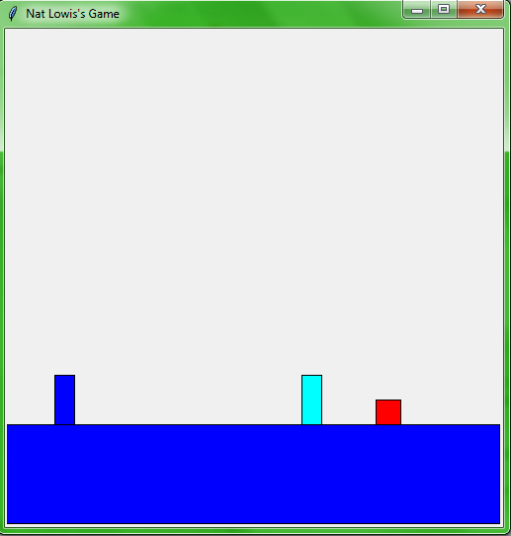

Enemy’s character

User’s character

This also shows that I can initialise a character and get it to output to the screen

I will now have the bullet be able to detect the enemy cyan character and to take health away and also to delete that bullet which has been shot. At the moment I am having a few errors concerning spelling and not defining everything.

**Testing** Firstly I ran the program to test with the numbers from my iterative programming part and all the numbers worked out perfectly 

**Testing** I then ran it and the power in the bullet was only 1.9. I worked the maths out manually: 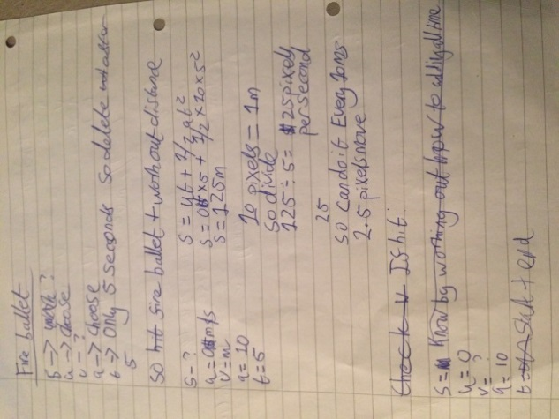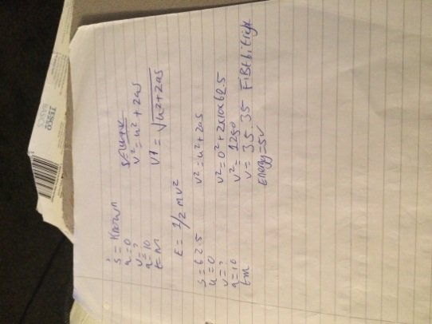 and it all worked out. So to counteract this I will up the initial speed and acceleration. With a bit of research I found the acceleration of bullet is 4.4x10^5 and the initial speed is 335 m/s so I will add these numbers in. The only problem with these numbers is that the bullet is too fast! I will scale it down a bit to make it easier to use. I now have the numbers both at 100 which makes it fast (It cannot multitask anymore) but easier to use. I will now get the enemy to lose health and then this prototype is finished which I could do with the enemy losing 50 health as needed:

**Testing** I am doing this well but I have got this error:

I started by commenting out all the code in the if statement which worked I then got it down to the line del(enemy) but when I played the game it still deleted the enemy when it should have done so this prototype is basically done. All I will do now to change the code is if the user presses q after the enemy is defeated the game dies so I will use try, except code. The problem is that enemy is deleted meaning it does not have anything to use. The same problem is found if you press the left key after reaching the endpoint. My first solution of putting a try except where the user presses q does not work but when I put it in the function where the code does not work, it gave me an infinite loop as the distance was not increasing. I will quickly add the code to allow the bullet to move on the screen and then stop and this worked. I will now comment the program and the second prototype will be done!!! (hallelujah)

What the game looks like when the bullet hits a character: 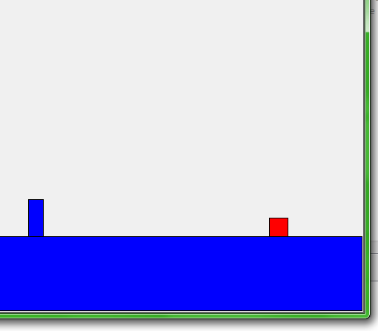The one character has been deleted when the bullet hit. This shows I could delete the character meaning the user can get to the end.

No enemy here

**Testing** When messing around with my game I saw that the bullet would be on the screen for longer than 5 seconds. To get around this I made a new variable called timeDone and every time the piece moved it added 100 to it until it reached 5000 and then it deleted which worked wonders.

I also ran the code to check whether the bullet ran for 5 seconds and this was the output: As you can see the bullet ended when it reached 5000 which is 5 seconds.

#### Review

I have now got a bullet to be fired for about 5 seconds and to move in a realistic direction. Sadly, I have had to give up on the idea of using threads to try and get all the pieces to work together. I will see if there is any way around this. I will now want to make another bullet and get the enemy to start firing at the user.

### Prototype 2 Code

from tkinter import * #This means I can use Tkinter

import time #Allows me to use time and measure how long bullets

class Bullet():

"""Made by Nathaniel Lowis 1st Edit: 10/9/18 Latest Edit: 25/9/18

This is the superclass which will allow me to model how thew bullet moves and output it to the screen. Parts of code has been adapted from:https://stackoverflow.com/questions/25430786/moving-balls-in-tkinter-canvas

"""

def __init__(self, x1BulletGiven, y1BulletGiven, x2BulletGiven, y2BulletGiven, canvasToUse):

"""Made by Nathaniel Lowis 1st Edit: 10/9/18 Latest Edit: 25/9/18

Inputs - the canvas, coordinates (Integers)

Outputs - None

Sets up the class when intialised"""

self.intialSpeed = 100 #These will set up the intial speed, acceleration for use in the rest of the code

self.finalSpeed = 0

self.distance = 0

self.horizontalAcceleration = 30

self.x1Bullet = x1BulletGiven #This 4 co-ordinates are where each corner should be placed

self.y1Bullet = y1BulletGiven

self.x2Bullet = x2BulletGiven

self.y2Bullet = y2BulletGiven

self.canvasBullet = canvasToUse #Sets up the code

self.ball = canvasToUse.create_oval(self.x1Bullet, self.y1Bullet, self.x2Bullet, self.y2Bullet, fill="green") #Outputs to screen

self.time = 5 #More constants made.

self.mass = 0.008

self.energy = 0

def deleteBullet(self): #Change to delete_Bullet

"""Made by Nathaniel Lowis 1st Edit: 12/9/18 Latest Edit: 12/9/18

Inputs - The class

Outputs - Deletes the bullet from the screen

Deletes the bullet from the screen"""

self.canvasBullet.delete(self.ball) #Deletes bullet

def energy_In_Bullet(self):

"""Made by Nathaniel Lowis 1st Edit: 12/9/18 Latest Edit: 12/9/18

Inputs - Class

Outputs - The energy of the bullet

Works out the amount of energy in the bullet"""

self.energy = .5 * self.mass * ( self.finalSpeed ** 2) #Uses E = 1/2 mv^2

#print(self.energy) #testing

def powerAtPoint(self, timeTaken):

"""Made by Nathaniel Lowis 1st Edit: 12/9/18 Latest Edit: 12/9/18

Inputs - Time, class

Outputs - The amount of power from the bullet

Works out the amount of power in the bullet"""

power = self.energy / timeTaken #Uses p = E/t

#print(power) #Testing

return power

def coord(self): #CHANGE TO COORD_BULLET

"""Made by Nathaniel Lowis 1st Edit: 31/8/18. Latest Edit: 12/9/18

Inputs - The class

Outputs - Where the bullet is

This will show where the bullet is"""

coordinatesBullet = self.canvasBullet.coords(self.ball) #This gives the coordinates for the bullet

return coordinatesBullet #Returns it to the main program

class HoriBullet(Bullet):

"""Made by Nathaniel Lowis 1st Edit: 10/9/18 Latest Edit: 12/9/18

This is a subclass of bullet which calculates and output it to the screen."""

def speedAtAnyPoint(self, distanceGone):

"""Made by Nathaniel Lowis 1st Edit: 12/9/18 Latest Edit: 12/9/18

Inputs - Distance Gone (Float), class

Outputs - The final speed of bullet

This works out the final speed of the bullet"""

self.finalSpeed = ((self.intialSpeed ** 2) + (2 * self.horizontalAcceleration * distanceGone) )** .5 #Uses V^2 = u^2 + (2as)

#print(self.FinalSpeed) #Testing

return self.finalSpeed

def move_ball(self, xMovement): #CHANGE TO MOVE_BULLET_HORI

"""Made by Nathaniel Lowis 1st Edit: 10/9/18 Latest Edit: 12/9/18

Input - How much to move by

Output - Moving on the screen"""

self.canvasBullet.move(self.ball, xMovement, 0) #Moves the bullet

self.canvasBullet.after(100) #Waits 100 ms until it updates screen

self.canvasBullet.update() #Updates the screen

def distanceToWorkOut(self):

"""Made by Nathaniel Lowis 1st Edit: 10/9/18 Latest Edit: 12/9/18

Inputs - class

Outputs - The distance to go"""

self.distance = (self.intialSpeed * self.time) + (.5 * self.horizontalAcceleration *(self.time **2)) #Uses S = ut + 1/2at^2

return self.distance

class Character():

"""Made By Nathaniel Lowis 1st Edit: 25/08/18. Latest Edit: 25/9/18

This class will make the people on the screen and will allow the computer/user use the character"""

def __init__(self, canvasCharacter, x0Given, x1Given, y0Given, y1Given, colour):

"""Made By Nathaniel Lowis 1st Edit: 25/08/18. Latest Edit: 31/08/18

Inputs - The canvas, and posistions to make the character

Outputs - Character on the screen

This will initilise the character meaning it can be used"""

self.characterOnScreen = canvasCharacter.create_rectangle(x0Given, y0Given, x1Given, y1Given, fill= colour) #Creates the character

self.canvas = canvasCharacter #Allows programmer to still use the screen

x0 = x0Given #These will give the different x and y points incase I need to use them again

x1 = x1Given

y0 = y0Given

y1 = y1Given

self.health = 200

def deleteCharacter(self):

"""Made by Nathaniel Lowis 1st Edit: 10/9/18 Latest Edit: 12/9/18

Input - Character Class

Outputs - Deletes the character

Deletes character if they are killed"""

self.canvas.delete(self.characterOnScreen) #Deletes the character

def lose_Health(self, healthToLose):

"""Made by Nathaniel Lowis 1st Edit: 11/9/18 Latest Edit: 12/9/18

Inputs - The health to lose (Float)

Outputs - Health left (Float)

Makes the character lose health"""

self.health = self.health - healthToLose #Lose health

return self.health

def move_Left(self):

"""Made By Nathaniel Lowis 1st Edit: 25/08/18. Latest Edit: 11/9/18

Inputs - The class

Outputs - Move the Character left

This will move the character left by 2 pixels"""

self.canvas.move(self.characterOnScreen, -2, 0)#Moves the character

self.canvas.update() #This will update the screen so the user can see it

def move_Right(self):

"""Made By Nathaniel Lowis 1st Edit: 25/08/18. Latest Edit: 11/9/18

Inputs - The class

Outputs - Move the Character Right

This will move the character right by 2 pixels"""

self.canvas.move(self.characterOnScreen, 2, 0) #Moves the character

self.canvas.update() #This will update the screen so the user can see it

def coord(self): #coord_Player CHANGE TO THIS

"""Made by Nathaniel Lowis 1st Edit: 31/8/18. Latest Edit: 31/8/18

Inputs - The character

Outputs - Where the character is

This will show where the character is"""

coordinates = self.canvas.coords(self.characterOnScreen) #This gives the coordinates for the character

return coordinates #Returns it to the main program

def fireHoriBulletClass(self, coordinateInFireBulletHori):

"""Made by Nathaniel Lowis 1st Edit: 10/9/18 Latest Edit: 12/9/18

Inputs - Cordinates of character in an array

Outputs - Shooting bullet

This controls the bullet"""

bulletShootingHori = HoriBullet(coordinateInFireBulletHori[2], coordinateInFireBulletHori[1], coordinateInFireBulletHori[2] + 5, coordinateInFireBulletHori[1]+5, self.canvas) #Makes an instant of the HoriBullet Class

fireHoriBullet(bulletShootingHori) #Controls the bullet

bulletShootingHori.deleteBullet() #These will delete the bullet afterwards

del(bulletShootingHori)

def setUp(): #CHANGE TO SET_UP

"""Made by Nathaniel Lowis 1st Edit: 25/8/18 Latest Edit: 25/9/18

Inputs - None

Outputs - A working screen with the floor and endpoint and sent to main program

This sets up the level the game"""

rootSetUp = Tk() #This makes the screen

rootSetUp.title("Nat Lowis's Game") #Gives game a name

rootSetUp.resizable(True, True) #This means the usre can make it full screen

canvasSetUp = Canvas(rootSetUp, width = 500, height = 500) #Sets up the

canvasSetUp.pack() #Outputs screen

floorSetUp = canvasSetUp.create_rectangle(500, 500, 0, 400, fill="grey") #Sets up the floor

endPointSetUp = canvasSetUp.create_rectangle(375, 375, 400, 400, fill="red") #Sets up the endpoint

heroSetUp = Character(canvasSetUp, 50, 70, 350, 400, "Blue") #This will make the user's character

enemySetUp = Character(canvasSetUp, 300, 320, 350 ,400, "Cyan") #This will make the enemy class

return rootSetUp, canvasSetUp, floorSetUp, endPointSetUp, heroSetUp, enemySetUp #Sends everything back to main program.

def fireHoriBullet(bulletFiring): #CHANGE TO FIRE_HORI_BULLET

"""Made by Nathaniel Lowis 1st Edit: 10/9/18 Latest Edit: 12/9/18

Inputs - The Class HoriBullet

Outputs - The bullet moving and interacting with the environment

This will allow the bullet to interact with the environment"""

timer1Start = time.time() #Starts a timer

distanceToGo = bulletFiring.distanceToWorkOut() #Works out how far the bullet goes

distPer10Milli = distanceToGo / 50 #Divides the distance by 50 so they are all in equal chunks

bulletGone = 0 #Creates a variable which works out how far the bullet has gone

timeDoneHoriBullet = 0

while bulletGone != distanceToGo and timeDoneHoriBullet < 5000: #Whilst the bullet has not gone as far as it needs to

enemyCoordinates = enemy.coord() #Gets enemy's coordinates in an array

bulletCoordinates = bulletFiring.coord() #Gets the bullets coordinates in an array

try: #The program will go down this route when there is an enemy class

if bulletCoordinates[2] > enemyCoordinates[2]: #If the bullet is past the enemy

timer1Finish = time.time() #Stops timer

timer1 = timer1Finish - timer1Start #Works out length of time the bullet has gone for

#print(bulletGone) #testing

#print(timer1) #testing

bulletFiring.speedAtAnyPoint(bulletGone) #Works out the speed of the bullet

bulletFiring.energy_In_Bullet() #Works out the energy of the bullet

bulletPower = bulletFiring.powerAtPoint(timer1) #Works out the power of the bullet

#print(bulletPower) #testing

bulletGone = distanceToGo #Means the while loop can stop

enemyHealth = enemy.lose_Health(bulletPower) #Makes the enemy lose health

if enemyHealth <= 0: #If the enemy's health is below or equal to 0

#CULD PUT THIS IN OWN FUNCTION

enemy.deleteCharacter() #Deletes the enemy

else:

bulletFiring.move_ball(distPer10Milli) #Moves the ball the amount it needs to

bulletGone = bulletGone + distPer10Milli #Added to bulletGone

timeDoneHoriBullet = timeDoneHoriBullet + 100

except: #This is when there is no enemy

bulletFiring.move_ball(distPer10Milli) #Moves the bullet

bulletGone = bulletGone + distPer10Milli #Added to BulletGone

timeDoneHoriBullet = timeDoneHoriBullet + 100

#def key(event):

# """Used as testing """

# print("pressed", repr(event.char)) TESTING

def callback(event):

"""Editied from: http://effbot.org/tkinterbook/tkinter-events-and-bindings.htm Made by Nathaniel Lowis 1st Edit: 25/8/18 1st Edit: 31/8/18

Inputs - What the user did

Output- Allows user to move left and right

Means we can press on the screen and use the buttons"""

frame.focus_set() #This will mean we can use the left and right button as you have to press the window

#print("clicked at", event.x, event.y) Used as testing

def heroMoveLeft(event):

"""Made by Nathaniel Lowis 1st Edit: 31/8/18 1st Edit: 31/8/18

Inputs - What the user did

Output- Allows user to move left

Makes the hero move left and checks if the game has finished"""

hero.move_Left()#Calls this method to move character

finishGame()

def heroMoveRight(event):

"""Made by Nathaniel Lowis 1st Edit: 31/8/18 1st Edit: 31/8/18

Inputs - What the user did

Output- Allows user to move Right

Makes the hero move Right and checks if the game has finished"""

hero.move_Right() #Calls this method to move character##

finishGame()

def finishGame():

"""Made by Nathaniel Lowis 1st Edit: 31/8/18 Latest Edit: 31/8/18

Inputs - Nothing

Outputs - Checks if game has finished

This will check if you have passed the ending point and if you have deletes the screen"""

#print("TRYING") Used for testing

x0Endpoint = 375 #These are the known coordinates for the endpoint

x1Endpoint = 400

y0Endpoint = 375

y1Endpoint = 400

characterPosistion = hero.coord() #Works out where the user's character is

if characterPosistion[2] >= x0Endpoint: #Checks if the character has passed the endpoint

frame.delete(ALL) #If they have it will delete all objects on the canvas

def fireBullet(letter):

"""Made by Nathaniel Lowis 1st Edit: 10/9/18 Latest Edit: 11/9/18

Inputs - The q which must (for some reason) be included

Outputs - None

This will start the process of firing a bullet"""

#MAYBE GET BOTH TO GO HERE AND USE IF STATMENT TO GO EITHER WAY

characterPosistion = hero.coord() #Gets the coordinates for the user's character

hero.fireHoriBulletClass(characterPosistion) #Fires bullet

root, frame, floor, endPoint, hero, enemy= setUp() #Sets up game

frame.bind("<Left>", heroMoveLeft) #Moves Character left if left button pressed

frame.bind("<Right>", heroMoveRight) #Moves Character Right if right button pressed

frame.bind("<Button-1>", callback) #Means user can press screen

frame.bind("<q>", fireBullet)

frame.pack() #Sends it to the screen

frame.mainloop() #Infinte loop used

## Third Prototype

– 2nd Bullet made and villain shoots

Firstly in this prototype I am going to add a jump (All games need a jump!). This will then mean the user can jump over bullets which the enemy shoots. This is going to be simplistic as all it will do is jump up to a certain height then go back down. I am making it simplistic now as it is not a very integral part of the program however I will want to try and make it that you cannot jump then stop the jump in the middle of the jump to move higher than you should.

**Testing** When I first did it was moving left then right and then when I changed it to the vertical component it moved down then up which was quickly changed to move up then down.

**Testing** At the moment when you can get the character to keep on jumping higher and higher if you spam the up button. To counteract this I will have a minimum height you can jump from. This works however when you shoot a bullet you stop jumping when you shoot. This would take too long to try and sort out however I will sort out that the endpoint and enemy will need both x and y coordinates to defeat the enemy and the endpoint instead of just an x component. I now have the code to be able to make the character to be over the endpoint and also the bullet must be hitting the character.

The code for ending the game now:

I will now try and get the parabolic bullet working. To do this I will take all the bullet code and copy and paste it into another Python file. Then I will start working to build the parabolic bullet.

Firstly, I did the maths on paper for the distance and the speed: 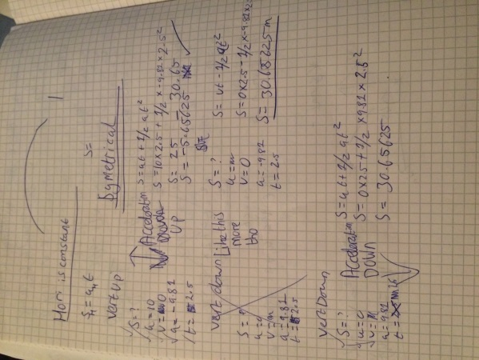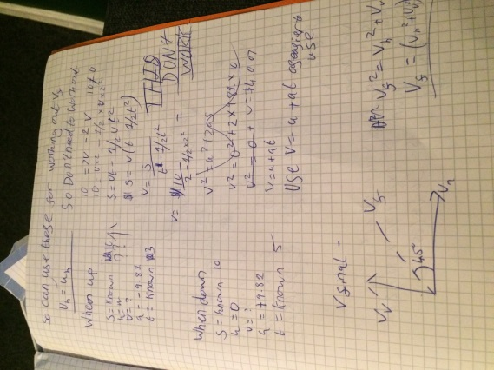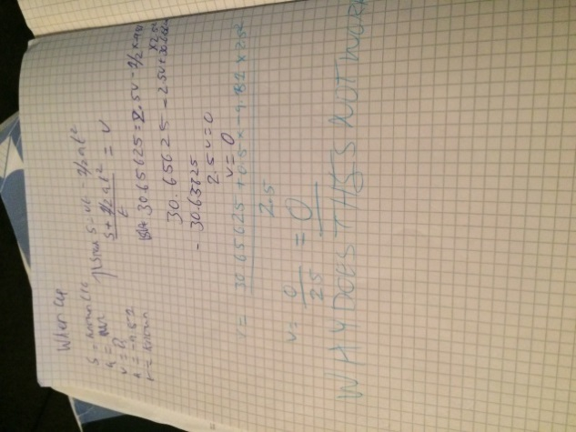 . **Testing** I then tried to see if the distance for when the bullet is moving up is correct and it wasn’t. The vertical component was right but the horizontal was 102.5 when it should be 250. This was because I added the numbers: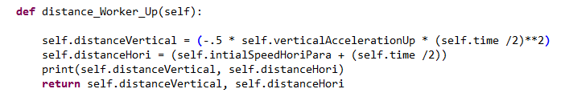

When changed to a * the answer worked. I then wrote the function for going down. **Testing** When I ran the code the horizontal distance was correct but for the vertical distance it was 7.755485961562951. This is badly wrong. When I used the debugger, the maths seemed to work fine so I went back to how I did it. The problem was that I was square rooting the time instead of squaring it:. It should be **2. Once I did this the maths worked perfectly so it now outputs the right vertical component. I then decided to write the code for the speed at different points of the program. When I ran the program however it did not work as I got an error by dividing by 0. This is because of how I used the equation so when I rewrote the equation I got the correct answer (on paper).Now becomes:

Should be a *

**Testing** This gave me an answer of 18.37375 which does not equal 0! I then tried it on paper again and it worked. So I decided to step through the code. The problem is here:

It is dividing too early and I will now use more brackets to make sure it works. **Testing** When I used more brackets it then gave me the answer of -0.00799999999999983 which still does not equal 0! The problem is rounding as 30.65625 – 30.65625 = -0.019999999999999574. To counteract this I will say any speed below 0 is actually equal to 0 as there cannot be a negative speed. This then worked. So I have the speed working for it going vertically upwards and now I will work it out for vertically downwards. **Testing** This is just acceleration multiplied by time so when time is 2.5 speed should be 24.525 and when I ran the code the answer was 24.525000000000002 (Close enough). The problem as you can see is the rounding errors however I do not mind if the error is about 10 decimal places below as this will barely effect the physics or the code. This means I do not mind if there is a rounding error but I do mind if there is a negative speed as this then mucks up the code by being unrealistic.

Finally I will use both the vertical and horizontal components to then work out the final velocity using Pythagoras Theorem. **Testing** Using my testing (VVertical = 100, hori = 50 or vice versa) the answer which the program gave was 111.80339887498948 which is correct!

I will now get the bullet moving which requires putting it in the main program. After a lot of working out with names of variables, I have the bullet going up! The problem is that pressing both q and w will send the parabolic bullet up not just w. I will sort this out next then get the bullet to go down. I also tested that if the bullet hit the enemy it which isn’t working at the moment (Another thing to sort out yay :/). I just took out the code to fire a bullet from the bulletFiring module and put it in its own one so you can now press q and a straight line bullet moves and press w and a parabolic bullet fires. **Testing** When I shot the bullet it would not notice if I hit the enemy. This was because I had written it down as bulletCoordinates2 when instead it should have been bulletCoordinates. I changed everything to be the same so now it should work. This still did not work sadly. What I will do is try and get the whole parabolic arc to work then try and get the bullets to start hitting the enemy.

**Testing** Firstly, I copied and pasted the work I did for moving the bullet up and after not naming the variables and methods correctly (At one point the bullet moved downward instead of upward!) the bullet moved in a parabolic arc!!!!! I now have two bullets which move in a way which physics suggest. I can mess around with the values to try and get the bullet to hit the enemy but that it moved is brilliant. I will now try and get the bullet hitting the enemy and hopefully meaning that the whole game for the user works!

**Testing** I added a print statement which says hit so hopefully when I get the bullet to hit the character I can see whether it hits. This is so I can see if the code is registering a hit. When I ran the code and got the bullet to move it did hit the character:. I also got a pile of red text: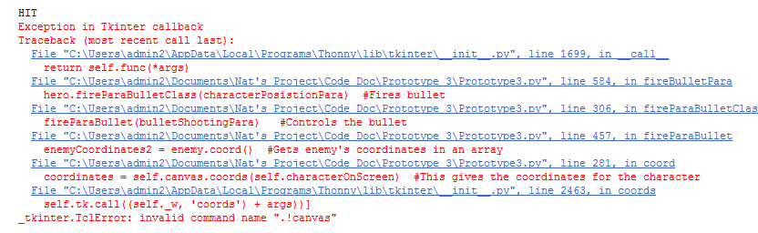I then put a print statement to say what the enemy’s health was at but it does not reach that far. It does not even go past the code which asks it to get the time: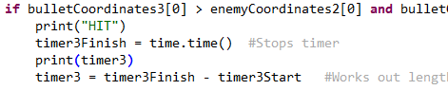

**Testing** This is because I am just looking at one aspect of the arc which is when the bullet goes down. I will look at going up as well. It printed the time (Here being 0.0 seconds). One of the reasons it might not work was that I had not changed the timer1 to timer2. When I next ran the code it seemed to work…. But it still does not work consistently.

**Testing** To try and work out how to do this I firstly got the program to output HIT UP or HIT DOWN depending when it noticed that we have ‘hit’ the enemy. When I ran the code next I was able to get the character to hit the enemy and it was able to output the time.  I then got the code to output what it has done: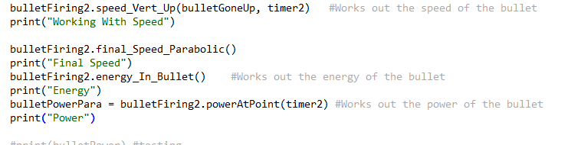

**Testing** I did change the conditions of the code so all the bullet had to do was go past the enemy and not go through it. I ran through the code and this was outputted: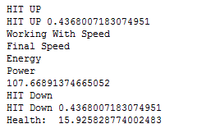As you can see there is both health taken away from going up and down and this can be solved by adding an if statement saying whether it needs to go down. THIS WORKED!!!!!!! (I am way too happy at this!)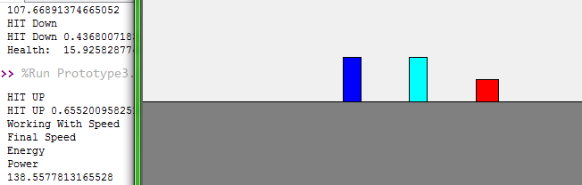

You can see there is no bullet here and this is all the code which has been outputted! So to make this code work a bit better I will have the hitbox (the area which the person can shoot at which the bullet will take as a hit) to be about 5 to 10 pixels a bit higher to make it a bit easier for the user to shoot. However, at the moment you can have the bullet miles from the enemy but it still hits the character as the hitbox is all the area behind the enemy. To change this I will just have in the while statement code specifying that it has to be the area which the enemy resides in. I now have two bullets which the user can shoot which harms the enemy and means the user can end the game.

I now have to make the enemy dangerous so if the user’s character hits the enemy, the ‘hero’ loses health and letting the enemy to shoot bullets. I will get the hero to lose health when touching the enemy first. This is the code at the moment: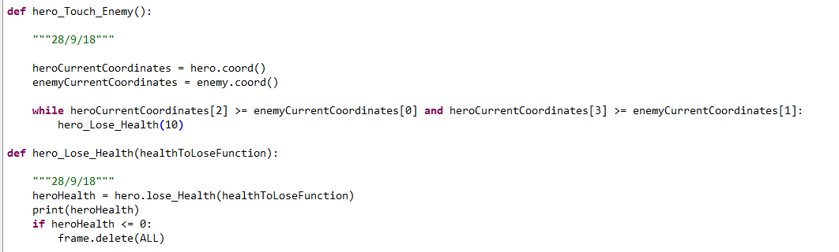

This is where the hero loses health

Here is what happens if the user’s character is touching the enemy

If the hero loses all his health the code will end making it harder for the user (unsurprisingly!). I am only saying if the bullet goes past the enemy (So does not wrap around the actual character) as it is nigh on impossible to jump over the enemy.

**Testing** The output at the moment is that the character is not being deleted and it is in an infinite loop. This is a loop which you cannot get out of. To change this I am going to change this to an if statement and increase the amount you should lose to 50. This worked so that if you were touching the enemy you lose health. Now it is a bit unfair that you lose so much health as the user is not pushed back, so what I will do is make a pushback by 10 pixels so you are out of the way. I could increase this if I want to but this shows that it works. Now if you try and jump over the enemy you are going to find it very hard so I will try and program the code if you get behind. Finally, if the enemy is deleted you get an error as the code is expecting an enemy. A simple try except clause will solve this problem. Now the program will not allow you to hit the enemy infinitely!

The next thing I need to try and do is get the enemy to shoot the character. I could have the enemy to alternate which bullet it shoots but this could be too complex. I will get the enemy to shoot a bullet every 5 seconds (So there is a bullet on the screen every 5 seconds). It will slow the game even more but this is a trade-off which I accept will happen unless magically I can work out suddenly how to do threads (Really Hard). However before I did this I commented out all the print statements. Now I will try and get the enemy to shoot a bullet.

Firstly I will put in a module which has an infinite loop (which will be needed to keep on shooting a bullet) and see how the program can deal with it. It did not like it when I had it before all the movement buttons.

When I put it afterwards which it did not like at all! So this is a slight problem! What I will do is try and see what happens if I put it in the callback function which is when the user presses the screen to get the character to move. When its here the game dies. So I need to think of how to do this.

What I decided to do was actually write the code to get the bullet to be shot. I copied and pasted the code for a horizontal bullet and added an Ene at the end of each variable so they could all work. Now what I have to do is get the bullet to shoot. I added it to the main code (To get the bullet to shoot):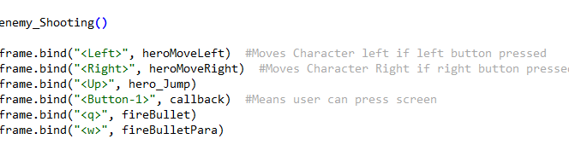

**Testing** This did not do anything so I put it in fireBullet. But when I did that the bullet was going the wrong way and was hurting the enemy! The problem was that I was not calling the right function:

Calls the way to shoot a bullet

This should be fireHoriBulletClassEnemy

**Testing** This did not work either! I put the bullet to -5 which could work however the bullet still was going the wrong way! So what I decided to do was go and see if I could see what was wrong later on in the code. I found the problem. Another spelling error:

Should be fireHoriBulletEne

The bullet is still going the wrong way! I will now check the fireHoriBulletEne. This works!! What I will now do is get the bullet to hit the hero and the hero to be able to jump over the bullet and also the bullet not requiring a user input. However when thinking about it I might keep it that you get fired at if you use the horizontal bullet as I have it whilst testing the bullet. This is because at the moment using the horizontal bullet is too overpowered as it only requires using this bullet 2 or 3 times. If I have it that you also get shot at and I then fiddle about with the parabolic bullet it will make the horizontal bullet less overpowered and means I do not have to program the code to fire a bullet every 5 seconds making it easier for me to stay on time.

**Testing** So I started changing the bullet and the first attempt the bullet was too large! I then had the bullet at the correct size and I will now get the bullet to be shot more from the hip area (Middle of the rectangle) so that the bullet can be jumped over. After a bit more fiddling about with the values I got the bullet to come from the middle and be the right size. However it was quite hard to jump over so I will try and make it lower. I also upped how high you could jump to make it easier to jump over the bullet. I changed it to 100 but this might be too large so I can still fiddle about with this value.

I now need to get it that when the bullet hits the hero it will hurt it. **Testing** The problem is that the bullet is not saying it has hit the hero. It does not like the canvas thing for some reason I believe. I did it! I took out the try except comment I had (will need to add this earlier) and also fixed another spelling error which meant I could get the enemy to shoot at the user’s character. I took out the try statement as this was only used if there was no enemy but it still allows the character to shoot but this is not needed as if there is no hero there is no way the enemy can shoot.

**Testing** I then wrote the code make the bullet hit the character allowing the user’s character to jump over it and then not be hit:When you defeat the enemy it then means that part of the code brings up red text. This can be fixed by a try except clause. Once this was added this prototype has been finished. I will add docstrings and comments then this prototype is completed. I will also fiddle about with the values meaning it is hard but not too hard and is a good game for the user. This will require me to change the amount which you can jump and the starting values for the 2 bullets. I changed the jump values to 50 meaning there is more skill to jump over the bullet but I could do it so it must be possible.

I have now commented and put docstrings on the whole program so now it should all work well. I have now finished the game side of my project and now need to add a scoring system and to try and store and save this then also to have a menu.

#### Review

I have now finished the game part of my project and now have got a working basic game however I will now want to add a better UI by adding a menu and add a scoring system.

### Prototype 3 Code

from tkinter import * #This means I can use Tkinter

import time #Allows me to use time and measure how long bullets

class Bullet():

"""Made by Nathaniel Lowis 1st Edit: 10/9/18 Latest Edit: 3/10/18

This is the superclass which will allow me to model how thew bullet moves and output it to the screen. Parts of code has been adapted from:https://stackoverflow.com/questions/25430786/moving-balls-in-tkinter-canvas

"""

def __init__(self, x1BulletGiven, y1BulletGiven, x2BulletGiven, y2BulletGiven, canvasToUse):

"""Made by Nathaniel Lowis 1st Edit: 10/9/18 Latest Edit: 3/1018

Inputs - the canvas (Tkinter Object), coordinates (Integers)

Outputs - None

Sets up the class when intialised"""

self.intialSpeedHori = 50.0 #These will set up the intial speed, acceleration for use in the rest of the code for both the Parabolic bullet and Horizontal Bullet

self.intialSpeedHoriPara = 50.0

self.finalSpeedHori = 0.0

self.finalSpeedVertical = 50.0

self.finalSpeed = 0.0

self.distanceHori = 0.0

self.distanceVertical = 0.0

self.horizontalAcceleration = 30.0

self.verticalAccelerationUp = -9.81

self.verticalAccelerationDown = 9.81

self.x1Bullet = x1BulletGiven #This 4 co-ordinates are where each corner should be placed

self.y1Bullet = y1BulletGiven

self.x2Bullet = x2BulletGiven

self.y2Bullet = y2BulletGiven

self.canvasBullet = canvasToUse #Sets up the code

self.ball = canvasToUse.create_oval(self.x1Bullet, self.y1Bullet, self.x2Bullet, self.y2Bullet, fill="green") #Outputs to screen

self.time = 5 #More constants made.

self.mass = 0.008

self.energy = 0.0

def deleteBullet(self): #Change to delete_Bullet

"""Made by Nathaniel Lowis 1st Edit: 12/9/18 Latest Edit: 12/9/18

Inputs - The class

Outputs - Deletes the bullet from the screen

Deletes the bullet from the screen"""

self.canvasBullet.delete(self.ball) #Deletes bullet

def energy_In_Bullet(self):

"""Made by Nathaniel Lowis 1st Edit: 12/9/18 Latest Edit: 12/9/18

Inputs - Class

Outputs - The energy of the bullet (float)

Works out the amount of energy in the bullet"""

self.energy = .5 * self.mass * ( self.finalSpeed ** 2) #Uses E = 1/2 mv^2

##print(self.energy) #testing

def powerAtPoint(self, timeTaken):

"""Made by Nathaniel Lowis 1st Edit: 12/9/18 Latest Edit: 12/9/18

Inputs - Time (float), class

Outputs - The amount of power from the bullet (float)

Works out the amount of power in the bullet"""

power = self.energy / timeTaken #Uses p = E/t

##print(power) #Testing

return power

def coord(self): #CHANGE TO COORD_BULLET

"""Made by Nathaniel Lowis 1st Edit: 31/8/18. Latest Edit: 12/9/18

Inputs - The class

Outputs - Where the bullet is (Array of floats)

This will show where the bullet is"""

coordinatesBullet = self.canvasBullet.coords(self.ball) #This gives the coordinates for the bullet

return coordinatesBullet #Returns it to the main program

class HoriBullet(Bullet):

"""Made by Nathaniel Lowis 1st Edit: 10/9/18 Latest Edit: 12/9/18

This is a subclass of bullet which calculates and output it to the screen."""

def speedAtAnyPoint(self, distanceGone):

"""Made by Nathaniel Lowis 1st Edit: 12/9/18 Latest Edit: 12/9/18

Inputs - Distance Gone (Float), class

Outputs - The final speed of bullet (Float)

This works out the final speed of the bullet"""

self.finalSpeedHori = ((self.intialSpeedHori ** 2) + (2 * self.horizontalAcceleration * distanceGone) )** .5 #Uses V^2 = u^2 + (2as)

##print(self.FinalSpeed) #Testing

self.finalSpeed = self.finalSpeedHori #This means the program can use it later

return self.finalSpeed

def move_Ball(self, xMovement): #CHANGE TO MOVE_BULLET_HORI

"""Made by Nathaniel Lowis 1st Edit: 10/9/18 Latest Edit: 12/9/18

Input - How much to move by (Float)

Output - Moving on the screen (Tkinter Object)

This will move the bullet on the screen"""

self.canvasBullet.move(self.ball, xMovement, 0) #Moves the bullet

self.canvasBullet.after(100) #Waits 100 ms until it updates screen

self.canvasBullet.update() #Updates the screen

def distanceToWorkOut(self):

"""Made by Nathaniel Lowis 1st Edit: 10/9/18 Latest Edit: 12/9/18

Inputs - class

Outputs - The distance to go (Float)

This will work out how far the bullet has to go"""

self.distanceHori = (self.intialSpeedHori * self.time) + (.5 * self.horizontalAcceleration *(self.time **2)) #Uses S = ut + 1/2at^2

return self.distanceHori

class ParabolicBullet(Bullet):

"""Made by Nathaniel Lowis 1st Edit: 26/9/18 Latest Edit: 26/9/18

This is a subclass of Bullet which works out the stuff for a parabolic Bullet"""

def distance_Worker_Up(self):

"""Made by Nathaniel Lowis 1st Edit: 26/9/18 Latest Edit: 26/9/18

Inputs - Class

Outputs - Vertical Distance (Float), Horizontal Distance (Float)

This will work out how far the bullet will have to move when the bullet moves upwards"""

self.distanceVertical = (-.5 * self.verticalAccelerationUp * (self.time /2)**2) # Uses S = vt - (1/2)at^2

self.distanceHori = (self.intialSpeedHoriPara * (self.time /2)) #Uses S = ut

##print(self.distanceVertical, self.distanceHori) #Testing

return self.distanceVertical, self.distanceHori

def distance_Worker_Down(self):

"""Made by Nathaniel Lowis 1st Edit: 26/9/18 Latest Edit: 26/9/18

Inputs - Class

Outputs - Vertical Distance (Float), Horizontal Distance (Float)

This will work out how far the bullet will have to move when the bullet moves downwards"""

self.distanceVertical = (.5 * self.verticalAccelerationDown * (self.time /2)**2) #Uses S = ut + (1/2)at^2

self.distanceHori = (self.intialSpeedHoriPara * (self.time / 2)) #Uses S = ut

##print(self.distanceVertical, self.distanceHori) #testing

return self.distanceVertical, self.distanceHori

def speed_Vert_Up(self, distanceVertUp, timeTakenSoFar):

"""Made by Nathaniel Lowis 1st Edit: 26/9/18 Latest Edit: 26/9/18

Inputs - Class, Distance Gone Vertically Up (Float), time (Float)

Outputs - The final Vertical speed (Float)

This will work out the final vertical speed of the bullet when the bullet goes upwards"""

self.finalSpeedVertical = (distanceVertUp + (.5 * self.verticalAccelerationUp * (timeTakenSoFar ** 2)))/ timeTakenSoFar #Uses S = vt - .5at^2

if self.finalSpeedVertical < 0: #If the speed is worked to be less than 0 it sets the final speed to 0

self.finalSpeedVertical = 0.0

##print(self.finalSpeedVertical) #Testing

return self.finalSpeedVertical

def speed_Vert_Down(self, timeTaken):

"""Made by Nathaniel Lowis 1st Edit: 26/9/18 Latest Edit: 26/9/18

Inputs - Class, time (Float)

Outputs - Final Vertical Speed (Float)

This will work out the final vertical speed of the bullet when the bullet goes upwards"""

self.finalSpeedVertical = self.verticalAccelerationDown * timeTaken #Uses v = u + at and u is assumed to be 0

##print(self.finalSpeedVertical) #Testing

return self.finalSpeedVertical

def final_Speed_Parabolic(self):

"""Made by Nathaniel Lowis 1st Edit: 26/9/18 Latest Edit: 26/9/18

Inputs - Class

Outputs - Final Overall Speed (Float)

This uses vector working to work out the final speed of a parabolic bullet"""

self.finalSpeed = ((self.finalSpeedVertical **2) + (self.intialSpeedHoriPara **2))**.5 #Uses Pythagorous Theorem to resolve into 1 vector

##print(self.finalSpeed) #Testing

return self.finalSpeed

def move_Ball_Para_Up(self, yMovement, xMovement): #CHANGE TO MOVE_BULLET_HORI

"""Made by Nathaniel Lowis 1st Edit: 26/9/18 Latest Edit: 27/9/18

Input - yMovement (Float), xMovement (Float)

Output - Moving on the screen (Tkinter Object)

Moves the bullet on the screen"""

self.canvasBullet.move(self.ball, xMovement, -yMovement) #Moves the bullet

self.canvasBullet.after(100) #Waits 100 ms until it updates screen

self.canvasBullet.update() #Updates the screen

def move_Ball_Para_Down(self, yMovement2, xMovement2): #CHANGE TO MOVE_BULLET_HORI

"""Made by Nathaniel Lowis 1st Edit: 26/9/18 Latest Edit: 27/9/18

Input - How much to move by

Output - Moving on the screen

Works out how far the bullet has to be moved """

self.canvasBullet.move(self.ball, xMovement2, yMovement2) #Moves the bullet

self.canvasBullet.after(100) #Waits 100 ms until it updates screen

self.canvasBullet.update() #Updates the screen

class Character():

"""Made By Nathaniel Lowis 1st Edit: 25/08/18. Latest Edit: 2/10/18

This class will make the people on the screen and will allow the computer/user use the character"""

def __init__(self, canvasCharacter, x0Given, x1Given, y0Given, y1Given, colour):

"""Made By Nathaniel Lowis 1st Edit: 25/08/18. Latest Edit: 31/08/18

Inputs - The canvas (Tkinter Object), and coordinates (Integers)

Outputs - Character on the screen

This will initilise the character meaning it can be used"""

self.characterOnScreen = canvasCharacter.create_rectangle(x0Given, y0Given, x1Given, y1Given, fill= colour) #Creates the character

self.canvasForCharacter = canvasCharacter #Allows programmer to still use the screen

x0 = x0Given #These will give the different x and y points incase I need to use them again

x1 = x1Given

y0 = y0Given

y1 = y1Given

self.health = 200

def jump(self):

"""Made By Nathaniel Lowis 1st Edit: 25/9/18 Latest Edit: 3/10/18

Inputs - Class

Outputs - None

This will allow the character to jump and it be shown on the screen"""

height = 0 #Sets how high the character is

while height <= 50: #Whilst the character has not reached the maxiumum height (50)

self.canvasForCharacter.move(self.characterOnScreen, 0, -1)#Moves the character up

self.canvasForCharacter.update() #This will update the screen so the user can see it

self.canvasForCharacter.after(10) #Waits 10 ms until running the program. Allows the user to move here I think

height = height + 1 #Increments height by 1

downHeight = 0 #Sets how high the character Needed to get the character down

while downHeight <=50: #Whilst the charcter has not reached the floor (Need to go down 50 pixels)

self.canvasForCharacter.move(self.characterOnScreen, 0, 1)#Moves the character

self.canvasForCharacter.update() #This will update the screen so the user can see it

self.canvasForCharacter.after(10) #Waits 10ms until it does the anything

downHeight = downHeight + 1 #Increments downHeight by 1

def deleteCharacter(self):

"""Made by Nathaniel Lowis 1st Edit: 10/9/18 Latest Edit: 12/9/18

Input - Character Class

Outputs - Deletes the character

Deletes character if they are killed"""

self.canvasForCharacter.delete(self.characterOnScreen) #Deletes the character

def lose_Health(self, healthToLose):

"""Made by Nathaniel Lowis 1st Edit: 11/9/18 Latest Edit: 12/9/18

Inputs - The health to lose (Float)

Outputs - Health left (Float)

Makes the character lose health"""

self.health = self.health - healthToLose #Lose health

return self.health

def move_Left(self, amount):

"""Made By Nathaniel Lowis 1st Edit: 25/08/18. Latest Edit: 26/9/18

Inputs - The class

Outputs - Move the Character left

This will move the character left by 'amount' pixels"""

self.canvasForCharacter.move(self.characterOnScreen, -amount, 0)#Moves the character

self.canvasForCharacter.update() #This will update the screen so the user can see it

def move_Right(self):

"""Made By Nathaniel Lowis 1st Edit: 25/08/18. Latest Edit: 11/9/18

Inputs - The class

Outputs - Move the Character Right

This will move the character right by 2 pixels"""

self.canvasForCharacter.move(self.characterOnScreen, 2, 0) #Moves the character

self.canvasForCharacter.update() #This will update the screen so the user can see it

def coord(self): #coord_Player CHANGE TO THIS

"""Made by Nathaniel Lowis 1st Edit: 31/8/18. Latest Edit: 31/8/18

Inputs - The character

Outputs - Where the character is

This will show where the character is"""

coordinates = self.canvasForCharacter.coords(self.characterOnScreen) #This gives the coordinates for the character

return coordinates #Returns it to the main program

def fireHoriBulletClass(self, coordinateInFireBulletHori):

"""Made by Nathaniel Lowis 1st Edit: 10/9/18 Latest Edit: 12/9/18

Inputs - Cordinates of character in an array

Outputs - Shooting bullet

This controls the bullet"""

bulletShootingHori = HoriBullet(coordinateInFireBulletHori[2], coordinateInFireBulletHori[1], coordinateInFireBulletHori[2] + 5, coordinateInFireBulletHori[1]+5, self.canvasForCharacter) #Makes an instant of the HoriBullet Class

fireHoriBullet(bulletShootingHori) #Controls the bullet

bulletShootingHori.deleteBullet() #These will delete the bullet afterwards

del(bulletShootingHori)

def fireHoriBulletClassEnemy(self, coordinateInFireBulletHoriEne):

"""Made by Nathaniel Lowis 1st Edit: 2/10/18 Latest Edit: 2/10/18

Inputs - Cordinates of enemy character in an array

Outputs - Shooting bullet

This controls the bullet for the enemy"""

bulletShootingHoriEne = HoriBullet(coordinateInFireBulletHoriEne[2], coordinateInFireBulletHoriEne[1] + 45, coordinateInFireBulletHoriEne[2] +5 , coordinateInFireBulletHoriEne[1] + 40 , self.canvasForCharacter) #Makes an instant of the HoriBullet Class

fireHoriBulletEne(bulletShootingHoriEne) #Controls the bullet

bulletShootingHoriEne.deleteBullet() #These will delete the bullet afterwards

del(bulletShootingHoriEne)

def fireParaBulletClass(self, coordinateInFireBulletPara):

"""Made by Nathaniel Lowis 1st Edit: 27/9/18 Latest Edit: 28/9/18

Inputs - Cordinates of character in an array

Outputs - Shooting bullet

This controls the Parabolic bullet """

bulletShootingPara = ParabolicBullet(coordinateInFireBulletPara[2], coordinateInFireBulletPara[1], coordinateInFireBulletPara[2] + 5, coordinateInFireBulletPara[1]+5, self.canvasForCharacter) #Makes an instant of the ParabolicBullet Class

fireParaBullet(bulletShootingPara) #Controls the bullet

bulletShootingPara.deleteBullet() #These will delete the bullet afterwards

del(bulletShootingPara)

def setUp(): #CHANGE TO SET_UP

"""Made by Nathaniel Lowis 1st Edit: 25/8/18 Latest Edit: 25/9/18

Inputs - None

Outputs - A working screen with the floor and endpoint and sent to main program

This sets up the level the game"""

rootSetUp = Tk() #This makes the screen

rootSetUp.title("Nat Lowis's Game") #Gives game a name

rootSetUp.resizable(True, True) #This means the usre can make it full screen

canvasSetUp = Canvas(rootSetUp, width = 500, height = 500) #Sets up the

canvasSetUp.pack() #Outputs screen

floorSetUp = canvasSetUp.create_rectangle(500, 500, 0, 400, fill="grey") #Sets up the floor

endPointSetUp = canvasSetUp.create_rectangle(375, 375, 400, 400, fill="red") #Sets up the endpoint

heroSetUp = Character(canvasSetUp, 50, 70, 350, 400, "Blue") #This will make the user's character

enemySetUp = Character(canvasSetUp, 300, 320, 350 ,400, "Cyan") #This will make the enemy class

return rootSetUp, canvasSetUp, floorSetUp, endPointSetUp, heroSetUp, enemySetUp #Sends everything back to main program.

def fireHoriBulletEne(bulletFiringEne): #CHANGE TO FIRE_HORI_BULLET

"""Made by Nathaniel Lowis 1st Edit: 2/10/18 Latests: 3/10/18

Inputs - The Class HoriBullet

Outputs - The bullet moving and interacting with the environment

This will allow the bullet to interact with the environment for the enemy bullet"""

timer1StartEne = time.time() #Starts a timer

distanceToGoEne = bulletFiringEne.distanceToWorkOut() #Works out how far the bullet goes

distPer10MilliEne = distanceToGoEne / 50 #Divides the distance by 50 so they are all in equal chunks

bulletGoneEne = 0 #Creates a variable which works out how far the bullet has gone

timeDoneHoriBulletEne = 0

while bulletGoneEne != distanceToGoEne and timeDoneHoriBulletEne < 5000: #Whilst the bullet has not gone as far as it needs to

heroCoordinatesEne = hero.coord() #Gets hero's coordinates in an array

#print(heroCoordinatesEne) #Testing

bulletCoordinatesEne = bulletFiringEne.coord() #Gets the bullets coordinates in an array

#print(bulletCoordinatesEne) #Testing

#try: #The program will go down this route when there is an enemy class #Not needed anymore

#print("TRY") #Testing

if bulletCoordinatesEne[0] <= heroCoordinatesEne[2] and bulletCoordinatesEne[2] >= heroCoordinatesEne[0] and bulletCoordinatesEne[1] <= heroCoordinatesEne[3]: #If the bullet has hit the hero

#print("HIT") #Testing

timer1FinishEne = time.time() #Stops timer

timer1Ene = timer1FinishEne - timer1StartEne #Works out length of time the bullet has gone for

##print(bulletGone) #testing

##print(timer1) #testing

bulletFiringEne.speedAtAnyPoint(bulletGoneEne) #Works out the speed of the bullet

bulletFiringEne.energy_In_Bullet() #Works out the energy of the bullet

bulletPowerEne = bulletFiringEne.powerAtPoint(timer1Ene) #Works out the power of the bullet

#print(bulletPower) #testing

bulletGoneEne = distanceToGoEne #Means the while loop can stop

hero_Lose_Health(bulletPowerEne) #Makes the hero lose health

else:

negativeDistPer10MilliEne = distPer10MilliEne * -1 #This will allow the bullet to move towards the hero

bulletFiringEne.move_Ball(negativeDistPer10MilliEne) #Moves the ball the amount it needs to

bulletGoneEne = bulletGoneEne + distPer10MilliEne #Added to bulletGone

timeDoneHoriBulletEne = timeDoneHoriBulletEne + 100

## except: #This is when there is no enemy #All not needed anymore

##

## print("Except")

##

## negativeDistPer10MilliEne = distPer10MilliEne * -1

## bulletFiringEne.move_ball(negativeDistPer10MilliEne) #Moves the ball the amount it needs to

## bulletGoneEne = bulletGoneEne + distPer10MilliEne #Added to BulletGone

## timeDoneHoriBulletEne = timeDoneHoriBulletEne + 100

##

def fireHoriBullet(bulletFiring): #CHANGE TO FIRE_HORI_BULLET

"""Made by Nathaniel Lowis 1st Edit: 10/9/18 Latest Edit: 12/9/18

Inputs - The Class HoriBullet

Outputs - The bullet moving and interacting with the environment

This will allow the bullet to interact with the environment"""

timer1Start = time.time() #Starts a timer

distanceToGo = bulletFiring.distanceToWorkOut() #Works out how far the bullet goes

distPer10Milli = distanceToGo / 50 #Divides the distance by 50 so they are all in equal chunks

bulletGone = 0 #Creates a variable which works out how far the bullet has gone

timeDoneHoriBullet = 0

while bulletGone != distanceToGo and timeDoneHoriBullet < 5000: #Whilst the bullet has not gone as far as it needs to

enemyCoordinates = enemy.coord() #Gets enemy's coordinates in an array

bulletCoordinates = bulletFiring.coord() #Gets the bullets coordinates in an array

try: #The program will go down this route when there is an enemy class

if bulletCoordinates[0] > enemyCoordinates[0] and bulletCoordinates[1] >= enemyCoordinates[1]: #If the bullet is past the enemy

timer1Finish = time.time() #Stops timer

timer1 = timer1Finish - timer1Start #Works out length of time the bullet has gone for

##print(bulletGone) #testing

##print(timer1) #testing

bulletFiring.speedAtAnyPoint(bulletGone) #Works out the speed of the bullet

bulletFiring.energy_In_Bullet() #Works out the energy of the bullet

bulletPower = bulletFiring.powerAtPoint(timer1) #Works out the power of the bullet

##print(bulletPower) #testing

bulletGone = distanceToGo #Means the while loop can stop

enemyHealth = enemy.lose_Health(bulletPower) #Makes the enemy lose health

if enemyHealth <= 0: #If the enemy's health is below or equal to 0

#CULD PUT THIS IN OWN FUNCTION

enemy.deleteCharacter() #Deletes the enemy

else:

bulletFiring.move_Ball(distPer10Milli) #Moves the ball the amount it needs to

bulletGone = bulletGone + distPer10Milli #Added to bulletGone

timeDoneHoriBullet = timeDoneHoriBullet + 100

except: #This is when there is no enemy

bulletFiring.move_Ball(distPer10Milli) #Moves the bullet

bulletGone = bulletGone + distPer10Milli #Added to BulletGone

timeDoneHoriBullet = timeDoneHoriBullet + 100

def fireParaBullet(bulletFiring2): #CHANGE TO FIRE_HORI_BULLET

"""Made by Nathaniel Lowis 1st Edit: 27/9/18 Latest Edit: 28/9/18

Inputs - The Class ParabolicBullet

Outputs - The bullet moving and interacting with the environment

This will allow the bullet to interact with the environment"""

#This bit is for the bullet moving upwards

timer2Start = time.time() #Starts a timer

distanceToGoUp, distanceLeft = bulletFiring2.distance_Worker_Up() #Works out how far the bullet goes

distLeft = distanceLeft / 25 #Divides the distance by 25 so they are all in equal chunks to go left

distPer10MilliUp = distanceToGoUp / 25 #Divides the distance by 25 so they are all in equal chunksto go up

bulletGoneUp = 0 #Creates a variable which works out how far the bullet has gone

timeDoneParaBullet = 0 #This will be how long the bullet has moved for

goDown = True #This is used to say whether the bullet should go down

while bulletGoneUp != distanceToGoUp and timeDoneParaBullet < 2500: #Whilst the bullet has not gone as far as it needs to and not gone for long enough

enemyCoordinates = enemy.coord() #Gets enemy's coordinates in an array

bulletCoordinates2 = bulletFiring2.coord() #Gets the bullets coordinates in an array

try: #The program will go down this route when there is an enemy class

if bulletCoordinates2[0] > enemyCoordinates[0] and bulletCoordinates2[1] >= enemyCoordinates[1] -5 and bulletCoordinates2[0] < enemyCoordinates[2]: #If the bullet is hitting the enemy

##print("HIT UP") #Testing

timer2Finish = time.time() #Stops timer

timer2 = timer2Finish - timer2Start #Works out length of time the bullet has gone for

##print("HIT UP", timer2) #Testing

##print(bulletGone) #testing

##print(timer1) #testing

bulletFiring2.speed_Vert_Up(bulletGoneUp, timer2) #Works out the speed of the bullet going upwards

##print("Working With Speed") #Testing

bulletFiring2.final_Speed_Parabolic() #Works out the final speed for the bullet

##print("Final Speed") #Testing

bulletFiring2.energy_In_Bullet() #Works out the energy of the bullet

##print("Energy") #Testing

bulletPowerPara = bulletFiring2.powerAtPoint(timer2) #Works out the power of the bullet

##print("Power") #Testing

print(bulletPowerPara) #testing

bulletGoneUp = distanceToGoUp #Means the while loop can stop

enemyHealth2 = enemy.lose_Health(bulletPowerPara) #Makes the enemy lose health

#print(enemyHealth)

goDown = False #Means the bullet dows not have to go down

if enemyHealth2 <= 0: #If the enemy's health is below or equal to 0

#CULD PUT THIS IN OWN FUNCTION

enemy.deleteCharacter() #Deletes the enemy

else:

bulletFiring2.move_Ball_Para_Up(distPer10MilliUp, distLeft) #Moves the ball the amount it needs to up and left

bulletGoneUp = bulletGoneUp + distPer10MilliUp #Added to bulletGoneUp how far it went

timeDoneParaBullet = timeDoneParaBullet + 100 #Time is updated

except: #This is when there is no enemy

bulletFiring2.move_Ball_Para_Up(distPer10MilliUp, distLeft) #Moves the ball the amount it needs to up and left

bulletGoneUp = bulletGoneUp + distPer10MilliUp #Added to bulletGone how far it went

timeDoneParaBullet = timeDoneParaBullet + 100 #Time is updated

if goDown == True: #Means the bullet can go downwards

timer3Start = time.time() #Starts a timer

distanceToGoDown, distanceLeft2 = bulletFiring2.distance_Worker_Down() #Works out how far the bullet goes

distLeftToGo = distanceLeft / 25 #Divides the distance by 25 so they are all in equal chunks to go up

distPer10MilliDown = distanceToGoDown / 25 #Divides the distance by 25 so they are all in equal chunks to go down

bulletGoneDown = 0 #Creates a variable which works out how far the bullet has gone

timeDoneParaBullet2 = 0 #Creates a variable for amount of time it has been

while bulletGoneDown != distanceToGoDown and timeDoneParaBullet2 < 2500: #Whilst the bullet has not gone as far as it needs to and not for long enough

enemyCoordinates2 = enemy.coord() #Gets enemy's coordinates in an array

bulletCoordinates3 = bulletFiring2.coord() #Gets the bullets coordinates in an array

try: #The program will go down this route when there is an enemy class

if bulletCoordinates3[0] > enemyCoordinates2[0] and bulletCoordinates3[1] >= enemyCoordinates2[1] -5 and bulletCoordinates3[0] < enemyCoordinates2[2]: #If the bullet is hitting the enemy

#print("HIT Down") #testing

timer3Finish = time.time() #Stops timer

timer3 = timer3Finish - timer3Start #Works out length of time the bullet has gone for

#print("HIT Down", timer3) #Testing

##print(bulletGone) #testing

##print(timer1) #testing

bulletFiring2.speed_Vert_Down(timer3) #Works out the speed of the bullet going downwards

bulletFiring2.final_Speed_Parabolic() #Works out the final speed of the bullet

bulletFiring2.energy_In_Bullet() #Works out the energy of the bullet

bulletPowerPara2 = bulletFiring2.powerAtPoint(timer3) #Works out the power of the bullet

#print(bulletPowerPara) #testing

bulletGoneDown = distanceToGoDown #Means the while loop can stop

enemyHealth3 = enemy.lose_Health(bulletPowerPara2) #Makes the enemy lose health

#print("Health: ", enemyHealth) #Testing

if enemyHealth3 <= 0: #If the enemy's health is below or equal to 0

#CULD PUT THIS IN OWN FUNCTION

enemy.deleteCharacter() #Deletes the enemy

else:

bulletFiring2.move_Ball_Para_Down(distPer10MilliDown, distLeft) #Moves the ball the amount it needs to left and down

bulletGoneDown = bulletGoneDown + distPer10MilliDown #Added to bulletGoneDown

timeDoneParaBullet2 = timeDoneParaBullet2 + 100 #Updates time

except: #This is when there is no enemy

bulletFiring2.move_Ball_Para_Down(distPer10MilliDown, distLeft) #Moves the ball the amount it needs to

bulletGoneDown = bulletGoneDown + distPer10MilliDown #Added to bulletGoneDown

timeDoneParaBullet2 = timeDoneParaBullet2 + 100 #Updates Time

#def key(event):

# """Used as testing """

# #print("pressed", repr(event.char)) TESTING

def enemy_Shooting():

"""Made By Nathaniel Lowis 1st Edit: 2/10/18, Latest Edit: 2/10/18

Inputs - None

Outputs - None

This allows the enemy to shoot"""

characterPosistionForEnemy = enemy.coord() #Gets the coordinates for the enemy's character

enemy.fireHoriBulletClassEnemy(characterPosistionForEnemy) #Fires bullet

def hero_Touch_Enemy():

"""Made By Nathaniel Lowis 1st Edit: 28/9/18, Latest Edit: 3/10/18

Inputs - None

Outputs - None

This will mean the user's charatcer is hurt if it touches the enemy"""

heroCurrentCoordinates = hero.coord() #Gets the hero's coordinates

enemyCurrentCoordinates = enemy.coord() #Gets the Enemy's coordinates

try: #If there is an enemy

if heroCurrentCoordinates[2] >= enemyCurrentCoordinates[0] and heroCurrentCoordinates[3] >= enemyCurrentCoordinates[1]: #If the hero touches the enemy

hero_Lose_Health(50) #Hero Loses health

hero.move_Left(20) #Hero pushed back

except: #If there is no enemy niothing should happen

pass

def hero_Lose_Health(healthToLoseFunction):

"""Made by Nathaniel Lowis 1st Edit: 28/9/18, Latest Edit: 28/9/18

Inputs - Health to lose (Float)

Outputs - None

This will take away health if the hero is hit and stop the game if the hero is dead"""

heroHealth = hero.lose_Health(healthToLoseFunction) #Gets Hero to lose health

#print(heroHealth) #Testing

if heroHealth <= 0: #If the hero is 'dead' it should delete everything

frame.destroy()

def callback(event):

"""Editied from: http://effbot.org/tkinterbook/tkinter-events-and-bindings.htm Made by Nathaniel Lowis 1st Edit: 25/8/18 1st Edit: 31/8/18

Inputs - What the user did

Output- Allows user to move left and right

Means we can press on the screen and use the buttons"""

frame.focus_set() #This will mean we can use the left and right button as you have to press the window

##print("clicked at", event.x, event.y) Used as testing

def heroMoveLeft(event):

"""Made by Nathaniel Lowis 1st Edit: 31/8/18 1st Edit: 28/9/18

Inputs - What the user did

Output- Allows user to move left

Makes the hero move left and checks if the game has finished"""

hero.move_Left(2)#Calls this method to move character

hero_Touch_Enemy()

finishGame()

def heroMoveRight(event):

"""Made by Nathaniel Lowis 1st Edit: 31/8/18 1st Edit: 28/9/18

Inputs - What the user did

Output- Allows user to move Right

Makes the hero move Right and checks if the game has finished"""

hero.move_Right() #Calls this method to move character##

hero_Touch_Enemy()

finishGame()

def hero_Jump(event):

"""Made by Nathaniel Lowis 1st Edit: 25/9/18. Latest Edit: 3/10/18

Inputs - What the user did

Output- Allows user to move Jump

Makes the hero move Right and checks if the game has finished"""

heroCoordinatesJumpFunction = hero.coord()

if heroCoordinatesJumpFunction[3] != 400: #This is so the code

pass

else:

hero.jump() #Calls this method to move character##

def finishGame():

"""Made by Nathaniel Lowis 1st Edit: 31/8/18 Latest Edit: 31/8/18

Inputs - Nothing

Outputs - Checks if game has finished

This will check if you have passed the ending point and if you have deletes the screen"""

##print("TRYING") Used for testing

x0Endpoint = 375 #These are the known coordinates for the endpoint

x1Endpoint = 400

y0Endpoint = 375

y1Endpoint = 400

characterPosistion = hero.coord() #Works out where the user's character is

if characterPosistion[2] >= x0Endpoint and characterPosistion[3] >= y0Endpoint and characterPosistion[3] <= y1Endpoint and characterPosistion[2] <= x1Endpoint: #Checks if the character has passed the endpoint

frame.destroy() #If they have it will delete all objects on the canvas

def fireBullet(letter):

"""Made by Nathaniel Lowis 1st Edit: 10/9/18 Latest Edit: 3/10/18

Inputs - The q which must (for some reason) be included

Outputs - None

This will start the process of firing a Horizontal bullet and get the enemy to shoot first"""

try: #If there is an enemy it should start the shooting process

enemy_Shooting()

except: #If there is no enemy it should do nothin

pass

characterPosistion = hero.coord() #Gets the coordinates for the user's character

hero.fireHoriBulletClass(characterPosistion) #Fires bullet

def fireBulletPara(letter):

"""Made by Nathaniel Lowis 1st Edit: 27/9/18 Latest Edit: 27/9/18

Inputs - The w which must (for some reason) be included

Outputs - None

This will start the process of firing a Parabolic bullet"""

characterPosistionPara = hero.coord() #Gets the coordinates for the user's character

hero.fireParaBulletClass(characterPosistionPara) #Fires bullet

root, frame, floor, endPoint, hero, enemy= setUp() #Sets up game

frame.bind("<Left>", heroMoveLeft) #Moves Character left if left button pressed

frame.bind("<Right>", heroMoveRight) #Moves Character Right if right button pressed

frame.bind("<Up>", hero_Jump) #Allows the user to jump

frame.bind("<Button-1>", callback) #Means user can press screen

frame.bind("<q>", fireBullet) #Allows the user can shoot a horizontal Bullet

frame.bind("<w>", fireBulletPara) #Allows the user to shoot a parabolic bullet

frame.pack() #Sends it to the screen

frame.mainloop() #Infinte loop used

## Fourth Prototype

– Scoring made and saved in csv files

For my final prototype I want to work out scoring and how to change screens and also to have a leader board (So lots!). I want a menu and more of a GUI to make it easier for the user to navigate the game and also means the user can see how well they are doing.

What I first did was to download my game into a new Python file like this: This is so I can use a game within another file which then means I can play the whole game in one file. **Testing** I have tried to create a menu and then delete itself when a button is pressed which is not working at all. I am trying to get a file to import another file and see if it can show the instructions. However it does not like me trying to download the file at the moment which is not good at all. So at the moment I have got the menu to show instructions but it does not delete the window (I can live with that) so at the moment it looks like this: **Testing** 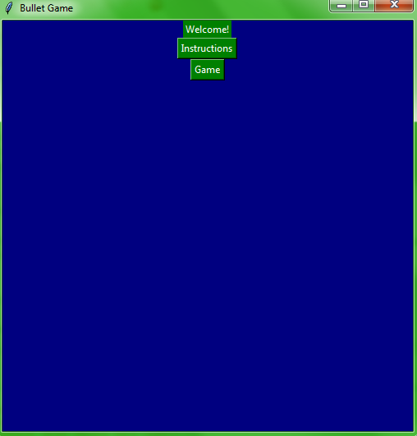 When I click the Instructions button it will send the user to a new screen: **Testing** 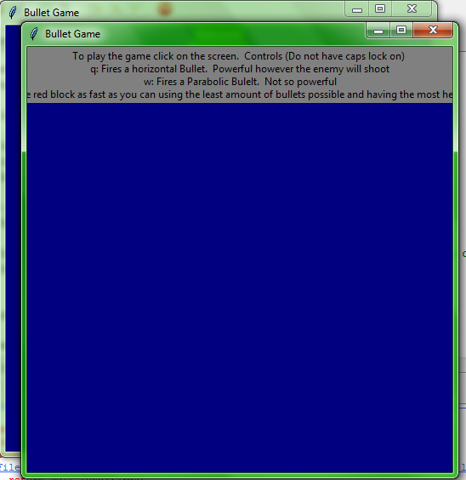. As you can see the other window has not been deleted but I cannot work out how to delete it all.

Then I started importing the game. After lots of fiddling around using exec commands and importing I have got it working. **Testing**  When the user presses the Game it will import the game and run it. What I will now do is get the game to work out what your score is by adding a scoring system. Adding a scoring system allows the user to see how well they are actually doing. Firstly I will now get the game to work out how many times you have shot the bullet and work out how long the game has run for.

Firstly, when I started trying to work out how many bullets has been shot, I tried setting up variables but this never worked as I could not get them global and also they never liked being reassigned. Instead I have made a class and set it up which can take bullets away and say how many bullets you have. **Testing** I will implement this into the game by saying whether there are more than 0 bullets. This worked! It was shooting when there were more than 0 bullets left! I then tried to shoot a bullet when I had already shot 10 (The limit is 10) and it did not allow me!! Now I will try and get the game to make a score. **Testing**  When making it I have had loads of spelling errors concerning attributes and now my games broken!!! (UGHHHHH) I have had to try and work out my code but one of my methods is saying I am not even passing self into the method. How has this happened. My character cannot die as my scoring module is not working correctly at all. So I need to fix that and work this all out then I should be fine.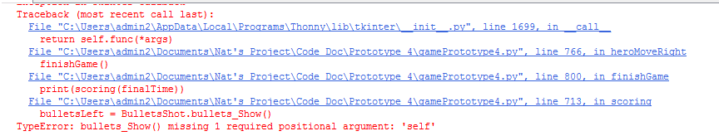

This problem was that I was calling BulletShot not bulletsLeft but now it is saying it is an unbound error so I am searching through my code looking for any other mentions of bulletsLeft. This was because I had named another variable that. Now I have changed it to howManyBulletsLeft. **Testing**  After a couple more errors concerning variable names I was able to get a score of 490 or so. When I used bullets I got a score of 209 meaning finishing it as quickly as possible is the most important part so if you died early you could get more points than if you completed the actual game. To sort this out I will give an extra 100 points for finishing the level to counteract this problem.

Now I will try and get this score onto the screen and then be able to add it to a database/csv. To do this I am going to import SQLite3 (A SQL language for Python) which then allows me to work with a database. I have code on how to program database which will help me to code this bit. I will need code to make the database, to get all the records off a database and use a sorting algorithm on it and also code to add data to the database. Finally, I will need code to ask for a username and for the code to query the database checking whether there is already a username like that already in the database. All of this is so I can allow the user to see how well they can do against other people. I also will use SQLite3 as this allows me to make and manipulate a database.

I will first tackle the problem of creating a database. **Testing**  My code is just adapted from code I already had and I then made the database: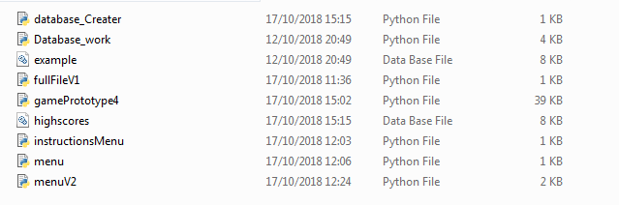

I will clear this out as there is a lot of unneeded files here (EG example, database_Work, menu). This has created my database and this will allow me to add files to it. I will then go into gamePrototype4 and get start to allow the user to add their username and add it to the file.

I started this by adding this code to my program: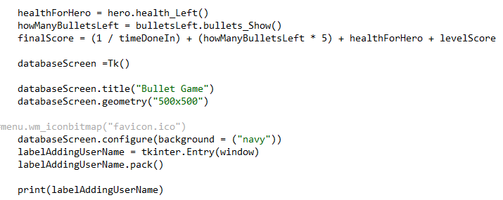

All this allows me to do is make a window for the database.

**Testing** The problem is that I could spam open a load of windows very easily. This was fine except I was not getting my entry but this was because I had written window instead of databaseScreen and I do not need the Tkinter ahead of Entry as I had already imported all Tkinter commands.

I also put all the code for the database into another file so it would not interfere with my game. I now need to work out how to enter my name and start to get it checked. After checking a website (Effbot is amazing here) I tried using the .get to get the contents from the user when they press a button. **Testing**  I did forget to pack the button but it did not work. This is because I am calling something which is not global (yay ☹). Even when I did call it, the program still did not take my name. So at the moment I cannot add a username. How I might get around this is to add it to a csv file and then have another file which sorts out the username. It is a bit complicated but I think it could work. This would also allow me to have the SQL work in the same file as adding the username. I now could get this to work so you can add a username and the program can check it. Now I need to save something to a csv file send it over and then delete what is in that csv file so then I can add it all to the database. (I said this was going to be complicated!).

Before doing all of that I am going to get the program to check through the whole database and see if there is already a person with that username. **Testing** The code I wrote returned this error: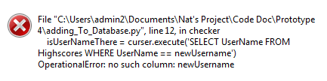 so for some reason it thinks newUsername is a column. When I added some quote marks around it, the code seemed to work. So hopefully it should all be working. Now I need to get it to print it all out which worked with a .fetchall. Now I need to get it to add data to the database but firstly I need to make sure the program can see that it is all empty.

I have now started to program it that the code checks if the username is there and see what happens if it does. **Testing** Firstly the label was not appearing but this is because I was forgetting to pack it to the screen. When I added Nat everything seemed to work so I now need to get it to add my score then using csv files for it all to work. This is because the code for the score and for the database is in different files. I am using a csv file as it can be overwritten very easily but also be read easily.

I have now written code to add your score to a file and then send it to the program which checks for username in the database. **Testing** When I ran the code I got an error this error: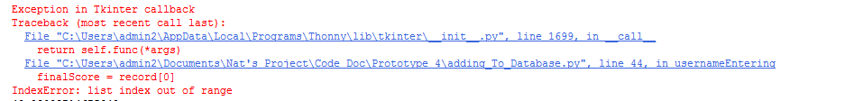

**Testing** So for some reason the score does not seem to be being added however it was. I ran the code again and it still did not seem to work. I used a debugger on the code and it did not seem to work. However when I added the number I was forgetting to add a “/n” so I added this and checked what happened but I still got the same error! However I got an error as there was always another row afterwards. So to counteract this I added an if statement saying if the array was empty it should just pass and not do anything. When I ran this code I did not get any error codes so I am assuming it works.

Now I need to add these values to the database and then just get the database to be displayed in order. To add the values into the database I used. Everything seemed to work but I am now going to check the code worked by displaying it. **Testing** When I displayed the database this was in it:This is slightly wrong! As well using my username as the Primary Key does not seem to work. So this is not working completely. I was able to get around this by using the command executemany which meant I added the tuple. How I was checking the database was not working either so I decided to change my code. The code which I rewrote might have crashed Python (oops). **Testing**  So the checker did work but it does not like to change the label. So instead of having unique usernames I will have a unique number. So I need to reset my database which I did with no problem. I then changed my checker to code to work out the largest ID number and after a few spelling errors I was able to I got an error as when I created the database I had a comma between the column name and what it will be. After running the code twice everything worked. **Testing** This is what the database looks like:

The next thing I need to do is to make it sort this all out and display it via Tkinter and then we will have everything done. The finish line is almost in sight! Firstly, I checked to see whet the sort algorithm for Python is like and the timsort is very good with a big O notation of O(nlogn) which is not bad at all. So I will use this to sort my database. However, it is hard to say which element to sort by so I will actually use Quick Sort (I have code for this) as it is the fastest sorting algorithm and is not hard to implement looking at a specific element. **Testing** After a few error with not having the right type to concentrate everything my whole table did not output to the screen: . However a more pressing was that it sorted the smallest item firstTo edit this in my sorting code I changed a < to a >. My other problem was that I forgot to have a tableDisplay + tableDisplay. This is now what my table looks like: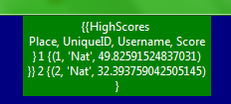. This has meant once I have added it to the main table I have finished my 4th prototype. I have now done it.

**Testing** I have also noted that you could earn more points by killing yourself by running into the enemy and earn more points than if you completed the level stilll. To counteract this, you earn an extra 100 points for completing the level. I also got one of my stakeholders (Max) to check and see how the colour scheme was. He said he could see everything correctly.

Finally, all I am doing is putting all the needed files in the same folder and renaming some folders. An interesting problem though is that I cannot run the code for the menu outside of the IDE which is different to every other code I have. I am not worrying as it does not matter. **Testing** When I was going through my code it looked like that my code would not work if the user touched the end which would be a bit embarrassing. I quickly took out my print statement for the scoring and it all worked (Though there were a few mistakes after I have changed a few variable names). I have now written all my code with correct variable and module names. All I have to now do is comment and to add my final docstrings and then I have completed all the code (Finally!). I also named the game Bullet Shot. I also changed some of the variable names along with some methods names (I had a few coordinate methods for different classes so I have changed them to coord_Bullet and coord_Player) and finally have changed what a few comments and docstrings say. All of these changes were just to make it clearer about what the code is doing. The variable name changes were to make sure each variable is unique.

#### Review

I have now finished! All the code works for the iterative testing and I have now a working UI.

### Prototype 4 code

I am not adding code here as the only difference between this prototype and the final one is me just changing some names of variables and not much else.

# Evaluation

## Testing to inform development.

### Provided annotated evidence of post development testing for function and robustness.

#### Videos: What they show

To find the evidence for each test check the notes which will specify the video and where it is.

Video 1 – This firstly shows the menu and the instructions screen. It then shows the game running with emphasis on moving to start with. You then see me get shot at by the enemy when I press one of the fire buttons. and the output of when it hits the user’s character. It then shows the User’s return fire after the bullet from the enemy. This is then repeated. Then you see me fire my parabolic bullet twice and you can see what happens when that is outputted. The single number after the pressed ‘w/q’ shows how many bullets I have remaining. You then see me ‘kill’ the enemy and end the game.

Video 2 – You see the menu then the game. You see the bullets being shot with me killing the enemy (you can see how much health is left and how many bullets are left). You then see the game end however there is a error with a variable name (which is what the next 10 seconds shows me finding). You then see me restart the game and kill the enemy and finsh the game. You then see me enter a user name andtry and restart the game. You them see me restart the game die by running into the enemy 4 times and enter a username. You then get to see the database of scores. You finally see me shoot a parabolic bullet and then different buttons to show the game does not break. You then see me kill the enemy and finish the level and enter another username.

Video 3 – Here you see the database being created.

#### How I tested the game.

In every video will be a black console. This shows the input from the keyboard of what the user presses and also the numbers for each bullet when shot. The user will not see this, however it is used here allowing me to see what button I have pressed thus knowing the input and you can see what the output is. 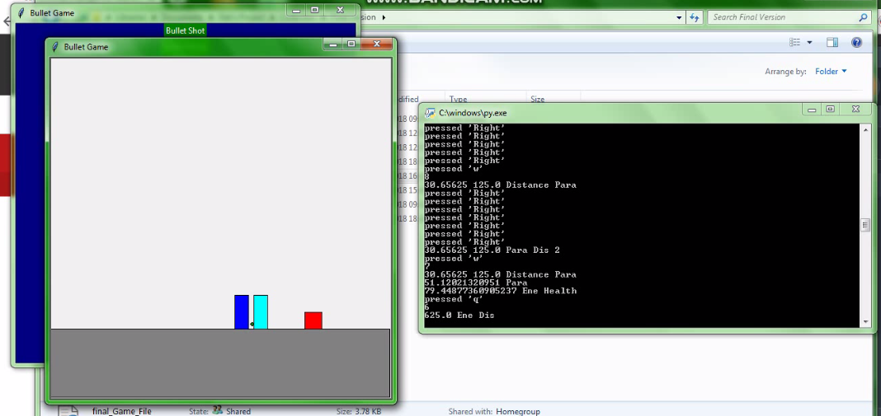

This shows the inputs and any other necessary outputs

#### Actual Output explanation

True – It means that the expected output did happen.

False – It means the expected output did not happen.

|  |  |  |  |  |  |  |
| --- | --- | --- | --- | --- | --- | --- |
| Test Number | Statement | Justification | Input | Expected Output | Actual Output | Notes |
| 1 | The program will work. The player will be able to play a game which is realistic and is a shooting 2D platform game with an enemy which you need to defeat in it. The program will be robust enough to not break if a wrong input is entered. | I do not want there to be any game breaking bugs or glitches so I will want to have caught them before I finished. I want the game to be finished and that the user feels that it is polished and finished. | - | The game does not unexpectedly dies or anything like that | FALSE | See all 3 videos. Can still output multiple bullets |
| 2 | The program will allow the user to move the character side to side and also to jump. | Again self-explanatory. The user will only be able to use one character and this will be the way to actually interact with the level. | Valid - Right Key | The character moves to the right | TRUE | See video1 19 – 20 seconds |
| 3 | The program will allow the user to move the character side to side and also to jump. | Again self-explanatory. The user will only be able to use one character and this will be the way to actually interact with the level. | Valid - Left Key | The character moves to the Left | TRUE | See video1 20 -21 seconds |
| 4 | The program will allow the user to move the character side to side and also to jump. | Again self-explanatory. The user will only be able to use one character and this will be the way to actually interact with the level. | Valid - Up key | The character moves up then down landing on the floor. | TRUE | See video1 22 – 23 seconds |
| 5 | The program will have an enemy | This is so there is some difficulty in the game. | - | There is more than one character on the level | TRUE | See video1 16 seonds (Cyan Block) |
| 6 | The program will end when the user’s character reaches an endpoint. | This means the level will end at one point and will not go on forever. | Valid - Reach the endpoint | The Game ends showing the next screen | TRUE | See video1 1:36 |
| 7 | The program will allow the user to change which bullet to use | This means they can use both bullets. | Valid – Press q, e, q | This should shoot 2 bullets | FALSE | See video1 34 – 45 seconds. Instead have two buttons to shoot each bullet |
| 8 | The program will detect when the bullet hits either a character or the wall. | This will make the bullet more realistic and also mean the bullet does not go for infinity. | Valid -Press q | The enemy should shoot a bullet. Hits the user’s character and disappears | TRUE | See video1 40 – 45 seconds |
| 9 | The program will detect when the bullet hits either a character or the wall. | This will make the bullet more realistic and also mean the bullet does not go for infinity. | Valid - Press q | Once the enemy’s bullet disappears the user will fire a bullet and when it hits the enemy, this too will be deleted | TRUE | See video1 40 – 35 seconds |
| 10 | The program will detect when the bullet hits either a character or the wall. | This will make the bullet more realistic and also mean the bullet does not go for infinity. | Valid -Press w | The hero will fire a bullet and when it hits the enemy it will disappear | TRUE | See video1 55 – 1:05. Cannot see bullet as the user’s character is so close |
| 11 | The program will take away health from a character when a bullet hits it using the power equation. | This makes it realistic and also means you can destroy the enemy/character. | Valid -Press q | When bullet hits the hero it will output the power of it and the health remaining | TRUE | See video1 32 – 36 seconds |
| 12 | The program will take away health from a character when a bullet hits it using the power equation. | This makes it realistic and also means you can destroy the enemy/character. | Valid -Press q | When the bullet hits the enemy it will output the power and the health remaining | TRUE | See video1 36 – 38 seconds |
| 13 | The program will take away health from a character when a bullet hits it using the power equation. | This makes it realistic and also means you can destroy the enemy/character. | Valid -Press w | When the bullet hits the enemy it will output the power and the health remaining | TRUE | See video1 55 – 1:05. Cannot see bullet as the user’s character is so close |
| 14 | The program will make the bullet go the correct distance using SUVAT. | This make the game realistic | Valid – Press q | The program will output how far the enemy bullet is going (Will be a float) | TRUE | See video1 30 – 35 seconds |
| 15 | The program will make the bullet go the correct distance using SUVAT. | This make the game realistic | Valid – Press q | The program will output how far the hero’s bullet is going (Will be a float) | TRUE | See video1 35 seconds |
| 16 | The program will make the bullet go the correct distance using SUVAT. | This make the game realistic | Valid – Press w | The program will output how far the bullet is going (Will be a float) | TRUE | See video1 55 seconds – 1:00 |
| 17 | The program will have two bullets a parabolic one and a horizontal one. | This allows the user to have more than one weapon | - | There is two bullets the user can use | TRUE | See video1 2 Bullets being shot |
| 18 | The program will take away bullets from the total amount of bullets when one is fired | This makes it more difficult to the user and gives the game a level of difficulty. | q | The amount of bullets left decreases by 1 | TRUE | See video1 41 seconds |
| 19 | The program will take away bullets from the total amount of bullets when one is fired | This makes it more difficult to the user and gives the game a level of difficulty. | w | The amount of bullets left decreases by 1 | TRUE | See video1 54 – 57 seconds |
| 20 | The program will have a timer which allows it to work out how long the user has taken. | This is to be used in the total points and allows the user to try and make it quicker | - | There is a time at the end which is similar to the time I will take on my phone | FALSE | See video1 1:36. Fixed in video2 2:12 (Time on Phone was 15 seconds) |
| 21 | The program will work out a total. | This is to give a point for the game | - | At the end the program will work out a score | TRUE | See video2 2:28 |
| 22 | The program will allow the user to see how well they have done | This will allow the user to see how well they have done | - | The score is outputted | TRUE | See video2 2:28 |
| 23 | The program will have a database of highscores | This is so all scores can be entered and also so the user can see how well they are doing. | Running database_Creator | highscore.db is made in same file | TRUE | See video3 (Whole) |
| 24 | The program will put the score in a database | This is so the user can see how they compare to other people. | - | The score is added into the database (We can see it on the highscores page) | TRUE | See video2 2:40 – 2:45 |
| 25 | The program will allow the user to enter a username. | This is so it can go into the database along with their score. | Valid: 10low1 | This is accepted | TRUE | See video2 1:30 – 1:40 |
| 26 | The program will only allow usernames which no one else has used before. | This is so it is easy for the User to see their score in the database | Invalid: 10low1 | This is not accepted | FALSE | See video2 2:25 – 2:30. Username accepted |
| 27 | The program will allow the user to choose whether to see the highscores or to play the game | This will be a menu and allow the user to see different bits. | - | There is a menu showing different options | TRUE | See video1 Start |
| 28 | The program will display a table of highscores. | This allows the user to see how well they are doing. | Press Leaderboard | There is a leaderboard | TRUE | See video2 2:40 – 2:45 |
| 29 | The program will make sure all characters are on the ground when jumping | This will then make sure it looks realistic and also means you can see how high they are. | Invalid: Press up button multiple times | Only jumps once until it reaches the ground | TRUE | See video2 3:20 – 3:25 |
| 30 | The program will end if the user’s character hits 0. | This is so there is a risk if you are hit by a bullet | Touch enemy 4 or more times | The program will open the page asking for the username | TRUE | See video2 2:00 – 2:12 |
| 31 | The program will have a bullet being shot by the enemy every 5 seconds | This is so there is a continuous risk to the user. | - | There is a bullet shooting every 5 seconds | FALSE | Never happens. Instead the enemy fires when the user fires a horizontal bullet |
| 32 | The program will allow any characters in the username | This means it’s easy for the user to have any name | Valid: hiTh1s @h! | This is accepted | TRUE | See video2 3:35 – 3:50 |
| 33 | The program will have an instructions screen | This will allow the user to know how to play the game | Press Instructions in menu | Instructions are outputted | TRUE | See video1 0:05 – 0:15 |
| 34 | The program will have a menu | Allows the user to go to different parts of the program | - | There is a menu | TRUE | See video1 Start |
| 35 | The program will have a leaderboard screen | This will allow the user to see the current best scores | Press Leaderboard | This will output the leaderboard | TRUE | See video2 2:40 – 2:45 |
| 36 | The program will output the leaderboard from the largest score (Best) to the smallest score (worst) | This will make it easy for the user to see the best and worst scores | - | Out of the multiple scores largest is top smallest bottom | TRUE | See video2 2:40 – 2:45 |
| 37 | The program will take away health if the user’s character touches the enemy | This means there is some danger to touching the enemy and means you cannot just run straight to the endpoint | Touch enemy | Hero will lose health | TRUE | See video2 2:10 – 2:12 |
| 38 | The game will do nothing if you press buttons which are not q,w or the arrow keys. | This means the game cannot break if you enter an accidental input. | Press g | Nothing | TRUE | See video2 3:10 – 3:22 |

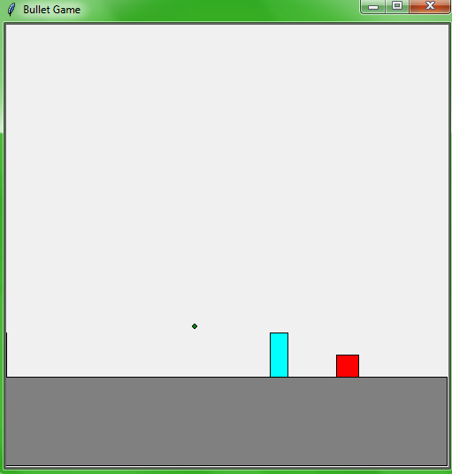

The bullet being shot by the user (Off screen)

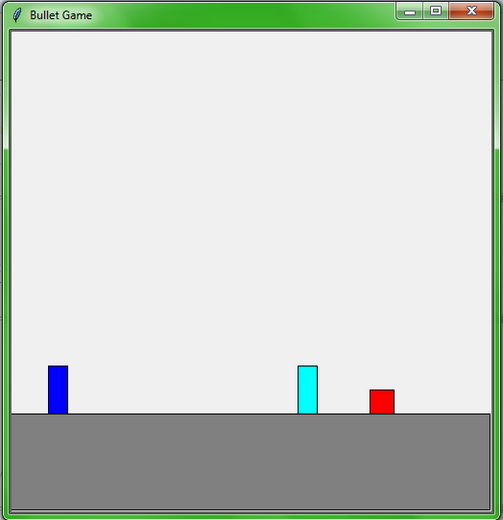

The endpoint

The enemy

The user’s character

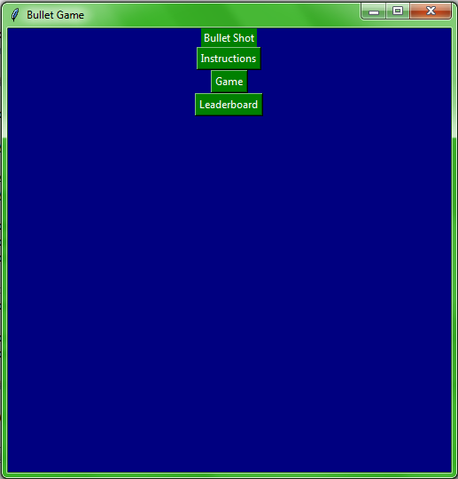

These are the buttons for the leaderboard and is the menu

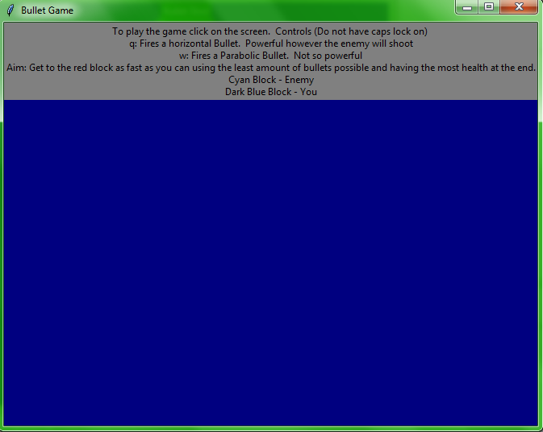

This is the instruction screen

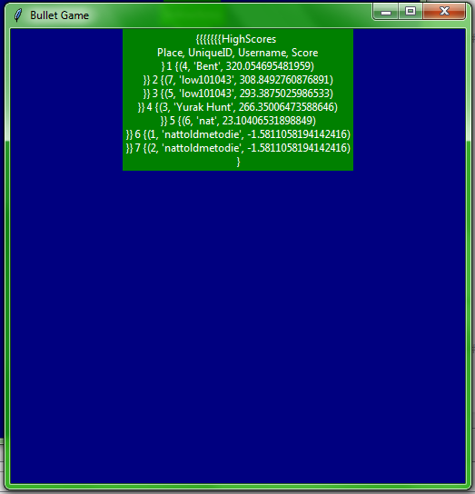

This is the leaderboard. (There is not the names which were required as I have overwritten the database). As you can see the scores are in order from highest to lowest

### Provided annotated evidence for usability testing.

|  |  |  |  |  |
| --- | --- | --- | --- | --- |
| Usability Feature | Explanation | Justification | Output | Notes |
| Different colours for the different objects | All the different objects made will be different colours. | This is done to make the user able to see what is what and also so that the user knows what is the enemy, your character and the bullet | Colours which can be seen by one of my stakeholders | See video1 and video2. See Screenshot 2 |
| High contrast colours | All the different colours will be very different | This makes it easier for mildly colour blind users see the level | Colours which can be seen by one of my stakeholders | See video1 and video2 and screenshot 1 |
| Instructions | There will be a choice for the instructions to make it easier for the user to know what is happening. | Means the user can know what is happening and helps the user understand how to play the game. | TRUE | See video1 Start. See Screenshot 3 |
| The buttons are close to each other. | This means that I am using buttons which are close to each other so q and w for shooting | This makes it easier for people who cannot move that much meaning they can still play the game | TRUE All keys are near to each other as all the user will use is w,q and the arrow keys |  |

Screenshot 1

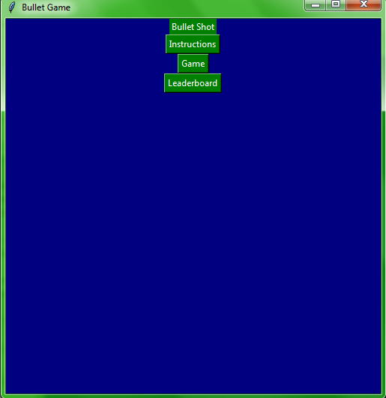

The green buttons are different enough so you can see them

This uses both blue and green and is used for all screens (apart from the game)

Screenshot 2

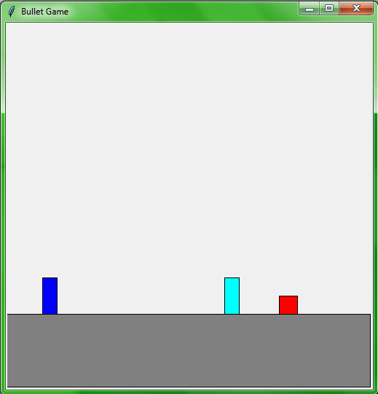

The red endpoint. All the colours are different enough to make it easy to see what you are doing

Cyan Colour for the enemy

Blue Character for user

Grey floor

These colours for the objects on the screen have been used as they are all different enough that users can differentiate between them

Screenshot 3

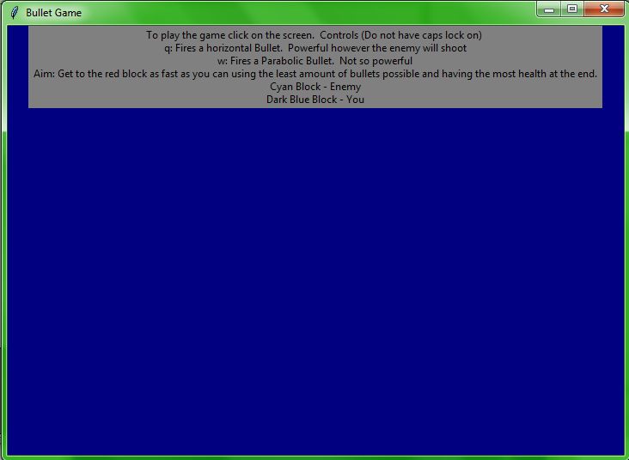

Text box for the instructions so it is easy to see and you can instantly see it

This is the instructions screen which the user can see. It specifies what each button does and the aim. One problem is that the instructions are slightly too large for the 500 x 500 pixels screen.

### Beta Testing

After my testing, I also allowed my stakeholders and other classmates to play the game as ‘beta’ testing. I then have recorded some of their reactions to the game.

One Stakeholder (Ben Lowis) commented how he did not like the game because of the graphics thus not making it look professional. He commented that it does not look good compared to games like Fortnite or even games you could find on websites like Coolmaths Games.

Quite a few people mentioned that the leader board was messy and did not look very good. I believe this will be from how I got the data out of the database, thus each record came in its own tuple.

Cameron mentioned that the game was fun and served its purpose. As a fellow classmate in Computer Science, he was impressed (along with the rest of my classmates) by how the game was written purely in Python and not using any game engine.

Finally all my testers said that the game was fun and enjoyable should be better by having more bullets, enemies, difficulty and graphics!

## Use the test evidence to cross reference with the success criteria to evaluate the solution explain how the evidence shows that the criteria has been fully, partially or not met in each case.

### Success Criteria

|  |  |  |  |
| --- | --- | --- | --- |
| Statement | Justification | Met | Comment |
| The program will work. The player will be able to play a game which is realistic and is a shooting 2D platform game with an enemy which you need to defeat in it. The program will be robust enough to not break if a wrong input is entered. | I do not want there to be any game breaking bugs or glitches so I will want to have caught them before I finished. I want the game to be finished and that the user feels that it is polished and finished. | Partially (Test Number: 1) | The program does work however you can spam the bullets and also cannot go to a different screen from the menu twice (Apart from instructions) because how I am calling the files. Also the program does not delete the window which you have just left |
| The program will allow the user to move the character side to side and also to jump. | Again self-explanatory. The user will only be able to use one character and this will be the way to actually interact with the level. | Met (Test Number: 2, 3, 4) | The character can move left, right and jump (Though jumping does stop everything else!) |
| The program will have an enemy | This is so there is some difficulty in the game. | Met (Test Number: 5) | There is an enemy which you have to defeat |
| The program will end when the user’s character reaches an endpoint. | This means the level will end at one point and will not go on forever. | Met (Test Number: 6) | The game will end when you reach the point |
| The program will detect when the bullet hits either a character or the wall. | This will make the bullet more realistic and also mean the bullet does not go for infinity. | Met (Test Number: 8, 9, 10) | There is no walls to hit. Might not always notice the enemy on the parabolic bullet |
| The program will take away health from a character when a bullet hits it using the power equation. | This makes it realistic and also means you can destroy the enemy/character. | Met (Test Number: 11, 12, 13) | This all works |
| The program will make the bullet go the correct distance using SUVAT. | This make the game realistic | Met (Test Number 14, 15, 16) | All works |
| The program will have two bullets a parabolic one and a horizontal one. | This allows the user to have more than one weapon | Met (Test Number: 17) | This works |
| The program will allow the user to change which bullet to use | This means they can use both bullets. | Partially (Test Number: 7) | How I initially planned that you would use the same button did not happen however now the user just have to press one of two buttons |
| The program will take away bullets from the total amount of bullets when one is fired | This makes it more difficult to the user and gives the game a level of difficulty. | Met (Test Number: 18, 19) | This works however both bullets take off the same amount of bullets instead of different amounts |
| The program will have a timer which allows it to work out how long the user has taken. | This is to be used in the total points and allows the user to try and make it quicker | Met (Test Number: 20) | This works (Might not work on another OS from windows as the time library is different for different Operating Systems |
| The program will work out a total. | This is to give a point for the game | Met (Test Number: 21) | Works |
| The program will allow the user to see how well they have done | This will allow the user to see how well they have done | Met (Test Number: 22) | This works |
| The program will put the score in a database | This is so the user can see how they compare to other people. | Met (Test Number: 24) | This works |
| The program will have a database of highscores | This is so all scores can be entered and also so the user can see how well they are doing. | Met (Test Number: 23) | This works |
| The program will allow the user to enter a username. | This is so it can go into the database along with their score. | Met (Test Number: 25) | This works |
| The program will allow the user to choose whether to see the highscores or to play the game | This will be a menu and allow the user to see different bits. | Met (Test Number: 27) | Also can see the instructions |
| The program will display a table of highscores. | This allows the user to see how well they are doing. | Met (Test Number: 28) | Works |
| The program will make sure all characters are on the ground when jumping. | This will then make sure it looks realistic and also means you can see how high they are. | Met (Test Number: 29) | This works. However you can spam the jump button to stay above bullet (Intentional) and stop all bullets |
| The program will end if the user’s character hits 0. | This is so there is a risk if you are hit by a bullet | Met (Test Number: 30) | This works |
| The program will have a bullet being shot by the enemy every 5 seconds | This is so there is a continuous risk to the user. | Not Met (Test Number: 31) | This was changed to shooting a bullet whenever the user fires a horizontal bullet. This change was made because of how for anything to happen, it requires a user input. |
| The program will allow any characters in the username | This means it’s easy for the user to have any name | Met (Test Number: 32) | This works |
| The program will only allow usernames which no one else has used before. | This is so it is easy for the User to see their score in the database | Not Met (Test Number: 26) | I could not program this to work. Instead have a unique number for each user |
| The program will have an instructions screen | This will allow the user to know how to play the game | Met (Test Number: 33) | Instructions could always be expanded |
| The program will have a menu | Allows the user to go to different parts of the program | Met (Test Number: 34) | This works |
| The program will have a leaderboard screen | This will allow the user to see the current best scores | Met (Test Number: 35) | However the leaderboard is messy with curly brackets |
| The program will output the leaderboard from the largest score (Best) to the smallest score (worst) | This will make it easy for the user to see the best and worst scores | Met (Test Number: 36) | This works |
| The program will take away health if the user’s character touches the enemy | This means there is some danger to touching the enemy and means you cannot just run straight to the endpoint | Met (Test Number: 37) | This works |
| The game will do nothing if you press buttons which are not q,w or the arrow keys. | This means the game cannot break if you enter an accidental input. | Met (Test Number: 38) | Works |

## Provide comments on how any partially or unmet criteria could be addressed in further development.

|  |  |  |  |
| --- | --- | --- | --- |
| The program will have a bullet being shot by the enemy every 5 seconds | This is so there is a continuous risk to the user. | Not Met (Test Number: 31) | This was changed to shooting a bullet whenever the user fires a horizontal bullet. This change was made because of how for anything to happen, it requires a user input. |

This could be changed in further development to try and get a bullet shooting every 5 seconds. I did not do this in my development as it would slow the game even more than it does. Maybe using a different language which is not Python as Python is not very good with using different threads. Using an actual game engine might also help with this (Mentioned later)

|  |  |  |  |
| --- | --- | --- | --- |
| The program will only allow usernames which no one else has used before. | This is so it is easy for the User to see their score in the database | Not Met (Test Number: 26) | I could not program this to work. Instead have a unique number for each user |

To do this I would have to be able to get better at SQLite3. My inexperience with it meant I could not get the username out in the correct format to look at. How I have it at the moment (Using a unique number), I would keep but I would see if I could get unique usernames as well.

|  |  |  |  |
| --- | --- | --- | --- |
| The program will work. The player will be able to play a game which is realistic and is a shooting 2D platform game with an enemy which you need to defeat in it. The program will be robust enough to not break if a wrong input is entered. | I do not want there to be any game breaking bugs or glitches so I will want to have caught them before I finished. I want the game to be finished and that the user feels that it is polished and finished. | Partially (Test Number: 1) | The program does work however you can spam the bullets and also cannot go to a different screen from the menu twice (Apart from instructions) because how I am calling the files. Also the program does not delete the window which you have just left |

This is down to the time I had to program the code and how easy it is to get small bugs into my code. To improve, I would need more time to iron out some of the bugs. However, none was too game-breaking and the game still works at all times even if you enter a wrong input.

|  |  |  |  |
| --- | --- | --- | --- |
| The program will allow the user to change which bullet to use | This means they can use both bullets. | Partially (Test Number: 7) | How I initially planned that you would use the same button did not happen however now the user just have to press one of two buttons |

My actual solution to this problem is better than using the same button with it switching with another as it is faster for the user to use two different buttons.

## Provide evidence of the usability features justifying their success, partial success or failure as effective usability features.

The evidence is in the section of ‘Providing annotated evidence for usablilty testing’

|  |  |  |  |  |
| --- | --- | --- | --- | --- |
| Usability Feature | Explanation | Justification | Output | Justifying success or not as effective usability features |
| Different colours for the different objects | All the different objects made will be different colours. | This is done to make the user able to see what is what and also so that the user knows what is the enemy, your character and the bullet | Colours which can be seen by one of my stakeholders | This was a success as all the colours could be seen but all were different enough that anyone could |
| High contrast colours | All the different colours will be very different | This makes it easier for mildly colour blind users see the level | Colours which can be seen by one of my stakeholders | Success as one of my stakeholders could see the different colours in both the menus and game |
| Instructions | There will be a choice for the instructions to make it easier for the user to know what is happening. | Means the user can know what is happening and helps the user understand how to play the game. | TRUE | This is a partial success. Could see it but probably not detailed enough |
| The buttons are close to each other. | This means that I am using buttons which are close to each other so q and w for shooting | This makes it easier for people who cannot move that much meaning they can still play the game | TRUE All keys are near to each other as all the user will use is w,q and the arrow keys | Success. All buttons are either in top left of keyboard (q, w) or the arrow keys |

## Provided comments on how any issues with partially or unmet usability features could be addressed in further development.

|  |  |  |  |
| --- | --- | --- | --- |
| Usability Feature | Explanation | Justification | How to improve |
| High contrast colours | All the different colours will be very different | This makes it easier for mildly colour blind users see the level | Maybe make the colours a bit more vivid and use colours with more association (So red for enemy, grey for the bullet) to make it easier for the user |
| Instructions | There will be a choice for the instructions to make it easier for the user to know what is happening. | Means the user can know what is happening and helps the user understand how to play the game. | To improve this I could use the colours in the game to tell which character is which (So red for enemy as red equals bad). Also probably mention more of the complex parts of my project (So you can move whilst jumping) |
| The buttons are close to each other. | This means that I am using buttons which are close to each other so q and w for shooting | This makes it easier for people who cannot move that much meaning they can still play the game | The problem with this is that on a larger keyboard you lose a lot of the accessibility you had |

## Considered maintenance issues and limitations of the solution.

### Maintenance

* The length of the code – This is a problem. As the code is over 1200 lines over 4 or 5 different files maintaining the code will be a nightmare. One change can trickle down the whole program.
* My use of global variables – I have used too many global variables than reasonable. The main reason for this is because of how Tkinter works and that it is very hard to send some variables to the right function when you press a button. To improve this I would consider using a different GUI (More on this later)
* The ‘flow’ of the code – The code does not run that smoothly. This is easiest to see when firing a bullet (There are 3 functions/methods for each bullet to be shot) meaning it is quite hard to see where the code should go. This will make it hard to maintain as you might not entirely know where to go
* How I import my own files – How I decided to import files is completely awful! When I import a file it runs the whole code making it hard for the next programmer to know entirely where the code goes next.
* Later updates – If Tkinter is updated and you lose some of the commands it would mean that the whole code might not work. As well, if you try and update the code to a later version of Python you might find it hard if Python or Tkinter has been significantly changed. Finally, you would have to test the code on all different OS systems you use just in case Tkinter or Python does not work on it.

### Limitations

* Length of code – Again this is a problem. At 900 lines my largest program make Thonny very slow. This means that it will take a while to actually program and hard for it to be completely readable
* Python and Tkinter – The limitation here is that Tkinter cannot produce very good looking graphics (Blocks do not look very good) and that Python has no way to do threading. It has meant that I could not get the enemy character to fire a bullet as it would have meant the user could not do anything. To improve this I should have used PyGame or an actual game engine
* Threading – As there is no threading in my game it means whenever there is an user input it will stop all other things on the screen (Most notable when you shoot 2 bullets – One of them stops).
* How hard the game is – If you know how to beat the game (IE when you jump it will stop the enemy bullet and you can go over it, Get close to the enemy and spam the parabolic bullets will kill it quickly) makes the game incredibly easy. I might want more than one enemy
* Parabolic arc – As I did the SUVAT equations using time as a constant it has meant that the parabolic arc is very hard to use. As it will barely hit the enemy you either need to be right next to the enemy or in the perfect spot to be able to use it. I would need to improve this next time.
* Importing my own files – When I wanted to use code from another file which I have written I import it meaning it starts as soon as imported. This then means once imported once you could not use it again (So could not play two games when you run the program once)

## Describe how the program could be developed to deal with limitations and potential improvements / changes.

A lot of my problems with the program, is down to the language I have used and also not using a game engine. Even using something like PyGame would have improved the game hugely as this will allow me to have better graphics and would probably help with the bullets moving. However, using a game engine would help even more. The reason I did not use it was because of the physics engine which I might accidently use, however the benefits of using a collision detector would outweigh the negatives. Also I could then use more realistic physics as the engine would be able to do the maths more easily. It might also mean I would not have to have different files with different code

Another problem was how my bullet classes were written. As I did not know how to override the constructor method the parent class Bullet has all the attributes. As I know how to override the constructor class now I would not have all attributes in the parent class and have it more specific.

Another thing I would improve on would be my database. At the moment when outputted there are loads of curly brackets which I would try and take out and also I would try and get the user to have a unique username instead of a unique ID. As it was an idea I was unsure I would have enough time to program, I am happy enough of how it ended. As well, as it was not in the ‘main’ part of the project (the Game), it did not have any usability feature testing. This would be an immediate change if I was going to improve the project.

If I kept on using Tkinter I would do more research to learn how to delete windows when you go onto a new window. This would make it look more professional. I would also learn how to make Tkinter look less like there were just batch colours and more professional.

Another huge improvement would be how I do the importing of different files. As mentioned in my limitations you can only import a file once, meaning you can only run the game once when you run the program. This yet again would be something I would like to change by looking to have all the code in one file or to improve how a the program calls a different file.

Another problem was how I wrote my code. A lot of my code basically is just reusing different parts just changing it ever so slightly. There is also repeated code. To improve this I would put a few more into their own functions/procedures and also see if I could generalise a few more functions (Certainly the horizontal bullets for the enemy and hero). This would then mean less code and easier code to check. TALK ABOUT REFACTOR CODE

Another problem is how the code is written. If I were to improve the code I would refactor it by combining the functions which fire the horizontal bullets for the user and the enemy by making it more general. This is so it is smaller and easier to read through.

Another thing I would improve on would be trying to find a better GUI than Tkinter. As I am using Tkinter, I have a lot of limitations with me having to have a lot of ‘try except’ statements (which do not help the flow of the code) and global variables (Which are hard to use to know what is global and what is not). If I could use a better GUI (like if it comes prepackaged with a game engine/physics engine) that would help as it means the code is easier to read. Another problem from my inexperience with Tkinter was that the user has to manually shut down a screen even if it should be completely deleted already. This would be something I would try to improve to make it easier for the user to run the game.

# Final Code

**adding_To_Database.py**

from tkinter import * #These commands will import external libraries which are needed for this file . Tkinter - GUI

import sqlite3 #See above . sqlite3 - Database

import csv #See above csv -holds score from other file

######################################################################################################################################################################################################################################

def checker():

"""Made By Nathaniel Lowis First Edit: 17/10/18 Latest Edit: 18/10/18

Inputs - None

Outputs - largest ID (Integer)

This will work out what the latest Unique ID is in the Database"""

connNew = sqlite3.connect("highscores.db") #This will connect to the database and set it up

curser = connNew.cursor()

largest = 0 #This will be the largest unique ID we have

curser.execute('SELECT UniqueID FROM Highscores') #gets all the Primary keys from the table (Will be in a list of tuples)

uniqueID = curser.fetchall() #Lets me use the primary keys

for idRecord in uniqueID: #Checks every primary key

if idRecord[0] > largest: #If the primary key is larger than the largest at the moment

largest = idRecord[0] #We will get largest to equal it

connNew.close() #Shuts the database

return largest #Returns it to the main program

#print(curser.fetchall()) #Testing

######################################################################################################################################################################################################################################

def username_Entering():

"""Made By Nathaniel Lowis. First Edit: 17/10/18 Latest Edit: 18/10/18

Inputs - None (Do get score (Float) and username (string) from csv file and gui though)

Outputs - None

This will allow the username to be entered and for the score to be taken out of the csv file and added to the database"""

#finalScore = 5

with open("Scores.csv", mode= "rt", encoding = "utf-8") as readingScores: #Opens the csv file as a reader

reader = csv.reader(readingScores) #Sets up a reader

for recordToBeRead in reader: #Checks all records in the csv file (should only be 1)

if recordToBeRead == []: #If the record is empty (EG the 2nd one) the code should do nothing

pass

else: #If the record has something in it

finalScoreDatabaseFile = recordToBeRead[0] #We allow the program to access it so it can be used

username = addingUserName.get() #This will get the username from the screen

uniqueIDFunction = checker() #This will get the largest uniqueID so far in the database

newID = uniqueIDFunction + 1 #This will add 1 to the last UniqueID to make the primary key for the code

labelChange.configure(text = "Your score is being added to the database. Your score was {}".format(finalScoreDatabaseFile)) #This will output the score and saying everything is being added to the database

adding_To_Database(newID, username, finalScoreDatabaseFile) #Adds everything to the database

######################################################################################################################################################################################################################################

def adding_To_Database(uniqueIDToUse, usernameToAdd, scores):

"""Made By Nathaniel Lowis First Edit: 18/10/18 Latest Edit: 18/10/18

Inputs - uniqueIDToUse (Integer), usernameToAdd (string), scores (Float)

Outputs - None

This will add the user's username and score to the database"""

connectionNew = sqlite3.connect("highscores.db") #Opens the database and sets it up to be used

curserNew = connectionNew.cursor()

toAdd = [(uniqueIDToUse, usernameToAdd, scores)] #This is all the data to be added to the database in a way which the database will allow

curserNew.executemany('INSERT INTO Highscores VALUES (?,?, ?)', toAdd) #Adds the data into the database. Done like this so it adds everything using variable names

connectionNew.commit() #Commits (Saves) it to the database

connectionNew.close() #Closes the database

######################################################################################################################################################################################################################################

#main

databaseScreen = Tk() #Makes a screen

databaseScreen.title("Bullet Game") #The name of the screen

databaseScreen.geometry("500x500") #The size

#menu.wm_iconbitmap("favicon.ico") #If I wanted to change the image for the file

databaseScreen.configure(background = ("navy")) #Sets the background

addingUserName = Entry(databaseScreen) #Adds an entry which the user will enter their username

addingUserName.pack() #Sends to the screen

labelChange = Label(databaseScreen, text = "Enter username", bg = "green", fg = "white") #Sets a label which will say what is going on

labelChange.pack() #Sends to the screen

buttonAskingForUserName = Button(databaseScreen, text = "Enter Username!", bg = "green", fg = "white", command = username_Entering) #The button which will send the username off

buttonAskingForUserName.pack() #Sends to the screen

databaseScreen.mainloop() #Infinite loop needed to allow GUI to work.

**database_Creator.py**

import sqlite3 #Imports an external library which will allow me to work with databases

######################################################################################################################################################################################################################################

def create_Table(name):

"""Made By Nathaniel Lowis. Edited from: https://repl.it/@NathanielLowis/Database-in-python First Edit: 17/10/18. Latest Edit: 18/10/18

Inputs - Name of the filename (String)

Outputs - None

This will set up a database"""

connection = sqlite3.connect(name) #Connects to a database and allow you to edit it

cursor = connection.cursor()

cursor.execute('CREATE TABLE Highscores ("UniqueID" integer,"UserName" text, "Score" real)') #This will make all the columns for the database

connection.commit() #Saves it and closes the database

connection.close()

######################################################################################################################################################################################################################################

#main

create_Table("highscores.db") #This creates a database

**displaying_Database.py**

import sqlite3 #Imports all the libraries needed for this file

from tkinter import * #Imports everything from the library Tkinter

######################################################################################################################################################################################################################################

def display_Database():

"""Made By Nathaniel Lowis Edited from: https://repl.it/@NathanielLowis/Database-in-python 1st Edit: 18/10/18. Latest Edit: 18/10/18

Inputs - None

Outputs - A sorted table of highscores (list of tuples)

Gets data from database and sorts it and sends it to the main program"""

connectionDisplay = sqlite3.connect("highscores.db") #Connects to the database and sets it up to be accessed

cursorDisplay = connectionDisplay.cursor()

cursorDisplay.execute('SELECT * FROM Highscores') #This will get all records from the database

table = cursorDisplay.fetchall() #Allows the program to access it

sortedTable = quick_Sort(table) #This will sort out the database

connectionDisplay.close() #Closes the database

return(sortedTable) #Returns the sorted database to the main program

######################################################################################################################################################################################################################################

def quick_Sort(dataArray):

"""Made By Nathaniel Lowis Edited from: https://repl.it/@NathanielLowis/Quick-Sort First Edit: 18/10/18 Latest Edit: 18/10/18

Inputs - dataArray (List of tuples)

Outputs - dataArray (List of tuples)

Sorts the data out on order of the scores."""

#print("running quick sort\n")

if len(dataArray) == 1 or len(dataArray) == 0: # base case for the recursive call

return dataArray

else:

pivot = dataArray[0][2] # using first value as the pivot value

i = 0

for j in range(len(dataArray)-1): # rearranging values around pivot

if dataArray[j+1][2] > pivot:

dataArray[j+1],dataArray[i+1] = dataArray[i+1], dataArray[j+1]

i = i + 1

dataArray[0],dataArray[i] = dataArray[i],dataArray[0]

#print("dataArray sorted either side of pivot", dataArray,"pivot", pivot)

first_part = quick_Sort(dataArray[:i]) # recursive calls on either side of pivot

second_part = quick_Sort(dataArray[i+1:])

first_part.append(dataArray[i]) # put pivot in correct position

#print("first part",first_part, "second part", second_part,"dataArray", dataArray)

return first_part + second_part

######################################################################################################################################################################################################################################

def make_Text():

"""Made By Nathaniel Lowis 1st Edit: 18/10/18 Latest Edit: 18/10/18

Inputs - None

Outputs - Text to display (String)

This creates the table needed to be displayed"""

tableToDisplay = display_Database() #Gets the database table

tableDisplay = "HighScores \n Place, UniqueID, Username, Score \n" #What the user will see

place = 0 #The posistion in the table#

for recordToDisplay in tableToDisplay: #Takes each record in the array

place = place + 1 #Increments place to the correct position

placeString = str(place) #Turns it into a string

recordToDisplayStr = str(recordToDisplay) #Turns the tuple into a string so it can be added to the final string

tableDisplay = tableDisplay, placeString, recordToDisplayStr + "\n" #Adds all the data to the main table so all the scores will be on it

return tableDisplay

######################################################################################################################################################################################################################################

#main

databaseShowScreen = Tk() #Makes Window

databaseShowScreen.title("Bullet Game") #Names Window

databaseShowScreen.geometry("500x500") #The size of the window

#window.wm_iconbitmap("favicon.ico")

databaseShowScreen.configure(background = ("navy")) #The background colour

displayTable = make_Text() #Makes the table to be displayed

labelWithTable = Label(databaseShowScreen, text = displayTable, bg = "green", fg = "white") #Adds the label with the scores on it

labelWithTable.pack() #Packs label to screen

databaseShowScreen.mainloop() #Infinite loop

**final_Game_File.py**

# Main Game

from tkinter import * #This means I can use Tkinter

#import gamePrototype4

######################################################################################################################################################################################################################################

def instructions():

"""Made By Nathaniel Lowis. 1st Edit: 17/10/18. Latest Edit: 17/10/18

Inputs - None

Outputs - None

Displays the instructions for how to play the game"""

instructionScreen = Tk() #Makes a window

instructionScreen.title("Bullet Game") #Name of the window

instructionScreen.geometry("500x500") #Size of the window

#menu.wm_iconbitmap("favicon.ico")

instructionScreen.configure(background = ("navy")) #Background of the window

instructionsToDo= Label(instructionScreen, text = "To play the game click on the screen. Controls (Do not have caps lock on) \n q: Fires a horizontal Bullet. Powerful however the enemy will shoot \n w: Fires a Parabolic Bullet. Not so powerful \n Aim: Get to the red block as fast as you can using the least amount of bullets possible and having the most health at the end. \nCyan Block - Enemy\nDark Blue Block - You", bg = "grey", fg = "black") #This will output all the instructions onto the window so the user can see how to play the game

instructionsToDo.pack() #Sends the label to the screen

######################################################################################################################################################################################################################################

def play_Game():

"""Made By Nathaniel Lowis 1st Edit: 17/10/18 Latest Edit: 17/10/18

Inputs - None

Outputs - None

Plays the game"""

import main_Game #Goes to file named gamePrototype4 and runs it. This will run the game

#exec(open("gamePrototype4.py").read()) #Testing

######################################################################################################################################################################################################################################

def database_To_Display():

"""Made By Nathaniel Lowis 1st Edit: 18/10/18 Latest Edit: 18/10/18

Inputs - None

Outputs - None

Will go to the file which ouputs the leaderboard"""

import displaying_Database #Goes to file called displaying_Database and runs the code

######################################################################################################################################################################################################################################

#main

window = Tk() #Makes a window for the GUI

window.title("Bullet Game") #Names the window

window.geometry("500x500") #The size of the window

#window.wm_iconbitmap("favicon.ico")

window.configure(background = ("navy")) #Sets the background colour

labelWelcome =Label(window, text = "Bullet Shot", bg = "green", fg = "white") #This is the welcome label saying the name of the game (Bullet Shot)

labelWelcome.pack() #Sends it to the main screen

buttonInstructions = Button(window, text = "Instructions", bg = "green", fg = "white", command = instructions ) #This is the button to Go to the instructions

buttonInstructions.pack() #Sends button to window

buttonGame = Button(window, text = "Game", bg = "green", fg = "white", command = play_Game) #This is the button to play the game

buttonGame.pack() #Sends button to the screen

buttonLeaderboard = Button(window, text = "Leaderboard", bg = "green", fg = "white", command = database_To_Display) #This is the button to go to the leaderboard

buttonLeaderboard.pack() #Sends button to the screen

window.mainloop() #Infinte loop.

**main_Game.py**

from tkinter import * #This means I can use Tkinter

import time #Allows me to use time and measure how long bullets

import csv #This allows me to use the library csv

######################################################################################################################################################################################################################################

class BulletsShot():

"""Made by Nathaniel Lowis 1st Edit: 17/10/18 Latest Edit:17/10/18

This will work out how many bullets you have in a game"""

######################################################################################################################################################################################################################################

def __init__(self):

"""Made by Nathaniel Lowis 1st Edit: 17/9/18 Latest Edit: 17/10/18

Inputs - None

Outputs - None

Sets up the class"""

self.howManyShot = 10 #How many shots the person will have

######################################################################################################################################################################################################################################

def bullets_Sub(self):

"""Made by Nathaniel Lowis 1st Edit: 17/9/18 Latest Edit: 17/10/18

Inputs - amount of bullets left (Integer)

Outputs - None

Takes bullets off when you shoot one"""

self.howManyShot = self.howManyShot - 1 #Will take away a bullet when you shoot one

######################################################################################################################################################################################################################################

def bullets_Show(self):

"""Made by Nathaniel Lowis 1st Edit: 17/9/18 Latest Edit: 17/10/18

Inputs - None

Outputs - How many bullets you have (integer)

Shows how many bullets you have"""

return self.howManyShot #Returns how many bullets you have to the main program

######################################################################################################################################################################################################################################

######################################################################################################################################################################################################################################

class Bullet():

"""Made by Nathaniel Lowis 1st Edit: 10/9/18 Latest Edit: 3/10/18

This is the superclass which will allow me to model how the bullet moves and output it to the screen. Parts of code has been adapted from:https://stackoverflow.com/questions/25430786/moving-balls-in-tkinter-canvas

"""

######################################################################################################################################################################################################################################

def __init__(self, x1BulletGiven, y1BulletGiven, x2BulletGiven, y2BulletGiven, canvasToUse):

"""Made by Nathaniel Lowis 1st Edit: 10/9/18 Latest Edit: 3/10/18

Inputs - the canvas (Tkinter Object), coordinates (Integers)

Outputs - None

Sets up the class when intialised"""

self.intialSpeedHori = 50.0 #These will set up the intial speed, acceleration for use in the rest of the code for both the Parabolic bullet and Horizontal Bullet

self.intialSpeedHoriPara = 50.0

self.finalSpeedHori = 0.0

self.finalSpeedVertical = 50.0

self.finalSpeed = 0.0

self.distanceHori = 0.0

self.distanceVertical = 0.0

self.horizontalAcceleration = 30.0

self.verticalAccelerationUp = -9.81

self.verticalAccelerationDown = 9.81

self.x1Bullet = x1BulletGiven #This 4 co-ordinates are where each corner should be placed

self.y1Bullet = y1BulletGiven

self.x2Bullet = x2BulletGiven

self.y2Bullet = y2BulletGiven

self.canvasBullet = canvasToUse #Sets up the code

self.ball = canvasToUse.create_oval(self.x1Bullet, self.y1Bullet, self.x2Bullet, self.y2Bullet, fill="green") #Outputs to screen

self.time = 5 #More constants made.

self.mass = 0.008

self.energy = 0.0

######################################################################################################################################################################################################################################

def delete_Bullet(self):

"""Made by Nathaniel Lowis 1st Edit: 12/9/18 Latest Edit: 12/9/18

Inputs - The class

Outputs - Deletes the bullet from the screen

Deletes the bullet from the screen"""

self.canvasBullet.delete(self.ball) #Deletes bullet

######################################################################################################################################################################################################################################

def energy_In_Bullet(self):

"""Made by Nathaniel Lowis 1st Edit: 12/9/18 Latest Edit: 12/9/18

Inputs - Class

Outputs - The energy of the bullet (float)

Works out the amount of energy in the bullet"""

self.energy = .5 * self.mass * ( self.finalSpeed ** 2) #Uses E = 1/2 mv^2

##print(self.energy) #testing

######################################################################################################################################################################################################################################

def power_At_Point(self, timeTaken):

"""Made by Nathaniel Lowis 1st Edit: 12/9/18 Latest Edit: 12/9/18

Inputs - Time (float), class

Outputs - The amount of power from the bullet (float)

Works out the amount of power in the bullet"""

power = self.energy / timeTaken #Uses p = E/t

##print(power) #Testing

return power

######################################################################################################################################################################################################################################

def coord_Bullet(self):

"""Made by Nathaniel Lowis 1st Edit: 31/8/18. Latest Edit: 12/9/18

Inputs - The class

Outputs - Where the bullet is (Array of floats)

This will show where the bullet is"""

coordinatesBullet = self.canvasBullet.coords(self.ball) #This gives the coordinates for the bullet

return coordinatesBullet #Returns it to the main program

######################################################################################################################################################################################################################################

######################################################################################################################################################################################################################################

class HoriBullet(Bullet):

"""Made by Nathaniel Lowis 1st Edit: 10/9/18 Latest Edit: 12/9/18

This is a subclass of bullet which calculates and output it to the screen."""

######################################################################################################################################################################################################################################

def speed_At_Any_Point(self, distanceGone):

"""Made by Nathaniel Lowis 1st Edit: 12/9/18 Latest Edit: 12/9/18

Inputs - Distance Gone (Float), class

Outputs - The final speed of bullet (Float)

This works out the final speed of the bullet"""

self.finalSpeedHori = ((self.intialSpeedHori ** 2) + (2 * self.horizontalAcceleration * distanceGone) )** .5 #Uses V^2 = u^2 + (2as)

##print(self.FinalSpeed) #Testing

self.finalSpeed = self.finalSpeedHori #This means the program can use it later

return self.finalSpeed #Returns the speed

######################################################################################################################################################################################################################################

def move_Bullet_Hori(self, xMovement):

"""Made by Nathaniel Lowis 1st Edit: 10/9/18 Latest Edit: 12/9/18

Input - How much to move by (Float)

Output - Moving on the screen (Tkinter Object)

This will move the bullet on the screen"""

self.canvasBullet.move(self.ball, xMovement, 0) #Moves the bullet

self.canvasBullet.after(100) #Waits 100 ms until it updates screen

self.canvasBullet.update() #Updates the screen

######################################################################################################################################################################################################################################

def distance_To_Work_Out(self):

"""Made by Nathaniel Lowis 1st Edit: 10/9/18 Latest Edit: 12/9/18

Inputs - class

Outputs - The distance to go (Float)

This will work out how far the bullet has to go"""

self.distanceHori = (self.intialSpeedHori * self.time) + (.5 * self.horizontalAcceleration *(self.time **2)) #Uses S = ut + 1/2at^2

return self.distanceHori

######################################################################################################################################################################################################################################

######################################################################################################################################################################################################################################

class ParabolicBullet(Bullet):

"""Made by Nathaniel Lowis 1st Edit: 26/9/18 Latest Edit: 26/9/18

This is a subclass of Bullet which works out the stuff for a parabolic Bullet"""

######################################################################################################################################################################################################################################

def distance_Worker_Up(self):

"""Made by Nathaniel Lowis 1st Edit: 26/9/18 Latest Edit: 26/9/18

Inputs - Class

Outputs - Vertical Distance (Float), Horizontal Distance (Float)

This will work out how far the bullet will have to move when the bullet moves upwards"""

self.distanceVertical = (-.5 * self.verticalAccelerationUp * (self.time /2)**2) # Uses S = vt - (1/2)at^2

self.distanceHori = (self.intialSpeedHoriPara * (self.time /2)) #Uses S = ut

##print(self.distanceVertical, self.distanceHori) #Testing

return self.distanceVertical, self.distanceHori

######################################################################################################################################################################################################################################

def distance_Worker_Down(self):

"""Made by Nathaniel Lowis 1st Edit: 26/9/18 Latest Edit: 26/9/18

Inputs - Class

Outputs - Vertical Distance (Float), Horizontal Distance (Float)

This will work out how far the bullet will have to move when the bullet moves downwards"""

self.distanceVertical = (.5 * self.verticalAccelerationDown * (self.time /2)**2) #Uses S = ut + (1/2)at^2

self.distanceHori = (self.intialSpeedHoriPara * (self.time / 2)) #Uses S = ut

##print(self.distanceVertical, self.distanceHori) #testing

return self.distanceVertical, self.distanceHori

######################################################################################################################################################################################################################################

def speed_Vert_Up(self, distanceVertUp, timeTakenSoFar):

"""Made by Nathaniel Lowis 1st Edit: 26/9/18 Latest Edit: 26/9/18

Inputs - Class, Distance Gone Vertically Up (Float), time (Float)

Outputs - The final Vertical speed (Float)

This will work out the final vertical speed of the bullet when the bullet goes upwards"""

self.finalSpeedVertical = (distanceVertUp + (.5 * self.verticalAccelerationUp * (timeTakenSoFar ** 2)))/ timeTakenSoFar #Uses S = vt - .5at^2

if self.finalSpeedVertical < 0: #If the speed is worked to be less than 0 it sets the final speed to 0

self.finalSpeedVertical = 0.0

##print(self.finalSpeedVertical) #Testing

return self.finalSpeedVertical

######################################################################################################################################################################################################################################

def speed_Vert_Down(self, timeTaken):

"""Made by Nathaniel Lowis 1st Edit: 26/9/18 Latest Edit: 26/9/18

Inputs - Class, time (Float)

Outputs - Final Vertical Speed (Float)

This will work out the final vertical speed of the bullet when the bullet goes upwards"""

self.finalSpeedVertical = self.verticalAccelerationDown * timeTaken #Uses v = u + at and u is assumed to be 0

##print(self.finalSpeedVertical) #Testing

return self.finalSpeedVertical

######################################################################################################################################################################################################################################

def final_Speed_Parabolic(self):

"""Made by Nathaniel Lowis 1st Edit: 26/9/18 Latest Edit: 26/9/18

Inputs - Class

Outputs - Final Overall Speed (Float)

This uses vector working to work out the final speed of a parabolic bullet"""

self.finalSpeed = ((self.finalSpeedVertical **2) + (self.intialSpeedHoriPara **2))**.5 #Uses Pythagorous Theorem to resolve into 1 vector

##print(self.finalSpeed) #Testing

return self.finalSpeed

######################################################################################################################################################################################################################################

def move_Ball_Para_Up(self, yMovement, xMovement):

"""Made by Nathaniel Lowis 1st Edit: 26/9/18 Latest Edit: 27/9/18

Input - yMovement (Float), xMovement (Float)

Output - Moving on the screen (Tkinter Object)

Moves the bullet on the screen"""

self.canvasBullet.move(self.ball, xMovement, -yMovement) #Moves the bullet

self.canvasBullet.after(100) #Waits 100 ms until it updates screen

self.canvasBullet.update() #Updates the screen

######################################################################################################################################################################################################################################

def move_Ball_Para_Down(self, yMovement2, xMovement2):

"""Made by Nathaniel Lowis 1st Edit: 26/9/18 Latest Edit: 27/9/18

Input - How much to move by

Output - Moving on the screen

Works out how far the bullet has to be moved """

self.canvasBullet.move(self.ball, xMovement2, yMovement2) #Moves the bullet

self.canvasBullet.after(100) #Waits 100 ms until it updates screen

self.canvasBullet.update() #Updates the screen

######################################################################################################################################################################################################################################

######################################################################################################################################################################################################################################

class Character():

"""Made By Nathaniel Lowis 1st Edit: 25/08/18. Latest Edit: 17/10/18

This class will make the people on the screen and will allow the computer/user use the character"""

######################################################################################################################################################################################################################################

def __init__(self, canvasCharacter, x0Given, x1Given, y0Given, y1Given, colour):

"""Made By Nathaniel Lowis 1st Edit: 25/08/18. Latest Edit: 31/08/18

Inputs - The canvas (Tkinter Object), and coordinates (Integers)

Outputs - Character on the screen

This will initilise the character meaning it can be used"""

self.characterOnScreen = canvasCharacter.create_rectangle(x0Given, y0Given, x1Given, y1Given, fill= colour) #Creates the character

self.canvasForCharacter = canvasCharacter #Allows programmer to still use the screen

self.health = 200 #Sets the health for the character

######################################################################################################################################################################################################################################

def health_Left(self):

"""Made By Nathaniel Lowis 1st Edit: 17/10/18 Latest Edit: 17/10/18

Inputs - Class

Outputs - health (Float)

This will output the health so the program can use it for scoring"""

return self.health #Returns the health

######################################################################################################################################################################################################################################

def jump(self):

"""Made By Nathaniel Lowis 1st Edit: 25/9/18 Latest Edit: 3/10/18

Inputs - Class

Outputs - None

This will allow the character to jump and it be shown on the screen"""

height = 0 #Sets how high the character is

while height <= 50: #Whilst the character has not reached the maxiumum height (50)

self.canvasForCharacter.move(self.characterOnScreen, 0, -1)#Moves the character up

self.canvasForCharacter.update() #This will update the screen so the user can see it

self.canvasForCharacter.after(10) #Waits 10 ms until running the program. Allows the user to move here I think

height = height + 1 #Increments height by 1

downHeight = 0 #Sets how high the character Needed to get the character down

while downHeight <=50: #Whilst the charcter has not reached the floor (Need to go down 50 pixels)

self.canvasForCharacter.move(self.characterOnScreen, 0, 1)#Moves the character

self.canvasForCharacter.update() #This will update the screen so the user can see it

self.canvasForCharacter.after(10) #Waits 10ms until it does the anything

downHeight = downHeight + 1 #Increments downHeight by 1

######################################################################################################################################################################################################################################

def delete_Character(self):

"""Made by Nathaniel Lowis 1st Edit: 10/9/18 Latest Edit: 12/9/18

Input - Character Class

Outputs - Deletes the character

Deletes character if they are killed"""

self.canvasForCharacter.delete(self.characterOnScreen) #Deletes the character

######################################################################################################################################################################################################################################

def lose_Health(self, healthToLose):

"""Made by Nathaniel Lowis 1st Edit: 11/9/18 Latest Edit: 12/9/18

Inputs - The health to lose (Float)

Outputs - Health left (Float)

Makes the character lose health"""

self.health = self.health - healthToLose #Lose health

return self.health

######################################################################################################################################################################################################################################

def move_Left(self, amount):

"""Made By Nathaniel Lowis 1st Edit: 25/08/18. Latest Edit: 26/9/18

Inputs - The class

Outputs - Move the Character left

This will move the character left by 'amount' pixels"""

self.canvasForCharacter.move(self.characterOnScreen, -amount, 0)#Moves the character

self.canvasForCharacter.update() #This will update the screen so the user can see it

######################################################################################################################################################################################################################################

def move_Right(self):

"""Made By Nathaniel Lowis 1st Edit: 25/08/18. Latest Edit: 11/9/18

Inputs - The class

Outputs - Move the Character Right

This will move the character right by 2 pixels"""

self.canvasForCharacter.move(self.characterOnScreen, 2, 0) #Moves the character

self.canvasForCharacter.update() #This will update the screen so the user can see it

######################################################################################################################################################################################################################################

def coord_Player(self):

"""Made by Nathaniel Lowis 1st Edit: 31/8/18. Latest Edit: 31/8/18

Inputs - The character

Outputs - Where the character is

This will show where the character is"""

coordinatesPlayer = self.canvasForCharacter.coords(self.characterOnScreen) #This gives the coordinates for the character

return coordinatesPlayer #Returns it to the main program

######################################################################################################################################################################################################################################

def fire_Hori_Bullet_Class(self, coordinateInFireBulletHori):

"""Made by Nathaniel Lowis 1st Edit: 10/9/18 Latest Edit: 12/9/18

Inputs - Cordinates of character in an array

Outputs - Shooting bullet

This controls the bullet"""

bulletShootingHori = HoriBullet(coordinateInFireBulletHori[2], coordinateInFireBulletHori[1], coordinateInFireBulletHori[2] + 5, coordinateInFireBulletHori[1]+5, self.canvasForCharacter) #Makes an instant of the HoriBullet Class

fire_Hori_Bullet(bulletShootingHori) #Controls the bullet

bulletShootingHori.delete_Bullet() #These will delete the bullet afterwards

del(bulletShootingHori)

######################################################################################################################################################################################################################################

def fire_Hori_Bullet_Class_Enemy(self, coordinateInFireBulletHoriEne):

"""Made by Nathaniel Lowis 1st Edit: 2/10/18 Latest Edit: 2/10/18

Inputs - Cordinates of enemy character in an array

Outputs - Shooting bullet

This controls the bullet for the enemy"""

bulletShootingHoriEne = HoriBullet(coordinateInFireBulletHoriEne[2], coordinateInFireBulletHoriEne[1] + 45, coordinateInFireBulletHoriEne[2] +5 , coordinateInFireBulletHoriEne[1] + 40 , self.canvasForCharacter) #Makes an instant of the HoriBullet Class

fire_Hori_Bullet_Ene(bulletShootingHoriEne) #Controls the bullet

bulletShootingHoriEne.delete_Bullet() #These will delete the bullet afterwards

del(bulletShootingHoriEne)

######################################################################################################################################################################################################################################

def fire_Para_Bullet_Class(self, coordinateInFireBulletPara):

"""Made by Nathaniel Lowis 1st Edit: 27/9/18 Latest Edit: 28/9/18

Inputs - Cordinates of character in an array

Outputs - Shooting bullet

This controls the Parabolic bullet """

bulletShootingPara = ParabolicBullet(coordinateInFireBulletPara[2], coordinateInFireBulletPara[1], coordinateInFireBulletPara[2] + 5, coordinateInFireBulletPara[1]+5, self.canvasForCharacter) #Makes an instant of the ParabolicBullet Class

fire_Para_Bullet(bulletShootingPara) #Controls the bullet

bulletShootingPara.delete_Bullet() #These will delete the bullet afterwards

del(bulletShootingPara)

######################################################################################################################################################################################################################################

######################################################################################################################################################################################################################################

def set_Up():

"""Made by Nathaniel Lowis 1st Edit: 25/8/18 Latest Edit: 25/9/18

Inputs - None

Outputs - A working screen with the floor and endpoint and sent to main program

This sets up the level the game"""

rootSetUp = Tk() #This makes the screen

rootSetUp.title("Bullet Game") #Gives game a name

rootSetUp.resizable(True, True) #This means the usre can make it full screen

canvasSetUp = Canvas(rootSetUp, width = 500, height = 500) #Sets up the

canvasSetUp.pack() #Outputs screen

floorSetUp = canvasSetUp.create_rectangle(500, 500, 0, 400, fill="grey") #Sets up the floor

endPointSetUp = canvasSetUp.create_rectangle(375, 375, 400, 400, fill="red") #Sets up the endpoint

heroSetUp = Character(canvasSetUp, 50, 70, 350, 400, "Blue") #This will make the user's character

enemySetUp = Character(canvasSetUp, 300, 320, 350 ,400, "Cyan") #This will make the enemy class

bulletsLeftSetUp = BulletsShot()

return rootSetUp, canvasSetUp, floorSetUp, endPointSetUp, heroSetUp, enemySetUp, bulletsLeftSetUp #Sends everything back to main program.

######################################################################################################################################################################################################################################

def fire_Hori_Bullet_Ene(bulletFiringEne):

"""Made by Nathaniel Lowis 1st Edit: 2/10/18 Latests: 3/10/18

Inputs - The Class HoriBullet

Outputs - The bullet moving and interacting with the environment

This will allow the bullet to interact with the environment for the enemy bullet"""

timer1StartEne = time.time() #Starts a timer

distanceToGoEne = bulletFiringEne.distance_To_Work_Out() #Works out how far the bullet goes

#print(distanceToGoEne, "Ene Dis") #testing

distPer10MilliEne = distanceToGoEne / 50 #Divides the distance by 50 so they are all in equal chunks

bulletGoneEne = 0 #Creates a variable which works out how far the bullet has gone

timeDoneHoriBulletEne = 0 #The time for how long the bullet has gone for

while bulletGoneEne != distanceToGoEne and timeDoneHoriBulletEne < 5000: #Whilst the bullet has not gone as far as it needs to

heroCoordinatesEne = hero.coord_Player() #Gets hero's coordinates in an array

#print(heroCoordinatesEne) #Testing

bulletCoordinatesEne = bulletFiringEne.coord_Bullet() #Gets the bullets coordinates in an array

#print(bulletCoordinatesEne) #Testing

#try: #The program will go down this route when there is an enemy class #Not needed anymore

#print("TRY") #Testing

if bulletCoordinatesEne[0] <= heroCoordinatesEne[2] and bulletCoordinatesEne[2] >= heroCoordinatesEne[0] and bulletCoordinatesEne[1] <= heroCoordinatesEne[3]: #If the bullet has hit the hero

#print("HIT") #Testing

timer1FinishEne = time.time() #Stops timer

timer1Ene = timer1FinishEne - timer1StartEne #Works out length of time the bullet has gone for

##print(bulletGone) #testing

#print(timer1Ene) #testing

bulletFiringEne.speed_At_Any_Point(bulletGoneEne) #Works out the speed of the bullet

bulletFiringEne.energy_In_Bullet() #Works out the energy of the bullet

bulletPowerEne = bulletFiringEne.power_At_Point(timer1Ene) #Works out the power of the bullet

#print(bulletPowerEne, "Power") #testing

bulletGoneEne = distanceToGoEne #Means the while loop can stop

hero_Lose_Health(bulletPowerEne) #Makes the hero lose health

else:

negativeDistPer10MilliEne = distPer10MilliEne * -1 #This will allow the bullet to move towards the hero

bulletFiringEne.move_Bullet_Hori(negativeDistPer10MilliEne) #Moves the ball the amount it needs to

bulletGoneEne = bulletGoneEne + distPer10MilliEne #Added to bulletGone

timeDoneHoriBulletEne = timeDoneHoriBulletEne + 100

## except: #This is when there is no enemy #All not needed anymore

##

## print("Except")

##

## negativeDistPer10MilliEne = distPer10MilliEne * -1

## bulletFiringEne.move_ball(negativeDistPer10MilliEne) #Moves the ball the amount it needs to

## bulletGoneEne = bulletGoneEne + distPer10MilliEne #Added to BulletGone

## timeDoneHoriBulletEne = timeDoneHoriBulletEne + 100

######################################################################################################################################################################################################################################

def fire_Hori_Bullet(bulletFiring):

"""Made by Nathaniel Lowis 1st Edit: 10/9/18 Latest Edit: 12/9/18

Inputs - The Class HoriBullet

Outputs - The bullet moving and interacting with the environment

This will allow the bullet to interact with the environment"""

timer1Start = time.time() #Starts a timer

distanceToGo = bulletFiring.distance_To_Work_Out() #Works out how far the bullet goes

#print(distanceToGo, "Distance Hori") #testing

distPer10Milli = distanceToGo / 50 #Divides the distance by 50 so they are all in equal chunks

bulletGone = 0 #Creates a variable which works out how far the bullet has gone

timeDoneHoriBullet = 0 #How long the bullet has gone for

while bulletGone != distanceToGo and timeDoneHoriBullet < 5000: #Whilst the bullet has not gone as far as it needs to

enemyCoordinates = enemy.coord_Player() #Gets enemy's coordinates in an array

bulletCoordinates = bulletFiring.coord_Bullet() #Gets the bullets coordinates in an array

try: #The program will go down this route when there is an enemy class

if bulletCoordinates[0] > enemyCoordinates[0] and bulletCoordinates[1] >= enemyCoordinates[1]: #If the bullet is past the enemy

timer1Finish = time.time() #Stops timer

timer1 = timer1Finish - timer1Start #Works out length of time the bullet has gone for

##print(bulletGone) #testing

##print(timer1) #testing

bulletFiring.speed_At_Any_Point(bulletGone) #Works out the speed of the bullet

bulletFiring.energy_In_Bullet() #Works out the energy of the bullet

bulletPower = bulletFiring.power_At_Point(timer1) #Works out the power of the bullet

#print(bulletPower, "Power") #testing

bulletGone = distanceToGo #Means the while loop can stop

enemyHealth = enemy.lose_Health(bulletPower) #Makes the enemy lose health

#print(enemyHealth, "EnemyHealth") #testing

if enemyHealth <= 0: #If the enemy's health is below or equal to 0

#CULD PUT THIS IN OWN FUNCTION

enemy.delete_Character() #Deletes the enemy

else:

bulletFiring.move_Bullet_Hori(distPer10Milli) #Moves the ball the amount it needs to

bulletGone = bulletGone + distPer10Milli #Added to bulletGone

timeDoneHoriBullet = timeDoneHoriBullet + 100

except: #This is when there is no enemy

bulletFiring.move_Bullet_Hori(distPer10Milli) #Moves the bullet

bulletGone = bulletGone + distPer10Milli #Added to BulletGone

timeDoneHoriBullet = timeDoneHoriBullet + 100

######################################################################################################################################################################################################################################

def fire_Para_Bullet(bulletFiring2):

"""Made by Nathaniel Lowis 1st Edit: 27/9/18 Latest Edit: 28/9/18

Inputs - The Class ParabolicBullet

Outputs - The bullet moving and interacting with the environment

This will allow the bullet to interact with the environment"""

#This bit is for the bullet moving upwards

timer2Start = time.time() #Starts a timer

distanceToGoUp, distanceLeft = bulletFiring2.distance_Worker_Up() #Works out how far the bullet goes

#print(distanceToGoUp, distanceLeft, "Distance Para") #testing

distLeft = distanceLeft / 25 #Divides the distance by 25 so they are all in equal chunks to go left

distPer10MilliUp = distanceToGoUp / 25 #Divides the distance by 25 so they are all in equal chunksto go up

bulletGoneUp = 0 #Creates a variable which works out how far the bullet has gone

timeDoneParaBullet = 0 #This will be how long the bullet has moved for

goDown = True #This is used to say whether the bullet should go down

while bulletGoneUp != distanceToGoUp and timeDoneParaBullet < 2500: #Whilst the bullet has not gone as far as it needs to and not gone for long enough

enemyCoordinates = enemy.coord_Player() #Gets enemy's coordinates in an array

bulletCoordinates2 = bulletFiring2.coord_Bullet() #Gets the bullets coordinates in an array

try: #The program will go down this route when there is an enemy class

if bulletCoordinates2[0] > enemyCoordinates[0] and bulletCoordinates2[1] >= enemyCoordinates[1] -5 and bulletCoordinates2[0] < enemyCoordinates[2]: #If the bullet is hitting the enemy

##print("HIT UP") #Testing

timer2Finish = time.time() #Stops timer

timer2 = timer2Finish - timer2Start #Works out length of time the bullet has gone for

##print("HIT UP", timer2) #Testing

##print(bulletGone) #testing

##print(timer1) #testing

bulletFiring2.speed_Vert_Up(bulletGoneUp, timer2) #Works out the speed of the bullet going upwards

##print("Working With Speed") #Testing

bulletFiring2.final_Speed_Parabolic() #Works out the final speed for the bullet

##print("Final Speed") #Testing

bulletFiring2.energy_In_Bullet() #Works out the energy of the bullet

##print("Energy") #Testing

bulletPowerPara = bulletFiring2.power_At_Point(timer2) #Works out the power of the bullet

##print("Power") #Testing

#print(bulletPowerPara, "Para") #testing

bulletGoneUp = distanceToGoUp #Means the while loop can stop

enemyHealth2 = enemy.lose_Health(bulletPowerPara) #Makes the enemy lose health

#print(enemyHealth2, "Ene Health") #testing

goDown = False #Means the bullet dows not have to go down

if enemyHealth2 <= 0: #If the enemy's health is below or equal to 0

#CULD PUT THIS IN OWN FUNCTION

enemy.delete_Character() #Deletes the enemy

else:

bulletFiring2.move_Ball_Para_Up(distPer10MilliUp, distLeft) #Moves the ball the amount it needs to up and left

bulletGoneUp = bulletGoneUp + distPer10MilliUp #Added to bulletGoneUp how far it went

timeDoneParaBullet = timeDoneParaBullet + 100 #Time is updated

except: #This is when there is no enemy

bulletFiring2.move_Ball_Para_Up(distPer10MilliUp, distLeft) #Moves the ball the amount it needs to up and left

bulletGoneUp = bulletGoneUp + distPer10MilliUp #Added to bulletGone how far it went

timeDoneParaBullet = timeDoneParaBullet + 100 #Time is updated

if goDown == True: #Means the bullet can go downwards

timer3Start = time.time() #Starts a timer

distanceToGoDown, distanceLeft2 = bulletFiring2.distance_Worker_Down() #Works out how far the bullet goes

#print(distanceToGoDown, distanceLeft2, "Para Dis 2") #testing

distLeftToGo = distanceLeft / 25 #Divides the distance by 25 so they are all in equal chunks to go up

distPer10MilliDown = distanceToGoDown / 25 #Divides the distance by 25 so they are all in equal chunks to go down

bulletGoneDown = 0 #Creates a variable which works out how far the bullet has gone

timeDoneParaBullet2 = 0 #Creates a variable for amount of time it has been

while bulletGoneDown != distanceToGoDown and timeDoneParaBullet2 < 2500: #Whilst the bullet has not gone as far as it needs to and not for long enough

enemyCoordinates2 = enemy.coord_Player() #Gets enemy's coordinates in an array

bulletCoordinates3 = bulletFiring2.coord_Bullet() #Gets the bullets coordinates in an array

try: #The program will go down this route when there is an enemy class

if bulletCoordinates3[0] > enemyCoordinates2[0] and bulletCoordinates3[1] >= enemyCoordinates2[1] -5 and bulletCoordinates3[0] < enemyCoordinates2[2]: #If the bullet is hitting the enemy

#print("HIT Down") #testing

timer3Finish = time.time() #Stops timer

timer3 = timer3Finish - timer3Start #Works out length of time the bullet has gone for

#print("HIT Down", timer3) #Testing

##print(bulletGone) #testing

##print(timer1) #testing

bulletFiring2.speed_Vert_Down(timer3) #Works out the speed of the bullet going downwards

bulletFiring2.final_Speed_Parabolic() #Works out the final speed of the bullet

bulletFiring2.energy_In_Bullet() #Works out the energy of the bullet

bulletPowerPara2 = bulletFiring2.power_At_Point(timer3) #Works out the power of the bullet

#print(bulletPowerPara2, "Power") #testing

bulletGoneDown = distanceToGoDown #Means the while loop can stop

enemyHealth3 = enemy.lose_Health(bulletPowerPara2) #Makes the enemy lose health

#print("Health: ", enemyHealth) #Testing

if enemyHealth3 <= 0: #If the enemy's health is below or equal to 0

#CULD PUT THIS IN OWN FUNCTION

enemy.delete_Character() #Deletes the enemy

else:

bulletFiring2.move_Ball_Para_Down(distPer10MilliDown, distLeft) #Moves the ball the amount it needs to left and down

bulletGoneDown = bulletGoneDown + distPer10MilliDown #Added to bulletGoneDown

timeDoneParaBullet2 = timeDoneParaBullet2 + 100 #Updates time

except: #This is when there is no enemy

bulletFiring2.move_Ball_Para_Down(distPer10MilliDown, distLeft) #Moves the ball the amount it needs to

bulletGoneDown = bulletGoneDown + distPer10MilliDown #Added to bulletGoneDown

timeDoneParaBullet2 = timeDoneParaBullet2 + 100 #Updates Time

######################################################################################################################################################################################################################################

#def key(event):

# """Used as testing """

# print("pressed", repr(event.char)) #TESTING

######################################################################################################################################################################################################################################

def enemy_Shooting():

"""Made By Nathaniel Lowis 1st Edit: 2/10/18, Latest Edit: 2/10/18

Inputs - None

Outputs - None

This allows the enemy to shoot"""

characterPosistionForEnemy = enemy.coord_Player() #Gets the coordinates for the enemy's character

enemy.fire_Hori_Bullet_Class_Enemy(characterPosistionForEnemy) #Fires bullet

######################################################################################################################################################################################################################################

def hero_Touch_Enemy():

"""Made By Nathaniel Lowis 1st Edit: 28/9/18, Latest Edit: 3/10/18

Inputs - None

Outputs - None

This will mean the user's charatcer is hurt if it touches the enemy"""

heroCurrentCoordinates = hero.coord_Player() #Gets the hero's coordinates

enemyCurrentCoordinates = enemy.coord_Player() #Gets the Enemy's coordinates

try: #If there is an enemy

if heroCurrentCoordinates[2] >= enemyCurrentCoordinates[0] and heroCurrentCoordinates[3] >= enemyCurrentCoordinates[1]: #If the hero touches the enemy

hero_Lose_Health(50) #Hero Loses health

hero.move_Left(20) #Hero pushed back

except: #If there is no enemy niothing should happen

pass

######################################################################################################################################################################################################################################

def scoring(timeDoneIn, levelScore):

"""Made By Nathaniel Lowis 1st Edit: 17/10/18 Latest Edit: 18/10/18

Inputs - the time the level has been done in (Float), the score for the level (integer)

Outputs - The final Score (Float)"""

healthForHero = hero.health_Left() #Gets how much health the hero has

howManyBulletsLeft = bulletsLeft.bullets_Show() #Gets how many bullets the user has

finalScore = (1 / timeDoneIn) + (howManyBulletsLeft * 5) + healthForHero + levelScore #Works outs the score for the level

with open("Scores.csv", mode = "wt", encoding = "utf-8") as addingScores: #OPens and wipes a csv file which will hold the score which will be added to the database

writingARow = csv.writer(addingScores) #Allows to write into the csv

arrayWithScoreIn = [finalScore, "\n"] #What needs to be entered into the csv

writingARow.writerow(arrayWithScoreIn) #Writes in the data to the csv

import adding_To_Database #Runs the code to add data to a database

return finalScore #Returns score to the main program

######################################################################################################################################################################################################################################

def hero_Lose_Health(healthToLoseFunction):

"""Made by Nathaniel Lowis 1st Edit: 28/9/18, Latest Edit: 17/10/18

Inputs - Health to lose (Float)

Outputs - None

This will take away health if the hero is hit and stop the game if the hero is dead"""

heroHealth = hero.lose_Health(healthToLoseFunction) #Gets Hero to lose health

#print(heroHealth, "Health Hero") #Testing

if heroHealth <= 0: #If the hero is 'dead' it should delete everything

# print("DEAD")

finalTimerEnd2 = time.time() #Gets the latest time

frame.destroy() #Deletes everything

finalTime2 = finalTimerEnd2 - finalTimerStart #Works out how long it took to complete the level

#print(finalTimerEnd2, "Time") #testing

scoring(finalTime2, 0) #Calls the function to work out the school

######################################################################################################################################################################################################################################

def callback(event):

"""Editied from: http://effbot.org/tkinterbook/tkinter-events-and-bindings.htm Made by Nathaniel Lowis 1st Edit: 25/8/18 1st Edit: 31/8/18

Inputs - What the user did

Output- Allows user to move left and right

Means we can press on the screen and use the buttons"""

frame.focus_set() #This will mean we can use the left and right button as you have to press the window

##print("clicked at", event.x, event.y) Used as testing

######################################################################################################################################################################################################################################

def hero_Move_Left(event):

"""Made by Nathaniel Lowis 1st Edit: 31/8/18 1st Edit: 28/9/18

Inputs - What the user did

Output- Allows user to move left

Makes the hero move left and checks if the game has finished"""

#print("pressed 'Left'") #testing

hero.move_Left(2)#Calls this method to move character

hero_Touch_Enemy() #This will check if you have touched the enemy

finish_Game() #Checks to see whether you have finished the game

######################################################################################################################################################################################################################################

def hero_Move_Right(event):

"""Made by Nathaniel Lowis 1st Edit: 31/8/18 1st Edit: 28/9/18

Inputs - What the user did

Output- Allows user to move Right

Makes the hero move Right and checks if the game has finished"""

#print("pressed 'Right'") #testing

hero.move_Right() #Calls this method to move character##

hero_Touch_Enemy() #Will check if you are touching the enemu

finish_Game() #Checks to see if the user has finished the game

######################################################################################################################################################################################################################################

def hero_Jump(event):

"""Made by Nathaniel Lowis 1st Edit: 25/9/18. Latest Edit: 3/10/18

Inputs - What the user did

Output- Allows user to move Jump

Makes the hero move Right and checks if the game has finished"""

#print("pressed 'Up'") #testing

heroCoordinatesJumpFunction = hero.coord_Player()

if heroCoordinatesJumpFunction[3] != 400: #This is used to check if the user is touching the floor. If not it will pass

pass

else:

hero.jump() #Calls this method to move character##

######################################################################################################################################################################################################################################

def finish_Game():

"""Made by Nathaniel Lowis 1st Edit: 31/8/18 Latest Edit: 17/10/18

Inputs - Nothing

Outputs - Checks if game has finished

This will check if you have passed the ending point and if you have deletes the screen"""

##print("TRYING") Used for testing

x0Endpoint = 375 #These are the known coordinates for the endpoint

x1Endpoint = 400

y0Endpoint = 375

y1Endpoint = 400

characterPosistion = hero.coord_Player() #Works out where the user's character is

if characterPosistion[2] >= x0Endpoint and characterPosistion[3] >= y0Endpoint and characterPosistion[3] <= y1Endpoint and characterPosistion[2] <= x1Endpoint: #Checks if the character has passed the endpoint

finalTimerEnd = time.time() #Gets the latest time

frame.destroy() #If they have it will delete all objects on the canvas

finalTime = finalTimerEnd - finalTimerStart #Work out how long it took the user to play the level

#print(finalTime, "time") #testing

scoring(finalTime, 100) #Works out the score for the user

######################################################################################################################################################################################################################################

def fire_Bullet(letter):

"""Made by Nathaniel Lowis 1st Edit: 10/9/18 Latest Edit: 17/10/18

Inputs - The q which must (for some reason) be included

Outputs - None

This will start the process of firing a Horizontal bullet and get the enemy to shoot first"""

#print("pressed 'q'") #testing

bulletLeftHori = bulletsLeft.bullets_Show() #Checks out how many bullets the user has

#print(bulletLeftHori) #testing

if bulletLeftHori > 0: # If you have bullets it will start the shooting process

bulletsLeft.bullets_Sub() #Takes away a bullet from your score

try: #If there is an enemy it should start the shooting process

enemy_Shooting() #Allows the enemy to shoot

except: #If there is no enemy it should do nothing

pass

characterPosistion = hero.coord_Player() #Gets the coordinates for the user's character

hero.fire_Hori_Bullet_Class(characterPosistion) #Fires bullet

######################################################################################################################################################################################################################################

def fire_Bullet_Para(letter):

"""Made by Nathaniel Lowis 1st Edit: 27/9/18 Latest Edit: 17/10/18

Inputs - The w which must (for some reason) be included

Outputs - None

This will start the process of firing a Parabolic bullet"""

#print("pressed 'w'") #testing

bulletLeftPara = bulletsLeft.bullets_Show() #Checks to see if you have bullets left

#print(bulletLeftPara) #testing

if bulletLeftPara > 0: #If you do it will start shooting

bulletsLeft.bullets_Sub() #Takes away a bullet

characterPosistionPara = hero.coord_Player() #Gets the coordinates for the user's character

hero.fire_Para_Bullet_Class(characterPosistionPara) #Fires bullet

######################################################################################################################################################################################################################################

#main

finalTimerStart = time.time() #Gets time so it can work out how long it took the user

root, frame, floor, endPoint, hero, enemy, bulletsLeft= set_Up() #Sets up game

frame.bind("<Left>", hero_Move_Left) #Moves Character left if left button pressed

frame.bind("<Right>", hero_Move_Right) #Moves Character Right if right button pressed

frame.bind("<Up>", hero_Jump) #Allows the user to jump

frame.bind("<Button-1>", callback) #Means user can press screen

frame.bind("<q>", fire_Bullet) #Allows the user can shoot a horizontal Bullet

frame.bind("<w>", fire_Bullet_Para) #Allows the user to shoot a parabolic bullet

#frame.bind("<Key>", key) # testing

frame.pack() #Sends it to the screen

frame.mainloop() #Infinte loop used

# Bibliography

New Mexico Tech (Last Accessed on 12/7/18) Tkinter 8.5 reference: a GUI for Python URL: <http://infohost.nmt.edu/tcc/help/pubs/tkinter/web/canvas-methods.html>

Stack Overflow (Last Accessed on 12/7/18) URL: <https://stackoverflow.com/questions/25430786/moving-balls-in-tkinter-canvas>

Effbot (Last Accessed on 12/7/18) URL: <http://effbot.org/tkinterbook/canvas.htm>

Repl.it @LevMckinney (27th June 2018) A simulator for calculating the flight of a projectile in the atmosphere Last Accessed 17/7/18 URL <https://repl.it/talk/share/-simulator-for-calculating-the-flight-of-a-projectile-in-the-atmosphere/4767>

New Mexico Tech Last Accessed 10/9/18. URL: <http://infohost.nmt.edu/tcc/help/pubs/tkinter/web/universal.html>

Google Search Last Accessed 11/9/19 URL: <https://www.google.co.uk/search?q=weight+of+bullet&rlz=1C1GGRV_enGB764GB764&oq=weight+of+bullet&aqs=chrome..69i57.2707j0j7&sourceid=chrome&ie=UTF-8>

Wikipedia (Last Accessed 4/10/18) Python programming Languages URL: <https://en.wikipedia.org/wiki/Python_(programming_language)>

New Mexico Tech (Last Accessed 25/8/18) Tkinter 8.5 reference: a GUI for Python. URL: <http://infohost.nmt.edu/tcc/help/pubs/tkinter/web/create_rectangle.html>

Effbot (Last Accessed 11/10/18) URL: <http://effbot.org/tkinterbook/tkinter-events-and-bindings.htm>

Stack Overflow (Last Accessed 11/10/18) Moving Balls in Tkinter URL: <https://stackoverflow.com/questions/25430786/moving-balls-in-tkinter-canvas>

The Physics Factbook (Last Accessed 11/10/18) URL:<https://hypertextbook.com/facts/2003/MichaelTse.shtml>

evatotuts+ (Last Accessed 7/9/18) URL: <https://code.tutsplus.com/articles/introduction-to-parallel-and-concurrent-programming-in-python--cms-28612>

REPL.it @NathanielLowis (Last Accessed 20/10/18) URL: <https://repl.it/@NathanielLowis/Database-in-python>

Stack Overflow (Last Accessed 7/11/10) URL: <https://stackoverflow.com/questions/7974849/how-can-i-make-one-python-file-run-another>

Effbot (Last Accessed 7/10/18) URL: [http://effbot.org/tkinterbook/entry.htm 17/10/18](http://effbot.org/tkinterbook/entry.htm%2017/10/18)

Wikipedia (Last Accessed 7/10/18) TimSort URL: <https://en.wikipedia.org/wiki/Timsort>

REPL.it @NathanielLowis (Last Accessed 7/10/18) URL: <https://repl.it/@NathanielLowis/Quick-Sort>